MODULE 15
Priority health interventions which impact nutrition in emergencies

PART 2: TECHNICAL NOTES

The technical notes are the second of four parts contained in this module. They provide an overview of the links between health and nutrition status; and health interventions that have a high impact on nutrition status in emergencies. The notes are not intended to train practitioners to implement each of these technical interventions, but to provide health and nutrition managers and planners with an understanding of the relationship between health and nutrition status and the linkages that are necessary for quality health and nutrition programming in emergencies. The notes provide technical details, highlight challenging areas and provide clear guidance on accepted current practices. Words in italics are defined in the glossary.

Summary
There are strong links between health and nutrition status. Undernutrition and infectious diseases are closely linked and reproductive health status impacts the nutritional status of both mothers and children. Nutrition programming in emergencies (prevention, promotion and treatment) is conducted through the health system by a variety of health and nutrition staff.

Given the close links between health and nutrition status and programming, it is essential that health and nutrition staff members work together to plan, implement, monitor and evaluate health and nutrition programming in emergencies. Nutrition staff should ensure they adequately consider key health issues and interventions when planning nutrition interventions, while health staff must ensure key nutrition issues are appropriately addressed and incorporated in health programmes. Other sectors also influence health and nutrition status in emergencies and so will also need to be considered in health and nutrition planning, implementation, monitoring and evaluation.

Key Messages
- Undernutrition contributes to more than one third of all deaths of children under five years.
- A child’s risk of dying is highest in the neonatal period with about 40% of under five deaths taking place during the period. Neonatal deaths are primarily caused by pre-term birth, birth asphyxia and infections.
- From the end of neonatal period through to the first five years of life the main causes of death are pneumonia, diarrhoea and malaria; and undernutrition is a contributory factor for each of these diseases.
- There is a close relationship between undernutrition and ill health: where a child is undernourished immunity to infection is compromised, so the child is more vulnerable to fall sick and the undernutrition worsens.

(Continued)

- Inadequate shelter, lack of access to clean water and sanitation facilities; and lack of access to basic health services will have a major impact on the health and nutritional status of young children.
- In emergencies the major causes of death are acute respiratory infections (ARI), diarrhoeal diseases, malaria, measles and undernutrition.
- Emergencies exacerbate the severity and magnitude of childhood diseases and subsequently mortality rates are highest in children under five.
- The health and nutritional status of pregnant women will significantly impact the health, well-being and nutritional status of their infants.
- Where a mother is sick, undernourished or has multiple pregnancies in quick succession, the child is more likely to be born premature, with low birth-weight and to be more vulnerable to illness and undernutrition.
- Humanitarian crises, which are often linked to displacement, food insecurity and poverty, increase vulnerability to Human Immunodeficiency Virus (HIV) and negatively affect the lives of those people living with HIV
- The role of operational health agencies in emergencies is to provide essential services that effectively reduce health risks.
- It is essential that agencies enhance the existing health system when planning and establishing essential health services in an emergency.
- Establishment of good quality control of communicable diseases interventions will have a significant impact on health and nutritional status of an emergency-affected population.
- Implementation of key priority reproductive health interventions before and during pregnancy; and during and after childbirth will have a positive affect on the health, well-being and nutritional status of both the infants and the mothers.
- Provision of quality basic child health care at first line health facilities, supported by promotion of key infant and young child feeding and care practices will have a positive impact on the health and nutritional status of young children.

These technical notes are based on the following key documents and the Sphere standards in the box below:

- The Sphere Project (2011). Humanitarian Charter and Minimum Standards in Humanitarian Response, Chapters 1, 2 and 5, (The Core Standards; Minimum Standards in Water Supply, Sanitation and Hygiene Promotion; and Minimum Standards in Health Action).
- Connolly, M. A. (ed.) (2005). Communicable disease control in emergencies, a field manual. Geneva: WHO.
- The Johns Hopkins University & International Federation of Red Cross and Red Crescent Societies (2008). Public Health Guide for Emergencies, 2nd edition. Baltimore: The Johns Hopkins University and IFRC.
- IASC Global Health Cluster (2009), Health Cluster Guide
- Interagency Working Group (2010), Interagency Field Manual for Reproductive Health in Humanitarian settings
- IASC (2010) Guidelines for addressing HIV/AIDS in humanitarian settings
- IASC (2007) Guidelines on Mental Health and Psychosocial Support in Emergency Settings
Sphere standards
Sphere Health System Standards

Health Service Delivery Standard 1.1: Prioritising Health Services
People have access to health services that are prioritised to address the main causes of excess mortality and morbidity
Health Service Delivery Standard 1.2: Organisation of Health Services
People have equal access to effective, safe and quality health services that are standardised and follow accepted protocols and guidelines.
Health System Standard 4: Health Financing
People have access to free primary health care services for the duration of the disaster

Sphere Essential Health Service Standards

Control of Communicable Diseases Standards
EHS 1.1 Prevention
People have access to information and services that are designed to prevent the communicable diseases that contribute most significantly to excess morbidity and mortality
EHS 1.2 Diagnosis and Case Management
People have access to effective diagnosis and treatment for those infectious diseases that contribute most significant to preventable excess morbidity and mortality
EHS 1.3 Outbreak Detection and Response
Outbreaks are prepared for, detected, investigated and controlled in a timely and effective way

Child Health Standards
EHS 2. 1 Prevention of Vaccine preventable diseases
Children aged 6 months to 15 years must have immunity against measles and access to routine Expanded Programme on Immunisation (EPI) services once the situation stabilises
EHS 2. 2 Management of newborn and childhood illnesses
Children have access to priority health services that are designed to address the major causes of newborn and childhood morbidity and mortality

Sexual and Reproductive Health Standards
EHS 3.1 Reproductive Health (RH)
People have access to the priority reproductive health services of the Minimum Initial Service Package (MISP) at the onset of an emergency and comprehensive RH as the situation stabilises
EHS 3. 2 HIV and AIDS
People have access to the minimum set of HIV prevention, treatment and support services during disasters
EHS 5 Mental Health
People have access to health services that prevent or reduce mental health problems associated with impaired functioning
Source: The Sphere Project (2011). Humanitarian Charter and Minimum Standards in Humanitarian Response. Geneva: The Sphere Project.

Introduction
In emergency situations the health environment often deteriorates rapidly. An emergency affected population may be living in an overcrowded situation with inadequate shelter and may not have access to adequate food supplies, clean water or sanitation facilities; or access to basic preventative and curative health services. In addition, the population may have been subjected to varying degrees of psychological trauma as a direct result of the emergency, while in a conflict situation there will be an increased incidence of physical trauma/injury. Sections of an emergency affected population may also have been subjected to sexual violence. The health of an emergency-affected population is impacted by all of these issues and so health assessments and interventions must consider and appropriately address them.

There are strong links between health and nutrition status. Undernutrition and infectious diseases are closely linked and reproductive health status impacts the nutritional status of both mothers and children.

There are also strong linkages between health and nutrition programming: a number of priority health interventions will significantly impact the nutritional status of the population, while many required nutrition interventions (prevention, promotion and treatment) are conducted through the health care system by a variety of health and nutrition staff, from community level through to referral hospital level,

Given the strong links between health and nutrition status and programming, it is essential to apply a holistic approach in the assessment, planning, management and evaluation of heath and nutrition interventions in emergencies

This module has been developed for health and nutrition programme managers to facilitate better understanding of the links between health and nutrition status and health and nutrition programming and to encourage integration of health and nutrition activities in emergencies.

The link between undernutrition and health

The World Health Organisation (WHO) estimates that undernutrition contributes to more than one third of all child deaths 0-59 months. Leading causes of death in under-five children are pneumonia, diarrhoea and health problems during the first month of life. A child's risk of dying is highest in the neonatal period (the first 28 days of life) with about 40% of child deaths under the age of five taking place during this period. Preterm birth, birth asphyxia (lack of breathing at birth), and infections cause most neonatal deaths and safe childbirth and effective neonatal care are essential to prevent these deaths.

From the end of the neonatal period and through the first five years of life, the main causes of death are pneumonia, diarrhoea, and malaria. Undernutrition is the underlying contributing factor in over one third of all child deaths 0-59 months, as it makes children more vulnerable to severe diseases.

Figure 1: Major cause of death in newborns and children WHO 2008

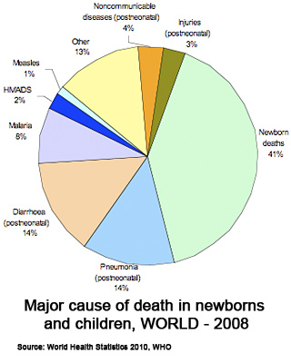
The conceptual framework of the causes of maternal and child undernutrition and its consequences was developed to facilitate greater understanding about the multiple and interrelated factors associated with undernutrition. It is shown in Figure 2 and discussed in detail in Module 5.

Figure 2: Framework of the causes of maternal and child under nutrition and its short-term consequences
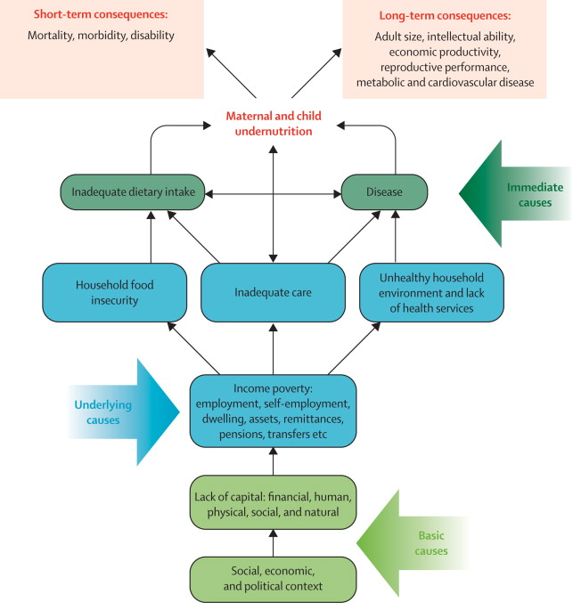

Source: Lancet series on Maternal and Child Undernutrition 2008 - adapted from United Nations Children’s Fund, Conceptual framework for analysing the causes of malnutrition, UNICEF, New York, 1997

The framework clearly illustrates the multiple causes of under nutrition at various levels.
The immediate causes of undernutrition are inadequate dietary intake (in terms of quantity and quality) and disease. There is a reciprocal relationship between these two immediate causes and the interplay between the two tends to create a vicious cycle: where a child is undernourished, immunity to infection is compromised, thus the child may fall ill and then undernutrition worsens, leading to further reduction in resistance to illness. Children who enter this undernutrition - infection cycle can quickly fall into a potentially fatal spiral, as the severity and duration of illnesses increases and one condition feeds off the other.

E.g. recurrent bouts of malaria will lower the immunity of a child and often leads to severe anaemia and acute malnutrition, which further reduces resistance to illness; while an HIV-positive child that is undernourished will develop advanced HIV much more quickly than a well-nourished child.

The underlying causes of undernutrition include income poverty, lack of employment, lack of assets; and are affected by the basic causes of undernutrition, which are lack of resources and deficiencies in the management of available resources (including financial, human and physical); these basic causes are ultimately determined by the larger political, economic and social context.

The consequences of the underlying causes of undernutrition are
- Household food insecurity, including issues of access, availability and utilisation of food;
- Inadequate care, including poor maternal nutrition and inadequate child care;
- Unhealthy household, environment and lack of health services including, inadequate water quality and quantity and poor hygiene and sanitation.

Poor maternal nutrition due to inadequate diet (quality and quantity), lack of micronutrient supplementation, and/or multiple pregnancies (due to lack of utilisation of or availability of appropriate family planning services), will contribute to poor intra-uterine growth; low birth weight of a baby and subsequent suboptimal growth and development of a child. (See link between reproductive and maternal health and child health and nutrition status pages 9 - 12).

Sub-optimal infant and young child feeding and care practices will have a major negative impact on the nutritional status of an infant: a baby that is not exclusively breastfed up to six months of age will be much more prone to diarrhoea and other diseases, and is much more likely to be become acutely malnourished, while poor hygiene practices at household level will also increase the risk of diarrhoea and other infectious diseases and, again, will increase the likelihood of a child becoming under-nourished.

Unhygienic food preparation (storage and cooking) will also increase the risk of diarrhoea- and other infections - subsequently increasing vulnerability to acute malnutrition; while unequal distribution of food within the household will also contribute to undernutrition.

Inadequate provision of water and sanitation facilities will significantly increase the risk of infection/illness.

Inadequate provision of basic health services will further compromise health and nutrition status when common illnesses are not properly treated, while inadequate provision of quality antenatal, safe delivery, post natal and newborn care will result in very high rates of maternal, newborn and neonatal deaths (neonatal period 0-28 days) (See link between reproductive and maternal health and child health and nutrition status pages 9 - 12).

Emergencies directly impact the basic and underlying causes of undernutrition. Humanitarian programming will primarily focus on addressing the immediate causes of undernutrition (disease and inadequate dietary intake) and the consequences of the underlying causes of undernutrition (household food insecurity, inadequate care, unhealthy environment and lack of services). While some of the underlying causes may be addressed as part of a humanitarian response the basic causes of undernutrition should be addressed through longer-term development strategies/programmes.

This conceptual framework is a useful starting point in understanding the links between health and nutrition and the need for multi-sector assessment and multi-sector interventions to prevent mortality and morbidity and undernutrition in an emergency context:

- Prevention of undernutrition is as important as treatment of undernutrition - food security interventions will have an impact on the health and nutritional status of a population in both the short and long term.
- Provision of adequate living facilities will go a long way towards preventing outbreaks of measles and acute respiratory infection in children, which will subsequently have a positive impact on the nutritional status of the children
- Provision of adequate water and sanitation facilities will significantly contribute to prevention of outbreaks of diarrhoea, which will subsequently have a positive impact on the nutritional status of the children
- Adequate provision of basic health services to treat the major common childhood diseases will also have a positive impact on nutritional status of the children

Case example 1: Inadequate health care in Democratic Republic of Congo: 2006
The volatile security situation in the Democratic Republic of Congo in 2006 caused displacement and food insecurity. In one district, levels of acute malnutrition at the end of 2006 were estimated at 11.3 per cent, with severe acute malnutrition levels at 3.2 per cent. Mortality rates for children under age five were high at 2.07/10,000/day.

Inadequate health care due to a disruption of supplies and services and steep increases in the cost of medicine was seen to be a major cause of the high levels of acute malnutrition. Only 0.9 per cent of children surveyed had proof of having had a measles vaccination, although 50 per cent claimed to have been vaccinated.

Source: World Food Programme, 2006.

Case example 2: Inadequate health care and poor health care practice in Darfur 2004
Following mass population displacement in West Darfur an International NGO established a Community-Based programme for Management of Acute Malnutrition. Significant contributory factors to the high levels of acute malnutrition in children were clearly recognised as being lack of provision of basic child healthcare services, poor infant and young child feeding and care practices and inadequate quality and quantity of water supply.

Source: Forsythe V personal communication

The links between reproductive health and maternal and child health and nutrition

The health and nutritional status of pregnant women will significantly impact the health, well-being and nutritional status of their infants as well as the well-being of the women.

Poor health, inadequate diet (quality and quantity) before and during pregnancy, lack of micronutrient supplementation, and/or multiple pregnancies, especially in quick succession (due to lack of utilisation of, or availability of, appropriate family planning services), will contribute to poor intra-uterine growth, low birth weight of a baby and subsequent suboptimal growth and development of a child.

Teenage pregnancy will also affect the health of an infant - a baby is much more likely to be born with low birth weight if a woman is in her teens when she conceives. Where a woman has pregnancies in quick succession, there will be impact on the mothers’ own health, the newborn infant and also the older infant as the mother may stop breastfeeding the older infant too soon.

Both the pregnant woman and the child she is carrying are exposed to greater risk if the woman has had more than 5 pregnancies or if she is younger than 18 or older than 35 (and particularly over 40). In other words, both are at risk if a woman gets pregnant too early or too late in her life, or if the pregnancies are too close together or too frequent.

Table 1: Consequences of maternal malnutrition
An undernourished mother places herself and her child at great risk
Maternal consequences | Child consequences
- Increased risk of maternal death  - Increased infections  - Anaemia  - Compromised immune functions  - Lethargy and weakness  - Lower productivity  - Lactational failure | - Increased risk of foetal and neonatal deaths  - Intrauterine growth retardation  - Low birth-weight  - Pre-term birth  - Compromised immune functions  - Birth defects  - Cretinism and reduced IQ
Source: UNICEF, 2006.

Iron supplementation is given to prevent and treat anaemia, and folate is given to prevent spinal chord defects in the foetus (unborn child). An undernourished, anaemic mother has decreased immunity and is more likely to become infected by diseases such as malaria or diarrhoeal disease.

Iodine supplementation may be needed in areas of severe iodine deficiency to prevent cretinism. Cretinism is a very serious disease of newborn children in which a lack of iodine stops the production of thyroxine, the hormone responsible for the speed of chemical reactions in the body (or metabolism). Babies do not develop their normal mental capacity or physical stature and will remain permanently stunted and with severe mental disability. It is therefore vital that pregnant and breastfeeding women eat iodized salt. See HTP modules 4 and 14 for more details on micronutrient deficiencies and interventions.

Malaria in pregnancy increases the risk of miscarriage and all serious illnesses in pregnancy will contribute to low birth weight of a baby.

Inadequate provision of quality ante-natal, safe delivery, post natal and newborn care results in very high rates of maternal, newborn and neonatal deaths. About 40% of child deaths under the age of five take place during the neonatal period and are usually caused by preterm birth, birth asphyxia (lack of breathing at birth) and infections. Antenatal care, safe childbirth and effective neonatal care are essential to prevent these deaths.

If a child is born with a low birthweight there is a high association with later undernutrition and death. In fact, a baby born underweight in a resource-poor country is 20 times more likely to die than a baby born with a normal weight of more than 2.5 kg. Being underweight at birth makes the baby much more susceptible to infectious diseases, inhibits both growth and cognitive development, and also predisposes the baby to chronic disease later in life. Of the estimated 19 million babies born underweight, one third of these are in south Asia, with 8.3 million born in India alone. However, 60 per cent of babies are not weighed at birth.

Where an infant’s nutritional deficiencies resulting from maternal undernutrition are compounded by poor infant and young child feeding practices, micronutrient deficiencies, poor quality and quantity of food and high incidence of morbidity, this will lead to another generation of undernourished mothers, who will in turn replicate the cycle. This is known as the intergenerational cycle of undernutrition.

Increased use of family planning by couples has a direct positive effect on the well-being of their children. Family planning can help delay the age at which a woman first becomes pregnant, can help a woman space her pregnancies (ideally more than 24 months after the previous birth according to the WHO Technical Consultation on Birth Spacing), can help to reduce the total number of children a women conceives, and can limit the upper age at which a women has a child. All this helps to increase the chance of child survival as there is a strong correlation between increased rates of family planning use and decreased child mortality.

Family planning could bring more benefits to more people at less cost than any other single technology now available to the human race – Peter Adamson, UNICEF, 1996

Mother to child transmission of HIV
Women who are pregnant or breastfeeding require additional energy and additional micronutrients to maintain their own health and to build strong babies. Mothers with HIV require the same increase in foods and added micronutrients as other women, plus an additional 10 percent to maintain their health in the context of HIV infection.

Mothers with HIV may transmit the virus to their infants during pregnancy and delivery or through breastfeeding. Prior to the use of antiretroviral treatment for prevention of mother to child transmission (MTCT), the combined effect of transmission during pregnancy, labour and delivery and transmission through breastfeeding was as high as 40%. However the introduction of antiretroviral therapy (ART) during pregnancy and delivery has reduced MTCT of HIV up to the point of delivery.

Access to contraception, safe delivery services, ART for HIV mothers and optimal infant feeding practices are necessary to reduce MTCT of HIV and promote child survival.

The most appropriate infant feeding option for an infant of an HIV-positive mother depends on the individual circumstances. Exclusive breastfeeding is recommended for HIV-infected women for the first six months of life unless replacement feeding is acceptable, feasible, affordable, sustainable and safe (AFASS) for them and their infants before that time. If, after six months replacement feeding is still not AFASS, when complementary feeding needs to be introduced, continuation of breastfeeding with additional complementary foods is recommended. All breastfeeding should stop once a nutritionally adequate and safe diet without breast milk can be provided.

Table 2: Key reproductive health interventions that promote child health and nutrition
Phase | Proven effective interventions
Care for girls and women before pregnancy | - Nutrition promotion, especially in girls and adolescents  - Prevention and management of HIV and sexually transmitted infections (STI)  - Family planning
Care during pregnancy | 4 visits focused on antenatal care (ANC) including:  - At least 2 doses of tetanus toxoid vaccination (TT2+) for pregnant women  - Intermittent preventive treatment for malaria in pregnancy (IPTp) and long lasting insecticide-treated mosquito nets (LLIN)  - Maternal nutrition during pregnancy, including iron and folate  - Treatment of disease, and mebendazole for worms  - Identification of high risk pregnancies and referral  - Prevention of mother-to-child transmission of HIV  - Preparation of a birth plan
Care during childbirth | - Skilled attendance at birth and clean delivery  - Emergency obstetric care  - Essential newborn care – delayed chord clamping, resuscitation, drying the baby, warmth, cleanliness  - Improved linking of home and health facility  - Companion of the woman’s choice at birth  - Preventing mother-to-child transmission (PMTCT) through antiretroviral therapy and safer infant feeding practices  - Active management of the third stage of labour
Care after birth | - Routine postnatal care (PNC) for early identification and referral for illness as well as preventive care:  – for the mother: promotion of healthy behaviours, danger sign recognition and family planning  – for the baby: promotion of healthy behaviours by mothers – hygiene, warmth, early and exclusive breastfeeding, clean cord care and immunization  - Extra care for babies with other problems (e.g., mothers with HIV/AIDS)  - Management and care of low birthweight (LBW) babies including Kangaroo Mother Care (KMC)  - Case management of neonatal illness especially sepsis  - Early and exclusive breastfeeding for babies  - Vitamin A supplementation for the mother
Source: adapted from ‘Evidence - based interventions to save new born lives’ Opportunities for Africa’s newborns, the Partnership for Maternal, Newborn and Child Health 2007.

Continuum of Care for maternal, newborn and child health
In recognition of the relationship between reproductive health and safe childbirth and the health of both the woman and the new born child, and that a healthy start in life is an essential step towards child health and development, the concept of the “Continuum of Care” has emerged to address maternal, newborn and child mortality globally.

Aspects of the "Continuum of Care" for maternal, newborn and child health include:

1) Time - from pre-pregnancy, through pregnancy, childbirth and the early days of life through infancy and childhood

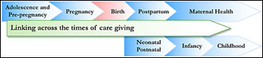

- Place - linking the various levels of care at home, community and health facility level

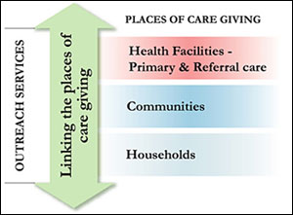

- Packages of key effective interventions have been developed to be provided along the continuum of care through pre- pregnancy, pregnancy, birth, post partum, newborn care, infancy and child care and are defined for family, community and facility levels. The packages are organised on each of the essential components needed to assure adequacy and quality of care for family planning, safe abortion, pregnancy care, child birth care, post partum care of mother, care of newborn, care during infancy and childhood. www.who.int/pmnch/topics.
Most of the key interventions outlined in the “Continuum of Care” are as relevant in an emergency as in a more settled situation. How much can be implemented and how quickly depends on the limitations imposed by the emergency. However as reproductive health and child health services are being established the “Continuum of Care” for maternal, newborn and child care should be applied as feasible.
Major causes of excess morbidity and mortality in emergencies and links with undernutrition

The major causes of excess morbidity and mortality in emergencies are: acute respiratory infections, diarrhoeal diseases, malaria (where prevalent), measles and undernutrition.
Other communicable diseases such as meningococcal meningitis and typhoid may cause large scale epidemics in emergencies, while tuberculosis is also a serious disease causing high levels of morbidity and mortality among emergency affected populations, especially in long term emergencies where living conditions are poor. Poor reproductive health significantly contributes to excess morbidity and mortality, while gender based violence (GBV) and its consequences, including HIV, are also a major concern. Trauma/injury, mental health and psychosocial issues also contribute to excess morbidity and mortality in emergencies.

Table 3: Major causes of excess morbidity and mortality in emergencies - contributing factors and preventative measures
Disease | Major contributing factors | Preventive measures
Acute respiratory infections | - Inadequate shelter - crowded with poor ventilation  - Lack of blankets and clothing  - Indoor cooking - in living area  - Undernutrition (preventative measures listed in last row) | - Minimum living space standards and proper shelter  - Adequate clothing, sufficient blankets
Diarrhoeal diseases | - Overcrowding  - Contaminated water and food  - Poor personal hygiene  - Poor washing facilities  - Poor sanitation  - Lack of soap  - Undernutrition | - Adequate living space  - Public health education  - Distribution of soap  - Good personal and food hygiene  - Safe water supply and sanitation
Malaria | - New environment: movement to area with higher endemic levels /strain to which the refugees are not immune  - Interruption of vector control measures  - Increased population density  - Stagnant water  - Flooding  - Inadequate health care services  - Undernutrition | - Destruction of mosquito breeding places, larvae and adult mosquitoes by spraying  - Provision of LLINs  - Drug prophylaxis (e.g. pregnant women and young children according to national protocols)
Measles | - Overcrowding  - Vaccination coverage below 90%  - Undernutrition (preventative measures listed in last row) | - Minimum living space standards  - Immunisation of children with distribution of Vitamin A -immunisation from 6 months up to 15 years (rather than the more usual 5 years) is recommended because of the increased risks from living conditions.
(Continued)

Undernutrition | - All the above +  - Maternal malnutrition  - Inadequate IYCF  - Inadequate care practices  - Food insecurity  - Inadequate household food distribution  - Illness/infections | - All the above +  - Promote optimal maternal care (including education, health care, micronutrient supplementation and food security)  - Promote optimal IYCF and care practices  - Ensure food security (quality and quantity)  - Provision of accessible basic health services
Source: World Health Organisation (2005) Communicable disease control in emergencies.

Because undernutrition and disease are closely linked, there is likely to be an increase in the incidence of infectious diseases, especially among young children and other vulnerable groups as the nutritional situation worsens. This illness can subsequently contribute to further deterioration in nutritional status of the individual. Furthermore, in middle and low income countries serious illnesses commonly occur sequentially or concurrently: measles may be complicated by pneumonia or diarrhoea and children with Vitamin A deficiency have an increased risk of dying from diarrhoea, measles or malaria.

Although table 3 highlights the major causes of excess morbidity and mortality in emergencies it should be recognised that the patterns of morbidity and mortality vary significantly from context to context.

Increased rates of morbidity and mortality due to communicable diseases occur more frequently in association with complex emergencies than with acute onset natural disasters. Sphere states that in many conflict-affected settings between 60% and 90% of deaths have been attributed to four major communicable diseases: Acute Respiratory Infections (ARI), Diarrhoea, Measles and Malaria where endemic, exacerbated by acute malnutrition. Tuberculosis is of particular importance in long term chronic emergencies due to poor living conditions and it is also exacerbated by undernutrition.

Basic information about important communicable diseases in emergencies

Acute Respiratory Infections
ARI encompasses upper respiratory tract infections - common cold and pharyngitis - and lower respiratory tract infections - bronchitis and pneumonia. The majority of ARIs involve upper respiratory tract only, are mild, and resolve spontaneously. Acute lower respiratory tract infections (LRTI) are a major cause of morbidity and mortality in emergencies. It is estimated that 25-30% of deaths in children under-5 years are due to LRTIs, and 90% of these deaths are due to pneumonia.

Risk factors for pneumonia include low birth weight, malnutrition, vitamin A deficiency, poor breastfeeding practices, poor ventilation in shelters (smoke from indoor fires for cooking or heat), chilling in infants and overcrowding.

Prevention interventions in emergencies include ensuring adequate shelter (space, ventilation and heat) and providing appropriate clothing and blankets. Zinc supplementation protects against pneumonia, while vaccination against measles, diphtheria and whooping cough is effective in reducing the impact of acute respiratory infections generally. It is important that pneumonia is recognised early and treated appropriately with antibiotic therapy according to protocols.

Diarrhoeal diseases
Diarrhoeal diseases are a major cause of morbidity and mortality in emergency situations, often accounting for over 40% of deaths in an acute phase of an emergency, with 80% of these deaths occurring among children under 2 years of age.

Diarrhoea is defined as three or more abnormally loose or fluid stools over a period of 24 hours. It may be caused by various bacteria - Salmonella, E Coli, Shigella Dysenteriae and Vibro Cholerae - or by protozoa - Giardia and Amoeba - or by viruses, e.g. rotavirus. Diarrhoea may occur as one of the symptoms of other infections.

Prevention of outbreaks of Cholera and Shigella dysentery are of particular concern in emergencies as these are highly infectious diseases, and if poorly managed can result in extremely high case fatality rates.

Box 1: Cholera and dysentery in the Democratic Republic of the Congo and Zaïre
The terrible epidemics of cholera and dysentery in the Rwandan refugee camps in Goma, Zaïre in 1994 caused an estimated 85 per cent of the 50,000 deaths, 60 per cent of which were from cholera and 40 per cent from dysentery (shigella). In the Democratic Republic of the Congo between March 2001 and October 2002 there were 55 cholera epidemics, with 38,000 cases and 2,129 deaths- with a Case Fatality Rate (CFR) of 5.6 per cent. These deaths occurred across 51 health districts in 7 provinces.

Source: ‘150 years of cholera epidemiology’, The Lancet, 266, 2005.

Cholera symptoms begin with abrupt onset copious watery diarrhoea, classically rice water stools with or without vomiting. This can result in rapid and profound dehydration and electrolyte imbalance including acidosis. Cholera affects the whole population rather than just children under two years. Cholera should be included in the Early Warning And Response System (EWARS) and a single confirmed case may indicate an outbreak.

Bacillary Dysentery Shigella usually presents with bloody diarrhoea associated with fever and abdominal cramps. Population groups at high risk of contracting bacillary dysentery include children under 5 years of age, especially malnourished and/or post measles (within the last six weeks); adults over 50 years of age; and older children and adults who are malnourished.

Prevention and early treatment of the other diarrhoeal diseases, especially in young children, is also essential to reduce excess mortality in emergencies. Young children often suffer chronic or recurrent bouts of diarrhoea, which will subsequently predispose the child to further infection and malnutrition.

Risk factors for diarrhoea include overcrowding, inadequate quantity and quality of water, poor personal hygiene, poor washing facilities, poor sanitation, poor cooking facilities and lack of soap.

Diarrhoea control interventions in emergencies include provision of adequate quantities of safe drinking water, provision of facilities for safe disposal of human excreta, provision of adequate storage for cooked and uncooked food, appropriate cooking utensils and fuel for cooking, provision of soap; promotion of optimal breastfeeding practices, and provision of information on all of the above activities. Prompt diagnosis and appropriate treatment according to protocols and guidelines is essential to reduce and prevent excess mortality in emergencies.

Malaria
According to WHO almost 300 million cases of malaria occur every year with more than 1million deaths, 90% of which occur in sub-Saharan Africa. It is also one of the major killer diseases in emergencies. Malaria is caused by the parasite plasmodium (and is transmitted from person to person by Anepholes mosquitoes. In the blood the parasites develop trophozite forms which are responsible for clinical attacks and gametocyte forms which are responsible for disease transmission. P.falciparum can cause a life-threatening form of malaria, while P. vivax has persistent liver forms which may lead to relapses after the initial blood infection has been cured.

Risk factors for malaria include movement to a new environment with a strain to which the population is not immune, increased population density promoting mosquitoes biting, stagnant water, flooding, interruption of vector control measures and inadequate health care service provision.

Malaria control interventions in emergencies include environmental control - clearing of stagnant water, indoor residual spraying (guided by entomological assessment /expertise), distribution of long lasting insecticide treated nets and intermittent presumptive treatment of pregnant women. Malaria should be included in the EWARS - an increase in number of cases above what is expected for the time of year may indicate an outbreak.

Prompt diagnosis (using a rapid test) and treatment with Artemether Combination Treatment according to protocols is also essential to reduce malaria-related mortality.

Measles
Measles is a highly communicable viral infection spread by respiratory droplets from person to person and is one of the key killer diseases in emergencies. It is a severe disease which damages the immune system and can increase susceptibility to other infections. It can lead to or exacerbate vitamin A deficiency, thus increasing risk of xerophthalmia and/or blindness. Children between the ages of 9 months and 5 years are the most vulnerable to measles. Deaths are usually due to complications such as pneumonia, croup or diarrhoea, and are frequently associated with acute malnutrition. Other (usually later) complications of measles include encephalitis, stomatitis, and otitis media.

Risk factors for measles include overcrowding, undernutrition and low vaccination coverage (below 90%).

Vaccination is the most important strategy for measles control and measles vaccination campaigns combined with vitamin A supplementation is one of the highest health priority interventions in emergency situations. Ensuring adequate living/shelter conditions is also key to measles control. Measles should be included on the EWARS and a single case may indicate an outbreak. Appropriate case management for uncomplicated and complicated measles should be provided according to clear protocols.

Meningitis
Meningococcal meningitis is an acute inflammation of the meninges usually caused by bacteria. Large outbreaks of meningitis are mainly due to meningococcus neisseria bacteria (various strains serogroups).

Clinical symptoms of meningitis are sudden onset fever >38°C axillary and one of the following: neck stiffness, altered consciousness, other meningeal signs, or purpural rash.
In infants under one year of age meningitis is suspected when fever is accompanied by a bulging fontanelle. Lumbar puncture is necessary to identify meningococcus and should be conducted before treatment is given.

Displaced populations are at increased risk of meningitis due to overcrowding, poor hygiene and poor access to health care. Eighty percent of cases of meningococcal meningitis occur in persons under 30 years of age and without appropriate treatment the case fatality rate (CFR) can be as high as 50%, while with antibiotic treatment the CFR can be reduced to 5-15%.

Risk factors for meningitis include overcrowding, dry season, dust storms and high rates of ARIs. Risk is also greater in the meningitis belt which includes eastern, southern and central Africa.

Meningococcal meningitis should be included in the EWARS, the threshold number of cases indicating an outbreak is variable depending on the context (Sphere).

Vaccines are available against a number of strains of meningococcus and these are effective in controlling epidemics. When rapid mass vaccination campaigns are conducted an outbreak can be controlled within 2-3 weeks.

Human immunodeficiency virus (HIV) infection
HIV is a virus that attacks the immune system. A person infected with HIV may be asymptomatic (no clinical signs or symptoms) for many years. After a period of time, if no treatment is given the effect of a weakened immune system will manifest itself through opportunistic infections, weight loss and low grade fever, progressing to the development of Acquired Immunodeficiency Syndrome (AIDS), which is the most advanced stage of HIV infection.

HIV is found across the globe, however prevalence is highest in sub Saharan Africa, where women and girls make up 57% of the adults living with HIV.

There are four main modes of transmission of HIV -
- Sexual intercourse with an infected partner, especially in the presence of a concurrent STI
- Use of contaminated needles - injecting drug use or needle stick injuries
- Transfusion of infected blood or blood products.
- Mother to Child Transmission - through pregnancy, labour, delivery, or breastfeeding

Humanitarian crises, which are often linked to displacement, food insecurity and poverty, increase vulnerability to HIV and negatively affect the lives of people living with HIV.

The factors that determine HIV transmission during a humanitarian crisis are complex and depend on the context. Existing gender inequalities may be further exacerbated, making women and children disproportionately more vulnerable to HIV, e.g. sex work and sexual exploitation may increase as a consequence of loss of livelihood and lack of employment opportunities. Population displacement may lead to separation of family members and breakdown of community cohesion and of the social and sexual norms that regulate behaviour. Women and children may be used by armed groups and may be particularly vulnerable to HIV infection as a result of sexual violence and exploitation, while rape may be used as a weapon of war.

Pre-emergency HIV services may be disrupted during humanitarian crises - people may no longer have access to information about HIV prevention, to Voluntary Counselling and Testing (VCT), to condoms or to services for PMTCT. People living with HIV may suffer due to disruption of services for treatment of opportunistic infections and for ART, including PMTCT. Their health is put at risk as nutritional needs are not met and palliative and home based care may be disrupted.

Breakdown in reproductive health services leading to lack of availability of family planning services, antenatal and safe delivery services and treatment of STIs, may also accelerate the spread of HIV in emergencies.

The impact of an emergency on mothers and other carers living with HIV (as above) may impact their ability to provide optimal nutrition and care for the children in their care and subsequently affect the nutritional status of those children.

Tuberculosis
Tuberculosis (TB) is a disease which most commonly affects the lungs but also affects other organs. It is caused by the bacterium Mycobacterium tuberculosis, which includes M. tuberculosis and M. africanum (primarily from humans) and M.Bovis (primarily from cattle).
M.tuberculosis and M.africanum are transmitted through airborne exposure to bacilli produced by people with pulmonary or laryngeal TB through coughing or sneezing. Bovine TB is usually contracted through ingestion of unpasteurised milk and sometimes airborne spread to farmer and animal handlers.

Risk factors for TB include overcrowding, malnutrition, and high HIV seroprevalance rates.

The most important symptoms of TB are productive cough for more than 3 weeks, haemoptysis and significant weight loss. Other symptoms include fever, night sweats, breathlessness, chest pain, and loss of appetite.

TB control is not a priority in the acute stages of an emergency when mortality rates are high owing to ARI, undernutrition, diarrhoeal diseases and malaria. A TB control programme should not be implemented until Crude Mortality Rate (CMR) is below 1 per 10,000 pop per day and there is some stability in the population so that patients commencing the treatment can complete the full 6-8 month treatment, however TB is a particularly important disease in long-term emergencies where refugees or Internally Displaced Persons (IDPs) are in overcrowded living conditions for long periods, and undernutrition is prevalent - this is further exacerbated where HIV seroprevalence rates are high.

In Kenya in 1993 the incidence of new infectious TB patients was four times the rate of the local population and in two camps in Sudan in 1990 over one third of all adult deaths were due to TB.
Source: World Health Organisation (2005) Communicable disease control in emergencies.

Child Health in Emergencies

Emergencies exacerbate the severity and magnitude of childhood diseases. Moss et al point out that in refugee populations the highest morality rates are in children under 5 years and that although mortality rates are higher in infants less than 1 year old, the relative increase (due to the emergency) is greatest in older children.

In 1991 at the Turkey - Iraq border 63% of deaths of Kurdish refugees were in children younger than five years, although this group comprised only 18% of the population. In 1992 during the famine in Somalia over 74% of children younger than 5 years in the displaced persons camps were estimated to have died. Among Rwandan and Burundian refugees in Democratic Republic of Congo in 1996, 54% of all deaths were among children under 5 years.

In some settings mortality rates of older children or adults are comparable to or exceed those of young children, but this is more probable after outbreaks of cholera or dysentery or where armed conflict results in many civilian deaths.

Moss et Al also point out that during complex emergencies the most commonly reported causes of death are the same as the major causes of death in countries with high child mortality rates: diarrhoeal disease, acute respiratory infections, measles, malaria and acute malnutrition.

Micronutrient deficiencies are also common in emergency-affected populations. Deficiencies found in children in non-emergency situations such as iron and vitamin A deficiencies, are more common in emergency situations. In addition, less common micronutrient deficiencies such as scurvy (vitamin C deficiency), pellagra (niacin and/or tryptophan) and beri beri (thiamine) may affect large populations in complex emergencies.

During a prospective evaluation of malaria prophylaxis in pregnancy in a refugee population on the north-western border of Thailand from 1987 to 1990, an extremely high infant mortality rate (18%) was documented despite good access to health care. Infantile beri-beri was recognized as the main cause of death accounting for 40% of all infant mortality. Infantile beriberi occurs, usually acutely, in breastfed babies at approximately 3 months of age. The mothers show no signs of thiamine deficiency but their body stores may be virtually nil.
Source Luxenburger C, White NJ, Kuile F, Singh HM, Allier-Frachon I, Ohn M, Chonguphajaisiddhi T, Nosten F, ( 2003); Beri Beri: The major cause of infant mortality in Karen refugees Royal Society of Tropical Medicine and Hygiene

Reproductive Health in Emergencies

As discussed in pages 9 - 12, the health and nutritional status of pregnant women will significantly impact the nutritional status of new born infants in any situation.

However the impact of emergencies further increases these vulnerabilities and risks. Maternal health may be negatively affected by a poor health environment, while maternal nutrition may be very seriously affected by inadequate quality and quantity of food.

For a variety of reasons reproductive health services are often inadequate in the early stages of an emergency. Pre-emergency facilities may be destroyed or damaged due to the conflict, or qualified staff may have fled the area, so leaving a limited capacity for provision of essential reproductive health services. Subsequently, lack of availability and/or utilisation of quality family planning services results in high numbers of women having multiple pregnancies in quick successions with serious health and nutritional consequences for both mother and child, while inadequate provision of quality antenatal, safe delivery and postnatal services and newborn care results in very high rates of maternal and newborn deaths.

Prior to the 1990s reproductive health services in emergencies were designed to address maternal and child health with an emphasis on the health of women primarily in regard to the contribution to the health of the child. Since the mid 1990s the understanding about reproductive health issues in emergencies has broadened to include family planning, gender based violence, sexual transmitted infections and HIV.
Box 2: Incorporating family planning into an emergency response
Although the importance of family planning has been recognised at a global policy level, many humanitarian organisations still have a blind spot for provision of family planning services and do not include this component in the emergency response package. For example, in southern Sudan where NGOs have been the first-line health care providers for the past 25 years, family planning methods and education were not effectively promoted as a standard part of the health response, and consequently only an average of 1.7 per cent of southern Sudanese couples use a modern method of family planning. This extremely low uptake partially accounts for the appallingly high maternal mortality rate of 2037 maternal deaths per 100,000 live births.

The situation is very different in Nepal where, despite a decade of internal conflict, there are relatively high rates of contraceptive use, with 54 per cent of women reporting using a modern method in 2006. This represents a 25 per cent increase from the previous study in 2001. There has also been a substantial decrease in the maternal mortality rate in Nepal, from 539 per 100,000 live births in the 1989 to1995 period, to 281 per 100,000 live births for the 1999–2005 period. There are many reasons to account for this decline, including a doubling of women attending antenatal care and more deliveries being conducted in health facilities or being assisted by a skilled birth attendant, but the increased utilisation of family planning may well have contributed significantly to this decline.

For an excellent guide to methods of family planning, WHO, together with numerous international partners, produced in 2007 the book Family planning: A global handbook for providers.
Sources: Sudanese Central Bureau of Statistics/Southern Sudan Commission for Census, Statistics and Evaluation, 2006, Sudan Household Health Survey; Demographic Health Survey Nepal, DHS, 2007; Dhakal, Sanjaya, (2007), ‘Maternal mortality falls in Nepal but inequalities exist’, The Lancet, 370 (9595), 13 October.

Gender Based Violence includes sexual violence including rape, sexual abuse, sexual exploitation and forced prostitution, domestic violence, forced and early marriage, harmful traditional practices (such as female genital mutilation and honour crimes) and trafficking. While sexual violence has been recognised as part of war, the nature and extent of GBV varies from context to context, and although GBV in emergencies is under-reported it has been widely documented in many humanitarian settings.

“Approximately 50 000 to 64 000 internally displaced women in Sierra Leone reported experiencing sexual violence at the hands of armed combatants. And half of internally displaced women who had face to face contact with combatants reported experiencing sexual violence.”

The majority of Tutsi women in Rwanda’s 1994 genocide were exposed to some form of gender based violence: of those, it is estimated that between 250,000 and 500,000 survived rape.”
Source: Inter-Agency Working Group on Reproductive Health in Crises (2010). Inter-Agency Field Manual on Reproductive Health in Humanitarian Settings.

The physical consequences of GBV include unintended pregnancies, unsafe and complicated abortions, adverse pregnancy outcomes including miscarriage, low birth weight and foetal death, STIs, including HIV, and Urinary Tract Infections (UTIs).

The psychological consequences of GBV include anxiety disorders including post traumatic stress disorder, depression, feelings of inferiority, inability to trust, fear, increased substance abuse, sleep disturbance, eating disorders, sexual dysfunction and suicide.

GBV also has a major impact on the social health of individuals and the community, in terms of stigma, isolation and rejection (including by husbands and families), loss of women’s potential income, interrupted education of adolescents and homicide (e.g. honour killings).

These consequences (physical, psychological and social health) all impact negatively on the nutritional status of infants and young children.

Sexually Transmitted Infections (including HIV) cause a large proportion of the global burden of ill health. There is a strong correlation between STIs and HIV transmission: the presence of other STIs (such as gonorrhoea, chlamydia and trichomoniasis) will increase the risk of sexual transmission of HIV. In humanitarian settings the risk of STI (including HIV) transmission may be high for a variety of reasons, including increased sexual violence, workers in high mobility jobs (such as truck drivers and peace-keepers), transactional sex, alcohol and drug abuse, lack of information and access to condoms, breakdown of community/societal norms.

Mental Health in Emergencies
Mental health and psychological problems occur in all humanitarian situations. The horrors, losses and uncertainties the affected population are exposed to in both conflict related and natural disasters, erode normal protective supports, increase risk of diverse problems and amplify pre-existing problems of social justice and inequality - natural disasters generally have a disproportionate impact on poor people, e.g. in many flood situations it is the poor who were living in relatively dangerous places who are most seriously affected.

Many people show resilience and have the ability to cope relatively well with the horrors, losses and uncertainties that an emergency brings. It is the numerous interacting social, psychological and biological factors which influence whether people develop problems or exhibit resilience and cope.

Inter-Agency Standing Committee (IASC) guidelines describe mental health and psychosocial problems in emergencies as predominately social or psychological in nature but add that that they are generally interconnected.

Mental health and psychosocial issues in emergencies include
- Pre-existing social problems (e.g. extreme poverty, discrimination against or marginalisation of particular groups)
- Emergency-induced social problems (e.g. family separation, disruption of social networks and/or community structures)
- Humanitarian-induced social problems (e.g. undermining community structures or traditional support mechanisms)
- Pre-existing psychological problems (e.g. mental disorders, alcohol abuse)
- Emergency-induced psychological problems (e.g. grief, depression, anxiety including post traumatic stress disorder)
- Humanitarian aid related problems (e.g. anxiety due to lack of information about food distribution )
Health of the elderly in emergencies

The impact of emergencies affects the health and nutritional status of the elderly population with issues such as loss, grief and depression, exhaustion and poor diet, exacerbating poverty, and chronic disease. One study showed that elderly people caring for adults dying with HIV-related illnesses experienced a significant decrease in their Body Mass Index. The following case example from Sudan illustrates the importance of not forgetting older people in nutritional and health planning.

Case example 3: Addressing severe acute malnutrition in older people in southern Sudan: 1998
During 1998 Ajiep in Bhar el Ghazal was regarded as the epicentre of the famine. The population of Ajiep had increased seven-fold from 3000 to 21,000 having been displaced as a result of severe food shortages, insecurity in the surrounding areas and the attraction of a general food ration.

Mortality rates began to rise in February and March 1998 and by August, despite a large amount of food and NGO inputs, the mortality and malnutrition rates remained very high for a prolonged period.

While emergency nutrition interventions had focused predominantly on the needs of children under five years of age, the needs of other population groups, namely adults and older people, had been largely neglected.

Levels of malnutrition among older people and adults were extremely high, exacerbated by an outbreak of dysentery caused by poor sanitation, over-crowding and lack of community-based public health interventions.

By September, a therapeutic and supplementary feeding programme had been established. Patients with dysentery were referred and treated in the field hospital and referred back for nutritional recovery. Of the 440 people admitted for therapeutic feeding during the next months, over 20 per cent of the admissions were older people (over 50 years).

The programme demonstrated high recovery rates (92 per cent), low mortality (5 per cent) and a low defaulter rate (3 per cent). Furthermore, as part of the evaluation of the programme, the ‘elders’ in the community were asked on their opinion of the programme. Their response was simply “finally, the old people have been considered”.

Source: Salama P. 1999 Concern Worldwide

Health programming in emergencies and links to nutrition

Given the multiple determinants of health, the health status of a population is dependent on interventions from a number of sectors including food, water and sanitation, shelter, protection and health.

The role of the health sector / operational health agencies in emergencies is to provide essential health services that effectively reduce health risks.

Essential health services are priority health interventions (curative, preventative and promotional) that are effective in addressing the major causes of excess morbidity and mortality. The way health interventions are planned, organised and delivered in response to an emergency can either enhance or undermine the existing health system and its future recovery and development, so implementation of essential services should be carried out in way to support and strengthen the health system, not undermine it.

Using Sphere Health Actions in Emergencies as a framework, this section provides an overview of key issues in relation to health systems and health services in emergencies, specifically focussing on those issues which have a relationship with / are significant in relation to nutrition status and/or nutrition programming. Please refer to Sphere and other referenced documents for more detailed information.

Health Systems

Health System Standard 1: Health Service Delivery

Sphere Health Service Delivery standard 1.1: Prioritising health services
People have access to health services that are prioritised to address the main causes of excess mortality and morbidity

Priority health interventions will vary form context to context /depending on the type of disaster and the impact, but should be based on evidence-based practices for public health benefit.

Access to health services should be based on principles of equity and impartiality without discrimination. The location and staffing of facilities should be organised to ensure optimal access and coverage; vulnerable groups should be identified and their needs addressed in the design of health services. Barriers to access (e.g. physical, financial and cultural) should be identified and addressed.

Sphere Health Service Delivery standard 1.2: Organisation of health services
People have equal access to effective, safe and quality health services that are standardised and follow accepted protocols and guidelines.

Level of care
In an emergency health services are provided through a variety of health facilities and community outreach workers. The health facilities are categorised according to size and services provided. The following table provides a guide for health facility needs in relation to population size.

Table 4: Health Facility by level of care
Level of care | Capacity
Community | 1 Community Health Worker (CHW) per 1000 people
Peripheral health facility | 1 basic health unit per 10,000 people
Central health facility | 1 health facility per 50,000 people
Hospital | 1 district/rural hospital per 250,000 people
Inpatient and maternity beds | >10 beds per 10,000 people

Health promotion
An active programme of community health promotion should be initiated in the early stages of an emergency, in consultation with local health authorities and community representatives, ensuring a balanced representation of women and men and providing information on:
- Major health problems,
- Health risks,
- Availability and location of health services
- Behaviours that protect and promote good health
- Addressing and discouraging harmful practices

Public health messages and materials should utilise appropriate language and media, be culturally sensitive and easy to understand. Schools and child-friendly spaces are important venues for spreading information and reaching children and parents. It is essential that the various target audiences are adequately considered and appropriate messages developed for each key group. In many emergency situations young children are the carers of younger siblings so health promotion messages / activities should include these children as a target group. Refer to HTP module 19 for more information on behaviour change and communication in emergencies.

Mobile clinics
In some situations it may be necessary to operate mobile clinics to meet the needs of isolated or mobile communities that have limited access to the health care available through static facilities. Mobile clinics have been proven effective in increasing access to treatment in outbreaks where a large number of cases are expected. However mobile clinics should be introduced only in consultation with the lead health agency and the local health authorities as major issues of cost, effectiveness and sustainability need to be considered.

Sphere Health System standard 4: Health financing
People have access to free primary health care services for the duration of the disaster

In terms of the impact on nutrition it is particularly important that child health services are free to facilitate and encourage early presentation of a sick or acutely malnourished child before the condition deteriorates.

A basic humanitarian principle is that services and goods provided by aid agencies should be free of charge to recipients. Where user fees are charged through the government system arrangements should be made for their abolition or temporary suspension for the duration of the emergency. Where an existing fee paying facility agrees not to charge fees the revenue lost and increased case load must be compensated (staff incentives, provision of additional medicines). In contexts where this is not possible members of the emergency affected population may be provided with cash and/or vouchers to enable access to health services.

Working with communities
Active community participation is essential for effective health and nutrition programming in emergencies to ensure relevance and acceptability of activity and to enhance the sustainability of interventions.

Community Participation is the active involvement of the community in the planning, management, implementation, monitoring and evaluation of services and projects/programmes.

It is the responsibility of health and nutrition programme managers to proactively work to facilitate community participation of the population, ensuring women and marginalised groups are actively engaged in the decision-making process. This involves developing relationships of trust and establishing and working through transparent mechanisms for community participation, where programme managers and the population discuss current and planned activities and the population can provide feedback and input into programme decisions.

The importance of working with a community is reflected in the Sphere standards where ‘working with communities’ is one of the common standards in humanitarian assistance that all sectors should follow. While it is appreciated that the level of community participation will vary depending on the phase of an emergency and the physical, social and political circumstances of the disaster affected population, there is a responsibility for agencies to facilitate active community participation.

Sphere Common standard 1: People centred humanitarian response
People’s capacity and strategies to survive with dignity are integral to the design and approach of the humanitarian response.

Key action (1 of 9) Agencies should act to progressively increase the disaster affected people’s decision making power and ownership of programmes during the course of a response.

Community outreach
Humanitarian agencies depend on the work of a significant number of community outreach staff and/or volunteers to support health programme activities. These community extension cadres include CHWs and community health volunteers CHVs, nutrition educators, health and hygiene promoters, and traditional birth attendants. Some of these cadres may be employed as paid staff members and others may work on a voluntary basis.

In a humanitarian situation where several health and nutrition agencies are working in the same geographical area (each with various technical responsibility) there are likely to be a whole network of community cadres employed/appointed on a voluntary basis: general health volunteers, environmental health volunteers and nutrition outreach workers. Often these groups are working independently with no coordination or communication between the various groups. This can lead to confusion, conflicting messages for the community and also a serious duplication of efforts/wastage of resources.

It is therefore essential that the work of the various extension workers is well coordinated, is complementary and that there is no duplication.

The sex ratio of CHWs also needs to be considered within the cultural context: in some situations it may be difficult for female CHWs to move from house to house and at times it may difficult for male CHWs to enter houses where there are no men present.

Where Community Health Volunteers are appointed it will be important to maintain motivation through some sort of non-cash incentives (these could include training, recognition and status, official identification (ID) and transport (e.g. bike), notebooks, boots, T-shirts etc.). Where Community Health Workers are paid a cash incentive it is important to ensure that the rates paid by the various agencies are relatively similar and not divisive to local /established systems/networks. Refer to HTP Module 19 for more information on community participation and working with community volunteers.

Essential Health Services

Communicable diseases
A communicable disease is one that can be transmitted by an infectious organism from one person to another. Transmission may be via Contact (scabies, trachoma, conjunctivitis), Vector (malaria, dengue, yellow fever), Water (non specific diarrhoea, amoebiasis and giardiasis, ascariasis, hookworm, cholera, shigella dysenteriae, typhoid, and hepatitis), Air (ARI, measles, meningitis, TB) or may be Sexually Transmitted (gonorrhoea, syphilis, HIV).

An epidemic is the occurrence of a number of cases of a disease that is unusually large or unexpected for a given place and time. Outbreaks and epidemics refer to the same thing.

Communicable disease outbreaks in emergencies have serious consequences and often result in high death rates, thus control of communicable diseases and prevention of communicable disease outbreaks is essential from the early stages of an emergency - including control of endemic diseases (present on a regular basis).

A systematic approach to the control of communicable diseases is key to a quality humanitarian response and requires cooperation among agencies working at all levels and collaboration among relevant sectors involved in the response - including shelter, water and sanitation, food and nutrition and health.

Sphere outline three communicable disease standards
Sphere Control of communicable diseases standard 1.1 prevention
People have access to information and services that are designed to prevent the communicable diseases that contribute most significantly to excess morbidity and mortality

Key Actions
- Develop and implement prevention measures in coordination with relevant sectors (this includes health promotion - (see below)
- Implement appropriate vector control measures for malaria, dengue and other vector-borne disease depending on local epidemiology
- Implement disease specific prevention measures, e.g. mass vaccination campaign against measles

General prevention measures

Shelter Sector - adequate numbers of climate appropriate shelters, well planned sites: sufficient space between shelters and well ventilated.

Water and Sanitation Sector - adequate quantity and quality water supply, adequate sanitation facilities, appropriate vector control interventions and hygiene promotion/education activity.

Food and Nutrition Sector - appropriate food basket ration (quality and quantity), general nutrition support of the population and management of acute malnutrition and micronutrient deficiencies.

Health Sector - prevention (vaccination and hygiene promotion), diagnosis and case management and outbreak detection, investigation and response.

Culturally appropriate health promotion messages for control of communicable diseases should be developed and disseminated on the following issues:
a) Hand washing
b) Safe Disposal of faeces
c) Keeping water safe/clean
d) Safe storage and preparation of food
e) Safe household refuse disposal
f) Vaccination against measles (and in some contexts also against other vaccine preventable diseases – e.g. meningococcal meningitis)
g) Use of Long Lasting Insecticide treated Nets (LLIN)
h) Community level hygiene promotion measures: environmental cleanliness, refuse disposal, drainage of stagnant water etc.

Refer to HTP module 19 for more details on behaviour change and communication in emergencies.

Malaria prevention measures
Specific interventions to control malaria will vary from context to context depending on the potential disease risk which is influenced by phase of emergency/environment (shelter type/presence of pools of stagnant water etc), immunity status of population (population may have moved from non-endemic to endemic area), vector species and numbers.

Based on assessment of the situation, specific malaria control interventions may include Indoor Residual Spraying (IRS) with effective insecticide and distribution of LLINs.

IRS requires 80% coverage of dwellings to be effective as a community control measure;
LLINs provide personal protection - however distribution of untreated nets is not recommended.

Sphere Control of communicable diseases standard 1.2 diagnosis and case management
People have access to effective diagnosis and treatment for those infectious diseases that contribute most significant to preventable excess morbidity and mortality

Key actions
-Develop public health education messages to encourage people to seek care early for fever, cough, diarrhoea etc
-Provide health care at all first level health facilities based on standard case management protocols Integrated Management of Childhood Illnesses (IMCI) and Integrated Management of Adult Illnesses, (where implemented); with referral for management of severe illness
-Implement triage, diagnostic and case management protocols for early treatment of conditions such as pneumonia, malaria, diarrhoea, measles, meningitis, malnutrition, dengue, and train staff on protocols
-A comprehensive TB control programme should be introduced only when specific criteria can be met (see below)

Tuberculosis is a serious communicable disease and, when a humanitarian emergency develops interruption of TB treatment / loss of patients on TB treatment is a problem. However, while management of individual patients with TB may be possible during emergencies, poorly implemented TB control programmes can potentially do a lot of harm - prolonging infectivity and contributing to spread of multi-drug resistant bacilli.

A comprehensive TB programme should only be implemented where an agency is committed and has resources; there is an assured stability of the population for 12-15 months; and assuredness that a good quality programme can be implemented (capacity of the agency). When TB programmes are established in a humanitarian scenario they should be integrated with the national country programme and follow the Direct Observation Treatment Strategy (short course). Links should be established with HIV programmes where they exist/function. See notes on TB pages 19 - 20.

Nutrition staff should work with TB programme managers to ensure TB patients are receiving appropriate nutritional intake, as loss of appetite and weight loss is associated with TB.

Sphere Control of communicable diseased standard ‘1.3 outbreak detection and response’

Outbreaks are prepared for, detected, investigated and controlled in a timely and effective way

Key actions
Detection
-Establish disease EWARS based on risk assessment of communicable diseases,
-Train health facility staff and CHWs to detect and report potential outbreaks,
-Provide communities with simple information on symptoms of epidemic-prone diseases and where to go for help
Preparedness
-Prepare outbreak investigation and response plan
-Ensure protocols for investigation and control of common outbreaks, including relevant treatment protocols, are available and distributed to relevant health staff
-Ensure reserve stocks of essential materials are available for priority diseases (or can be procured rapidly from a pre-identified source)
-Identify sites for isolation and treatment of infectious diseases in advance, e.g. cholera treatment centres
-Identify laboratory services that can provide confirmation of outbreaks (locally, nationally or regionally)
-Ensure materials for sampling and transporting are available for the infectious agents most likely to cause a sudden outbreak
Control
-Describe the outbreak according to time, place and person, leading to identification of high risk groups and adapted control measures
-Implement appropriate control measures that are specific to the disease and context

Case Fatality Rates

The acceptable CFR for communicable diseases varies according to the general context, accessibility to health services and the speed and quality of case management.

According to Sphere, with appropriate case management CFRs for the following communicable diseases should be kept to the following:
- Cholera: 1% or lower
- Shigella dysentery: 1% or lower
- Typhoid: 1% or lower
- Meningococcal meningitis: varies 5-15%
- Malaria: <5% in severely ill malaria patients
- Measles: <5%

If CFRs exceed these levels an immediate evaluation of control measures should be undertaken and corrective steps taken to ensure CFRs are reduced to and maintained at acceptable levels.

Child Health

In any emergency situation children are especially vulnerable, and it is well documented that child morbidity and mortality rates increase significantly during emergencies - with children under-5 having the highest mortality rates.

In terms of emergency health programming it is therefore essential to establish child-focused health interventions which address the major causes of excess morbidity and mortality: ARI, diarrhoea, measles, malaria (where prevalent), neonatal causes and undernutrition.

Sphere Child Health Standard 2.1 Prevention of vaccine preventable diseases

Children aged 6 months to 15 years must have immunity against measles and access to routine Expanded Programme on Immunisation (EPI) services once the situation stabilises

It is essential to estimate vaccination coverage of children aged 9 months - 15 years of the affected population at the outset of a disaster response to determine the risk of outbreaks (review coverage data of the population for the last five years and whether a mass campaign has been conducted in the last 12 months).

Where coverage of children between 9 months and 15 years is below 90% or unknown a mass vaccination campaign should be conducted for children aged 6 months to 15 years.

Vitamin A should be administered at the same time to children between 6-59 months of age.

Infants that have been vaccinated between the ages of 6-9 months should have a follow up dose of measles vaccination at 9 months of age and a system should be established to ensure that any newcomers to the area or camp aged between 6 months and 15 years receive measles vaccination.

Routine EPI services for measles and other vaccine preventable diseases should be re-established as soon as conditions permit.

Child Health Standard 2. 2 Management of newborn and childhood illnesses

Children have access to priority health services that are designed to address the major causes of newborn and childhood morbidity and mortality

Care of newborns
Childbirth should be supported by a skilled practitioner, ideally at a health facility (see Reproductive Health previous section).
Care of the newborn just after birth includes (as part of Reproductive Health)
- Care of airway - resuscitation if required
- Care of umbilical cord
- Early initiation of breastfeeding and promotion of exclusive breastfeeding
- Care of body temperature ensure baby is kept warm - keeping next to mothers skin and wrapping in material - Kangaroo Mather Care
- Eye care - (wash, prophylaxis ointment)
- Immunisation (polio and BCG)
- Treatment for any infections - skin, eye, cord, mouth
- Identification and initial management of severe illness and referral for treatment
- Care of pre-term, low birth weight baby with breathing problems (support for breastfeeding, kangaroo mother care)

Health care workers should promote and support the following practice at community level-
- Exclusive breastfeeding
- Infection prevention (general hygiene, hand washing, cord care, and safe disposal of babies faeces)
- Prevention of indoor air pollution
- Newborn stimulation and play
- Recognition of problems/illness and timely care seeking

Care of children
Health care for children should be provided at first level health facilities, using national protocols, or the IMCI guidelines where implemented, with referral to hospital for severely ill children.

IMCI was initiated in 1992 by WHO and UNICEF to reduce mortality and morbidity due to the major childhood illnesses: ARI, Diarrhoea, Malaria, Measles and Acute Malnutrition. IMCI uses a three pronged approach: a) improving case management skills of health care staff; b) improving overall health systems; and c) improving family and community health practices.

The corner stone of the IMCI is the set of clinical guidelines for integrated management of childhood illnesses from two months to five years at first level health facilities. Using clinical algorithms formatted in flow charts, the guidelines take a health care worker through a logical process of correct diagnosis and provision of treatment of a sick child and provision of information to caregivers. Technical updates of the guidelines for IMCI were produced by WHO in 2005 for countries to use as they update national IMCI guidelines.
An alternative guideline “Manual for the health care of children in emergencies” was developed by WHO in 2008, based on the IMCI guidelines and again using algorithms formatted as flow charts. However, in addition to the illnesses covered by IMCI, this guide also incorporates emergency resuscitation, management of trauma and burns, care of the newborn and young infants, and evaluation of mental health and psychosocial support.

It is essential to ensure that the nutritional status of all children attending health facilities is assessed and that those with acute malnutrition are referred for treatment. Assessment of nutritional status and potential feeding problems are incorporated into the IMCI integrated case management process, however it will be important to customise this to the country situation ensuring that the appropriate admission criteria and referral processes for acutely malnourished children are clear. For details of management of acute malnutrition see HTP modules 12 (moderate acute malnutrition (MAM)) and 13 (severe acute malnutrition (SAM)). For full details on prevention and treatment of micronutrient deficiencies see HTP modules 4 and 14.

Box 3: Importance of linking child health services with therapeutic treatment services
In 2006 an international NGO was implementing a nutrition programme in two counties in south Sudan. The NGO was providing therapeutic treatment and supplementary care to children using a community based approach; holding weekly outpatient consultations in temporary static facilities and mobile clinics across both counties, with referral to an inpatient stabilisation centre for those children with SAM and medical complications. Another international NGO was providing maternal and child health care services (sick children consultations and vaccinations) in static health facilities in the same geographical catchment area.

There was no coordination mechanism between these two agencies and no system for referral of acutely malnourished children for treatment. Subsequently many severely acutely malnourished children were not identified / did not present for treatment until the condition reached the late stages with medical complications having developed.

Coordination between these two agencies and establishment of a referral system for acutely malnourished children identified during sick children consultation would have facilitated earlier presentation of children with SAM - before medical complications set in - making for easier treatment (outpatient rather than inpatient) and speedier recovery.
Source: Personal communication Forsythe V

A key aspect of child health care in emergencies is promotion of key infant and young child feeding and care practices; therefore it will be important to design and disseminate culturally appropriate health promotion messages to:
a) Encourage the affected population to seek early care for any illness in newborns and young infants - (symptoms of major diseases and information about where to go for treatment)
b) Promote optimal IYCF and care practices including:
    - Exclusive breastfeeding 0-6 months,
    - Prevention of infection (hand washing, care of cord, safe disposal of faeces, general, household and food hygiene practices)
    - Prevention of indoor air pollution
    - Vaccination
    - Newborn and infant stimulation and play

See Annex 4 “12 key family practices to improve child survival” and refer to HTP module 19 for more information on behaviour change and communication in emergencies.

Sexual and Reproductive Health
Inadequate provision of reproductive health services significantly contributes to excess maternal, neonatal and infant morbidity and mortality in emergencies. Thus reproductive health is a key health programme component that should be initiated in the early stages of an emergency. Planning for the integration of quality reproductive health services into the Primary Health Care (PHC) system from the outset of an emergency is essential to ensure sustainability of provision of services for maternal, neonatal and child care.

According to the Inter Agency Working Group (IAWG) on Reproductive Health in Crises, Sexual and Reproductive Health in Emergencies encompasses the following: A Minimum Initial Services Package (MISP), Adolescent Reproductive Health, Family Planning, Maternal and Newborn Care, Comprehensive Abortion Care, Gender based Violence (protection and care), STI Care, and HIV Care.

Sphere Sexual and Reproductive Health standard 3.1 Reproductive Health
People have access to the priority reproductive health services of the Minimum Initial Service Package (MISP) at the onset of an emergency and comprehensive reproductive health services as the situation stabilises

Sphere Sexual and Reproductive Health standard 3. 2 HIV & AIDS
People have access to the minimum set of HIV prevention, treatment and support services during disasters

The MISP outlines the most important services for preventing reproductive health morbidity and mortality among women, men and adolescents in humanitarian settings. It comprises a set of priority interventions to:
- Prevent, and manage the consequences of sexual violence,
- Reduce the transmission of HIV,
- Prevent maternal and newborn morbidity and mortality, and
- Begin planning for comprehensive RH services.

Key objectives of MISP and related activities are to:
Ensure a Lead Reproductive Health Agency is appointed from within the health sector/cluster to facilitate coordination of the MISP (includes health sector and multi-sector coordination)
- A Reproductive Health Officer should be nominated to provide support to agencies providing health services
- Regular stakeholder meetings should be held to facilitate the implementation of the MISP

Prevent and manage the consequences of sexual violence
- Put in place measures to protect the affected population, particularly girls and women.
- Make clinical care available for victims of rape
- Ensure the community is aware of available clinical services

Reduce HIV transmission
- Ensure safe blood transfusion
- Facilitate and enforce respect for standard precautions
- Make free condoms available

Prevent excess maternal and newborn morbidity and mortality
- Ensure availability of emergency obstetric care (EmOC) and newborn care services, including
    - At health facilities: skilled birth attendants and supplies for normal births and for management of obstetric and newborn complications
    - At referral hospitals: skilled medical staff and supplies for the management of obstetric and newborn emergencies.
- Establish a referral system to facilitate transport and communication from the community to the health centre and between the health centre and the hospital
- Provide clean delivery kits to visibly pregnant women and birth attendants to promote clean home deliveries when access to a health facility is not possible
Plan for comprehensive Reproductive Health services integrated into PHC as the situation permits.

MISP also highlights that it is important to ensure:
- Contraceptives are available to meet demand;
- Treatment of STIs is available to patients presenting with symptoms;
- Antiretrovirals (ART) are available to continue treatment for patients already on ART, including PMTCT; and
- Culturally appropriate menstrual protection materials are distributed to women and girls.

Comprehensive Reproductive Health Services
As the situation stabilizes comprehensive reproductive health services are established to augment MISP services and include the following services by component:
- Family Planning - comprehensive family planning programming and community education
- GBV - expanded medical, psychological, social and legal care for survivors; prevent and address other form of GBV including domestic violence, forced/early marriage, female genital mutilation; provide community education; engage boys and men in GBV programming
- Maternal and Newborn Care - provide antenatal and postnatal care; increase access to basic and comprehensive EmOC and newborn care
- Prevention and treatment of STIs, including HIV- establish comprehensive STI prevention and treatment services including STI surveillance systems; raise awareness of prevention, care and treatment services for STIs, including HIV (see below);

HIV service to be established as comprehensive reproductive health services are developed:
- Community education;
- Comprehensive service to provide care, support and treatment for people living with HIV and AIDS
- Establish links between HIV and TB programmes where TB programmes exist
- Establish referral for required health and nutritional care and support
- Ensure provision of treatment, care and support for infants born from mothers known to be HIV-positive, including guidance and counselling on infant feeding.
- Ensure people who are at high risk of exposure to HIV have access to HIV prevention interventions for sexual transmission of HIV and access to clean injecting equipment for known injecting drug users where these services already exist
- Broaden range of HIV control service in the post emergency phase
- Ensure Post Exposure Prophylaxis (PEP) is available for individuals potentially exposed to HIV (occupational exposure and non-occupational exposure). PEP should be given within 72 hours

The Inter-Agency Field Manual for Reproductive Health in humanitarian settings stresses that it will be important to design and disseminate key RH messages that are disseminated consistently by all the health and social welfare promoters throughout the community.

Sample RH messages:
- At the onset of humanitarian response (MISP implementation): “women experiencing problems during childbirth should seek care at the hospital near the water point”
- As the situation stabilises (comprehensive RH care): “spacing pregnancies at least two years apart promotes the health of women, children and families”.

Nutrition staff should work with providers of antenatal, newborn and postnatal care to ensure promotion of maternal nutrition (diet and supplementation) and promotion of optimal infant nutrition (including promotion of early initiation of breastfeeding, exclusive breastfeeding from 0-6 months, vitamin A supplementation of babies, support of infant feeding in the context of mothers with HIV).

Nutrition staff should work with other providers of HIV-related care to ensure appropriate nutritional support for persons living with HIV including targeted food support and treatment of acute malnutrition.

Mental health and psychosocial support services
Post-traumatic mental and psychological stress is another major cause of excess morbidity in emergencies and when a mother is suffering from mental illness or psychological stress it is likely to impact her ability to provide optimal nutrition and care for her children; and this will subsequently affect their nutritional status..

Mental health and psychosocial support involves multi-sector interventions requiring coordinated implementation, which should be planned and overseen through a cross-cluster or cross-sector working group.

The IASC guidelines describe interventions by function/domains:
- Part A: Common functions across domains- Coordination; Assessment, monitoring and evaluation; Protection and human rights standards; and Human resources
- Part B: Core mental health and psychosocial support domains - community mobilisation and support; Health services; Education; Dissemination of Information
- Part C: Social consideration in sector domains - Food security and nutrition; Shelter and planning; Water and Sanitation.

The Sphere mental health standard focuses on actions that should be conducted by health actors.

Essential Health Services Standard 5: Mental health

“People have access to health services that prevent or reduce mental health problems associated with impaired functioning”

Enabling community members including marginalised groups to strengthen community self health and social support is a key element of overall multi-sector support including the health sector. Health sector may employ or engage with community workers and volunteers who can facilitate and enable community members, including marginalised groups, to increase self help and social support.

Specific services should include:
-Psychological first aid. Management of acute anxiety after exposure to extreme stressors should be by psychological first aid. This is not a clinical intervention, rather it provides support for a person who is suffering and entails non-intrusive pragmatic care focussing on listening, but not forcing to talk; assessing needs and concerns, ensuring basic needs are met; encouraging social support from others and protecting from further harm. Health facility staff and CHW and/or Community Health Volunteers (CHVs) should be trained to provide this support.
-Basic mental health care. People with severe mental health problems should have access to community based social supports and clinical care through available health facilities.
-People in institutions - mental hospitals and residential homes for people with severe mental problems - need to be visited regularly, especially in the early stages of an emergency, because risk of neglect or abuse of people in institutions is high. Safety, basic physical needs, human rights surveillance and basic psychiatric and psychosocial care must be provided throughout the crisis.
-Early recovery: humanitarian crises increase the rates of a broad range of mental and psychosocial disorders and so plans need to be developed to scale up effective mental health treatment for the affected population.

Sphere has adapted the IASC intervention pyramid to show types of mental health and psychosocial services in emergencies:

The impact of MHPP issues on a mother’s ability to provide optimal feeding and care for a young infant is enormous. Nutrition staff should work with health and social care providers to facilitate/support optimal care of infants and children of carers suffering from mental health and psychosocial issues.

Health and nutritional support for various vulnerable groups in emergencies

People living with a variety of chronic medical conditions, will require appropriate medical treatment along with necessary nutritional support.

Specific consideration must also be given to the health and nutrition needs of the elderly to ensure that they have access to appropriate medical treatment, and that the vulnerable elderly receive an adequate and appropriate diet and that they have the capacity to prepare and cook food. See Annex 5 for guidelines on recognising basic clinical symptoms associated with severe malnutrition in older people.

Annex 1: Measles vaccination in emergencies
Source: The Sphere Project (2011). Humanitarian Charter and Minimum Standards in Humanitarian Response, (Minimum Standards in Health Action)

- It is essential to estimate vaccination coverage of children aged 9 months - 15 years of the affected population at the outset of a disaster response to determine the risk of outbreaks (review coverage data of the population for the last five years and whether a mass campaign has been conducted in the last 12 months).

- Where coverage of children between 9 months and 15 years is below 90% or unknown a mass vaccination campaign should be conducted for children aged 6 months to 15 years.

- Vitamin A should be administered at the same time to children between 6-59 months of age.

- Infants that have been vaccinated between the ages of 6-9 months should have a follow up dose of measles vaccination at 9 months of age and a system should be established to ensure that any newcomers to the area or camp aged between 6 months and 15 years receive measles vaccination.

- Routine EPI services for measles and other vaccine preventable diseases should be re-established as soon as conditions permit.

Annex 2: Prevention and care of illness in newborn children (from IMCI guidelines. Retrieved 14 July 2009 from www.who.int/child_adolescent_health/en/)

The key elements of care of sick neonates are the following:
- Warmth. Keep the baby’s temperature between 36.50 Cº – 37.50 Cº and ensure that the feet are pink and warm to the touch.
- Stabilization. Clear the mouth and the nose. Revive the baby if it is not breathing or has a slow heartbeat. Administer normal saline if there is poor circulation. Infuse glucose if low blood glucose levels are suspected.
- Feeding and fluids. If the baby can suck, offer direct breastfeeding. If not, provide expressed breastmilk with cup/spoon or feeding tube. If oral feeding is not possible, start intravenous fluids.
- Specific therapy. Administer antibiotics, oxygen, vitamin K or other medication as required.
- Monitoring. Monitor clinical signs to assess the progress of the baby.
- Prevention. Prevent infections by clean delivery, hand washing, and cord, skin and eye care. Prevent breastfeeding problems in the mother by milk expression and counselling. Prevent eye damage in preterm infants by avoiding excessive exposure to oxygen.
- Communication. Explain to the mother and family the condition of the baby and the treatment being given. At discharge, counsel the mother regarding care at home, exclusive breastfeeding, plans for follow up care, immunization and when to seek care.
Annex 3: IMCI case management for ages 2 months to 5 years
PINK
Urgent Referral

REFERRAL FACILITY
Emergency triage and treatment (ETAT)
Diagnosis
Treatment
Monitoring and follow-up
Check for DANGER SIGNS
Convulsions
Lethargy/unconsciousness
Inability to drink/breastfeed
Vomiting
Check for OTHER PROBLEMS
Assess MAIN SYMPTOMS
Cough/difficulty breathing
Diarrhoea
Fever
Ear problems
Assess NUTRITION and IMMUNIZATION STATUS and POTENTIAL FEEDING PROBLEMS
CLASSIFY CONDITIONS and IDENTIFY TREATMENT ACTIONS
According to colour-coded treatment charts
PINK
Urgent referral

YELLOW
Treatment at outpatient health facility

GREEN
Home management
OUTPATIENT HEALTH FACILITY
Pre-referral treatments
Advise parents
Refer child

OUTPATIENT HEALTH FACILITY
Treat local infection
Give oral drugs
Advise and teach caretaker
Follow-up
HOME
Caretaker is counselled on how to:
Give oral drugs
Treat local infections at home
Continue feeding
When to return immediately
Follow-up
OUTPATIENT HEALTH FACILITY
The Integrated Case Management Process

Source: WHO and UNICEF (2001) Model Chapter for Text books: IMCI. WHO and UNICEF, Geneva and New York

Annex 4: 12 key family practices to improve child survival
Source: Ref WHO and UNICEF - retrieved 2011 from www.emro.int/cah/CommunityComponent-FamilyPactice

Communities need to be strengthened and families supported to provide the necessary care to improve child survival, growth and development. The evidence suggests that families should:

- Breastfeed infants exclusively for at least six months (mothers found to be HIV positive require counselling about possible alternatives to breastfeeding).
- Starting at about six months of age, feed children freshly prepared energy and nutrient-rich complementary foods, while continuing to breastfeed for up to two years or longer.
- Ensure that children receive adequate amounts of micronutrients (vitamin A and iron in particular) either in their diet or through supplementation.
- Dispose of faeces, including children’s faeces, safely and wash hands after defecation, before preparing meals, and before feeding children.
- Take children as scheduled to complete a full course of immunizations (BCG, DPT, OPV, and measles) before their first birthday.
- Protect children in malaria-endemic areas, by ensuring that they sleep under insecticide-treated mosquito nets.
- Promote mental and social development by responding to a child’s needs for care, and through talking, playing, and providing a stimulating environment.
- Continue to feed and offer more fluids, including breastmilk, to children when they are sick.
- Give sick children appropriate home treatment for infections.
- Recognize when sick children need treatment outside the home and seek care from appropriate providers.
- Follow the health worker’s advice about treatment, follow-up and referral.
- Ensure that every pregnant woman has adequate antenatal care. This includes having at least four antenatal visits with an appropriate health care provider, and receiving the recommended doses of the tetanus toxoid vaccination. The mother also needs support from her family and community in seeking care at the time of delivery and during the postpartum and lactation period.

Annex 5: Guidelines for recognising basic clinical symptoms associated with severe acute malnutrition in elderly people
Source: Borrel, Annalies, Help Age International (2001) Addressing the nutritional needs of older people in emergency situations in Africa: ideas for action.

These clinical symptoms can be observed through physical examination and patient consultation. A physician or senior health worker usually carries out a physical examination on patients admitted to a therapeutic feeding programme.

Clinical symptom or sign
Famine oedema
This occurs bilaterally, e.g., in both feet or legs (accumulation of fluid in the tissues). On pressing down gently with a thumb a pit is formed which remains visible for a few seconds (hence sometimes called ‘pitting oedema’).

Oedema occurring following sleep or immobility, disappears after some exercise and is usually a result of poor circulation or heart condition.

Inability to stand/immobile
Some patients will be too weak to stand and/or walk. These patients are usually carried on stretchers by family members or outreach workers. In some cases, this inability to stand may be part of the natural ageing process and general debilitation, e.g., kyphosis.

Extreme weakness
Patients do not have the strength to carry out daily tasks and may, in some cases, be too weak to prepare and eat food by themselves. Patients will spend long hours sitting or resting. Muscle strength is severely depleted and muscle tissue is wasted.

Dehydration
Patient has dry mucosal membranes and dry mouth. When the skin is gently lifted away from the bone, it remains upright for a few seconds.

Anorexia
Patient is vomiting and unable to keep food in their stomach. Often the patient will refuse to take food.

Annex 6: Essential elements of a focused approach to antenatal care (From World Health Organization (2006), ‘Opportunities for Africa's newborns: Practical data, policy and programmatic support for newborn care in Africa’, The Partnership for Maternal, Newborn and Child Health)

• Identification and surveillance of the pregnant woman and her expected child

• Recognition and management of pregnancy-related complications, particularly pre-eclampsia

• Recognition and treatment of underlying or concurrent illness

• Screening for conditions and diseases such as anaemia, STIs (particularly syphilis), HIV infection, mental health problems and/or symptoms of stress or domestic violence

• Preventive measures, including tetanus toxoid immunisation, de-worming, iron and folic acid, intermittent preventive treatment of malaria in pregnancy (IPTp), insecticide-treated mosquito nets (ITN)

• Advice and support to the woman and her family for developing healthy home behaviours and a birth and emergency preparedness plan to:

- Increase awareness of maternal and newborn health needs and self-care during pregnancy and the postnatal period, including the need for social support during and after pregnancy.

- Promote healthy behaviours in the home, including healthy lifestyles and diet, safety and injury prevention, and support and care in the home, such as advice and adherence support for preventive interventions such as iron supplementation, condom use, and use of ITN.

- Support care seeking behaviour, including recognition of danger signs for the woman and the newborn as well as transport and funding plans in case of emergencies.

- Help the pregnant woman and her partner prepare emotionally and physically for the birth and care of their baby, particularly preparing for early and exclusive breastfeeding and essential newborn care and considering the role of a supportive companion at birth.

- Promote postnatal family planning/birth spacing.

Annex 7: Routine postnatal care: What when, where and who?

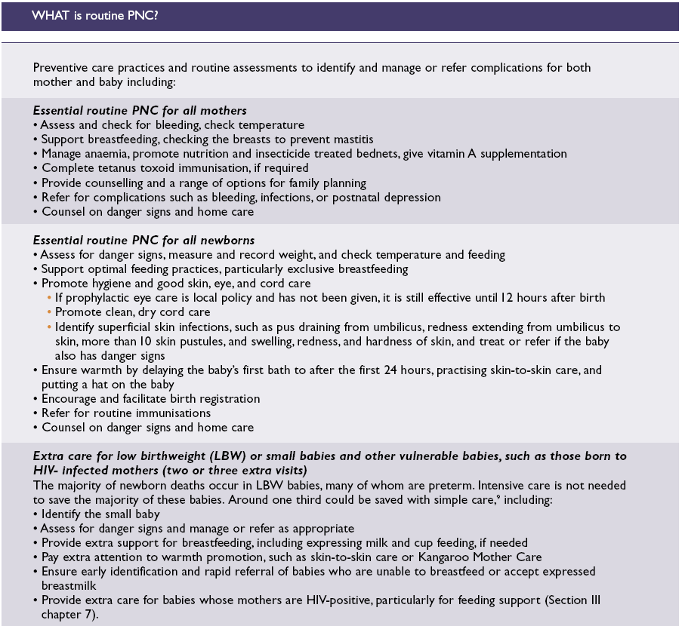

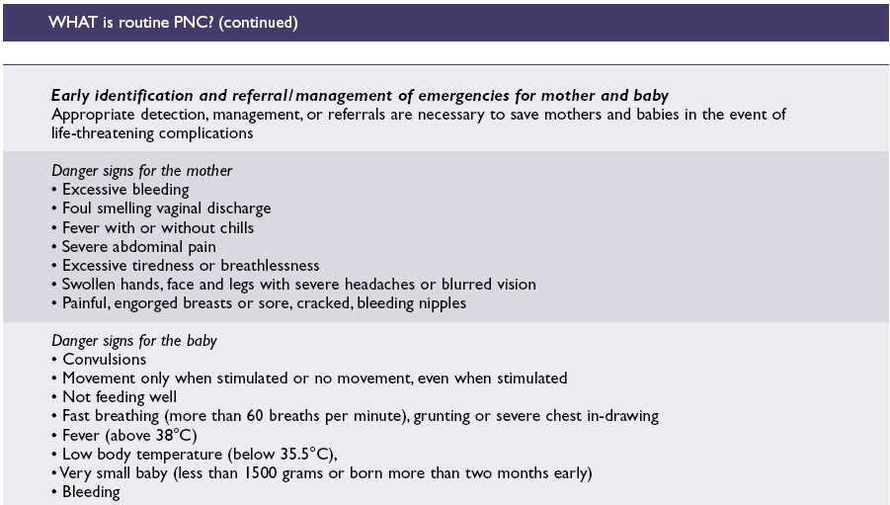
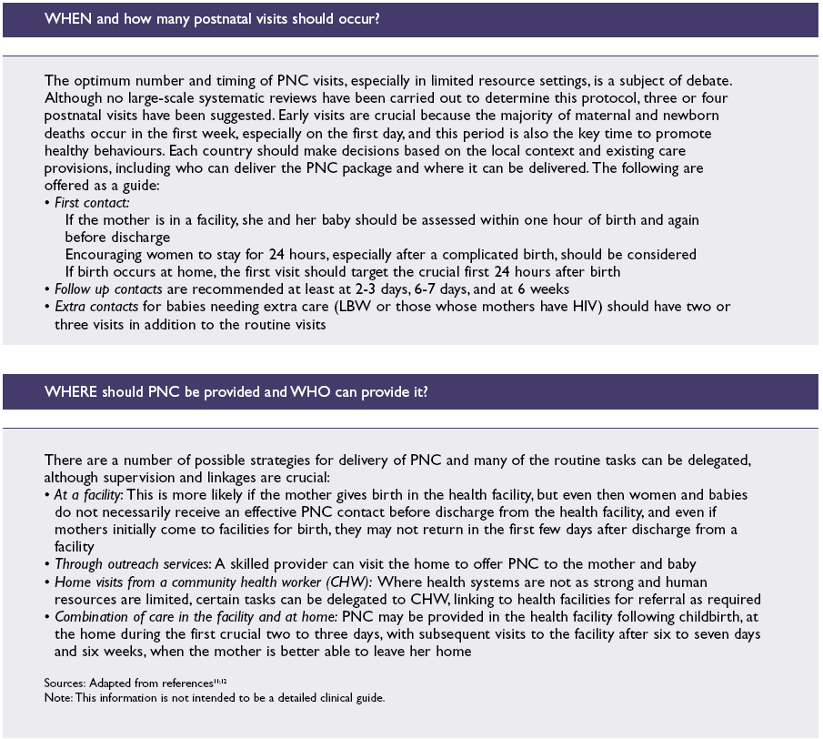

Annex 8: Malaria Intervention Strategy

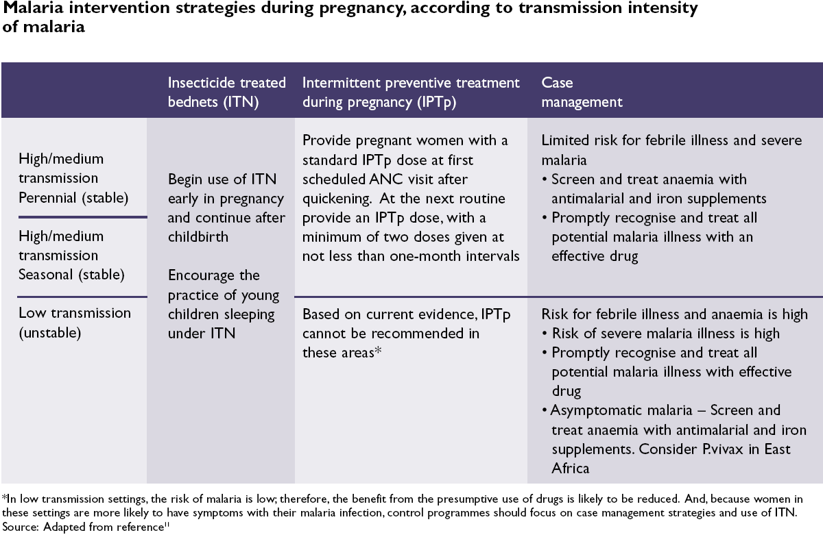

WHO World Health Statistics 2010
Lancet series on Maternal and Child Undernutrition 2008 - adapted from United Nations Children’s Fund, Conceptual framework for analysing the causes of malnutrition, UNICEF, New York, 1997
United Nations Children’s Fund, Progress for children: A World Fit for Children Statistical Review, No. 6, UNICEF, December 2007.
State of the World’s Mothers 2007: Saving the lives of children under 5, Save the Children, 2007. Retrieved 14 July 2009 from www.savethechildren.org/campaigns/state-of-the-worlds-mothers-report/2007/.
Adamson, Peter, ‘A Failure of Imagination’, The Progress of Nations 1996, United Nations Children’s Fund, 1996. Retrieved 14 July 2009 from www.unicef.org/pon96/womfail.htm.
Facts about the “Continuum of Care for Maternal, Newborn and Child Health” and the Partnership for Maternal, Newborn and Child Health are available on www.who.int/pmnch
Black RE, Moris SS, Bryce J, (2003) Where and why are 10 million children dying every year Lancet 361:2226-34
World Health Organisation, Ed. Connolly, M.A. (2005). Communicable disease control in emergencies: A field manual. Geneva; WHO.
Moss William, Ramakrishnan M, Storms Dory, Seigle Anne, Weis William, Lejnev I & Muhe L; WHO Bulletin 2006; 84:58-64
Centre for Disease Control (1992). Famine-affected, refugee and displaced populations; recommendations for public health issues. MMWR Recomm Rep:41:1-76
Moore P, Marfin AA, Quenemoen LE, Gesner BD, Ayub Y, Miller D, et al. (1993) Mortality rates in displaced and resident populations of central Somalia during 1992 famine. Lancet:341:935-8
Nabeth P, Vasset B, Guerin P, Doppier B, Tectonids M (1997), Health situation of refugees in Eastern Zaire. Lancet; 349:1031-2.
Inter-Agency Standing Committee (2007), Guidelines on Mental Health and Psychosocial Support in Emergency Settings. New York: United Nations
Ainsworth, Martha and Julia Dayton, ‘The elderly and AIDS: coping with the impact of adult death in Tanzania’, Social Science & Medicine, 59, November 2004.
Salama, Peter, Concern Worldwide, Presentation at ACCSCN, April 1999.
CFRs as high a 21% have been reported in some conflict settings
Inter-Agency Woking Group on Reproductive health in Crises (2010), Inter-Agency Field Manual (IAFM) on Reproductive Health in Humanitarian settings.
IAWG Reproductive Health in Crises, (2010), IAFM Reproductive Health in humanitarian settings.
World Health Organization (2006), Opportunities for Africa's newborns: Practical data, policy and programmatic support for newborn care in Africa, The Partnership for Maternal, Newborn and Child Health.
From the World Health Organization (2006), Opportunities for Africa's newborns: Practical data, policy and programmatic support for newborn care in Africa, The Partnership for Maternal, Newborn and Child Health..

