MODULE 4
Micronutrient malnutrition

PART 3: TRAINER’S GUIDE

The trainer’s guide is part three of four parts contained in this module. It is NOT a training course. Rather it provides guidance on how to design a training course by giving tips and examples of tools that the trainer can adapt. The trainer’s guide should only be used by experienced trainers to help develop a training course which meets the needs of a specific audience. The trainer’s guide is linked to the technical information found in part two of the module.

Module 4 is about micronutrient malnutrition. It aims to help participants learn about a range of diseases that can be caused by micronutrient deficiencies, recognise the common signs and symptoms of these diseases, and understand the importance of good nutrition for avoiding these important public health problems. The module can used to provide a practical training for field workers involved in assessing micronutrient malnutrition. It can also provide a short practical briefing on different aspects of micronutrient malnutrition for senior managers.

Navigating your way round these materials

The trainer’s guide is divided into six sections.

- Tips for trainer provide pointers on how to prepare for and organise a training course.
- Learning objectives sets out examples of learning objectives for this module that can be adapted for a particular participant group.
- Testing knowledge contains an example of a questionnaire that can be used to test participants’ knowledge of micronutrient malnutrition, either at the start or at the end of a training course.
- Classroom exercises provide examples of practical exercises that can be carried out in a classroom context either by participants individually or in groups.
- Case studies contain examples of case studies that can be used to get participants thinking through real-life scenarios.
- Field-based exercises outline ideas for field visits that may be carried out during a longer training course.

Contents

- Tips for trainers
- Learning objectives
- Testing knowledge
Exercise 1: What do you know about micronutrient malnutrition?
Handout 1a: What do you know about micronutrient malnutrition? Questions
Handout 1b: What do you know about micronutrient malnutrition? Answers
- Classroom exercises
Exercise 2: Identifying clinical signs of micronutrient deficiency diseases
Handout 2a: Photo cards of micronutrient deficiency diseases
Handout 2b: Test cards for micronutrient deficiency diseases
Handout 2c: Answers for test cards
Exercise 3: Analysing the nutrient content of a planned food aid ration
Handout 3a: Analysing the nutrient content of a planned food aid ration. Questions
Handout 3b: Food composition table
Handout 3c: Analysing the nutrient content of a planned food aid ration. Answers
Exercise 4: Analysing on-site distribution monitoring (food basket monitoring) data
Handout 4a: Analysing on-site distribution monitoring (food basket monitoring) data. Questions
Handout 4b: Onsite Distribution Monitoring data
Exercise 4c: Analysing on-site distribution monitoring (food basket monitoring) data. Answers
- Case studies
Exercise 5: Planning an outbreak investigation
Handout 5a: Planning an outbreak investigation
Handout 5b: Planning an outbreak investigation (model answer)
- Field-based exercises
Exercise 6: Micronutrient malnutrition risk assessment
Handout 6a: Micronutrient malnutrition risk assessment (trainer guide)

Tips for trainers

Step 1: Do your reading!
- Read parts 1 and 2 of this module.
- Familiarise yourself with the technical terms from the glossary
- Read through the key documents recommended for each exercise

Step 2: Know your audience!
- Find out about your participants in advance of the training:
- How many participants will there be?
- Do any of the participants already have experience of micronutrient malnutrition?
- Could participants with micronutrient malnutrition experience be involved in the sessions by preparing a case study or contribute through describing their practical experience?

Step 3: Design the training!
- Decide how long the training will be and therefore what activities you can cover within the time available. In general the following guide can be used:
- A 90 minute classroom-based training can provide a basic overview.
- A half-day classroom-based training can provide an overview of micronutrient malnutrition and include some practical exercises.
- A 1-day classroom-based training can provide a more in depth understanding of micronutrient malnutrition and include a number of practical exercises and/or one case study.
- A 3-8 day classroom plus field-based training can provide a full training in order to carry out an actual assessment suitable for a particular context. This would include case studies and field practical exercises.
- Identify appropriate learning objectives. This will depend on your participants, their level of understanding and experience, and the aim and length of the training.
- Decide exactly which technical points to cover based on the learning objectives that you have identified.
- Divide the training into manageable ‘chunks’. One session should generally not last longer than an hour.
- Ensure the training is a good mix of activities i.e. mix PowerPoint presentations in plenary with more active participation through classroom-based exercises, mix individual work with group work.

Step 4: Get prepared!
- Prepare PowerPoint presentations with notes (if they are going to be used) in advance and do a trial run. Recommended PowerPoint presentations that can be used or adapted are indicated in the exercises.
- Prepare exercises and case studies. These can be based on the examples given in this trainers’ guide but should be adapted for the particular training context.
- Prepare material for the participants (one copy each) to be given out at the start of the training. This should include:
- Timetable showing break times (coffee and lunch) and individual sessions
- Parts 1 and 2 from this module
- Ensure participants are provided with pens and paper, and calculator (if necessary).

REMEMBER
People remember 20% of what they are told, 40% of what they are told and read, and 80% of what they find out for themselves.

People learn differently. They learn from what they read, what they hear, what they see, what they discuss with others and what they explain to others. A good training is therefore one that offers a variety of learning methods which suit the variety of individuals in any group. Such variety will also help reinforce messages and ideas so that they are more likely to be learned.

Learning objectives

Below are examples of learning objectives for a session on micronutrient malnutrition. Trainers may wish to develop alternative learning objectives that are appropriate to the particular participant group. The number of learning objectives should be limited; up to five per day of training is appropriate. Each exercise should be related to at least one of the learning objectives.

Examples of learning objectives

At the end of the training participants will:
- Have a basic understanding of the causes of micronutrient malnutrition
- Be able to recognise the common clinical signs of micronutrient deficiency disease
- Understand the indirect and direct approaches to assessing the risk and level of deficiency in a population
- Understand the meaning and significance of nutrient intake values
- Be able to calculate the micronutrient content of a food aid ration by hand
- Know how to use NutVal software to calculate the micronutrient content of a food aid ration
- Know how to calculate results from on-site distribution monitoring data
- Understand the importance of intra household food distribution in determining the risk of micronutrient malnutrition
- Be able to plan and carry out an investigation of a suspected outbreak of a micronutrient deficiency disease

Testing knowledge

This section contains exercises that can be used to test participants’ knowledge of micronutrient malnutrition either at the start or at the end of a training session. The exercises could be adapted by the trainer to make them as relevant as possible to the participant group.

Exercise 1: What do you know about micronutrient malnutrition?
What is the learning objective?
- To test participants’ knowledge about micronutrient malnutrition.

When should this exercise be done?
- Either at the start of a training session to establish knowledge level.
- Or at the end of a training session to check how much participants’ have learnt.
It is possible to use the first 6 questions at the start and the last 6 at the end.

How long should the exercise take?
- 25 minutes

What materials are needed?
- Handout 1a: What do you know about micronutrient malnutrition? Questionnaire
- Handout 1b: What do you know about micronutrient malnutrition? Answers (the answers can be read out to save on paper)

What does the trainer need to prepare?
- Familiarise yourself with the questionnaire and answers.
- Add your own questions and answers based on your knowledge of the participants and their knowledge.

Instructions
Step 1: Give each participant a copy of handout 1a
Step 2: Give participants 15 minutes to complete the whole questionnaire or 10 minutes for half of it.
Step 3: Give each participant a copy of handout 1b or read out the answers
Step 4: Give participants 10 minutes to mark their own questionnaires and clarify the answers with them where necessary.

Handout 1a: What do you know about micronutrient malnutrition? Questionnaire

Time for completion: 15 minutes

Answer all the questions (Choose one answer only for each question)

- Which of the following sentences about micronutrients is true?
Circle the correct answer

- Micronutrients include proteins, fat and carbohydrate.
- Micronutrients include vitamins and minerals that are essential for the healthy functioning of the human body but they are only required in small amounts.
- Micronutrients are required in large amounts to prevent obesity.

- What is pellagra? Circle the correct answer
- A disease caused by a deficiency in niacin (vitamin B3).
- A disease caused by a deficiency in ascorbic acid (vitamin C).
- A rough area on the skin caused by a gunshot wound.

- Iron deficiency is likely to lead to which symptom? Circle the correct answer
- Pain in the leg joints
- Double vision
- Tiredness

- Goitre is a clinical sign of which micronutrient deficiency? Circle the correct answer
- Vitamin A
- Iron
- Iodine

- Which of the following can cause anaemia? Circle the correct answer
- Eating beans
- Malaria
- Catching a cold

- Which of the following sentences is true? Circle the correct answer
- Outbreaks of micronutrient deficiency disease happened in the past but are no longer seen
- Modern food aid operations always supply adequate diets
- Micronutrient deficiency disease is an ongoing public health problem

- What is scurvy? Circle the correct answer
- A disease caused by a deficiency in niacin (vitamin B3).
- A disease caused by a deficiency in ascorbic acid (vitamin C).
- A disease caused by a deficiency of vitamin D.

- A deficiency in riboflavin (vitamin B2) can cause which clinical sign? Circle the correct answer
- Bowlegs
- Oedema
- Angular stomatitis

- Which of these people is most likely to suffer from a micronutrient deficiency? Circle the correct answer
- A women with a mixed diet of cereals, beans, vegetables and milk
- A man who only eats maize porridge most days of the week
- A child who eats adequately fortified blended food

- Which of these statements about onsite monitoring of food aid distributions is true? Circle the correct answer
- It monitors whether people are getting the planned ration
- It reduces work for the implementing agency
- It should always be done by the same agency that distributes the food ration

- Which of these statements about doing a micronutrient malnutrition assessment is true? Circle the correct answer
- A standard nutrition cluster survey is always the best way to assess micronutrient deficiencies
- You will always save time by only consulting hospital records
- Data on food aid distributions, case reports, and survey results may all be useful

- Which of these statements about biochemical tests for micronutrient malnutrition is true? Circle the correct answer
- A biochemical test is always better than using clinical signs
- Easy to do biochemical tests are available for all micronutrient deficiencies
- Biochemical tests can be useful for confirming a diagnosis and for measuring the extent of sub-clinical deficiency

Handout 1b: What do you know about micronutrient malnutrition? Answers

1 B
2 A
3 C
4 C
5 B
6 C
7 B
8 C
9 B
10 A
11 C
12 C

Classroom exercises

This section provides examples of practical exercises that can be carried out in a classroom context either by participants individually or in groups. Practical exercises are useful to break up plenary sessions where the trainer has done most of the talking as they provide an opportunity for participants to engage actively in the session. The choice of classroom exercises will depend upon the learning objectives and the time available. Trainers should adapt the exercises presented in this section to make them appropriate to the particular participant group. Preferably, trainers should use case examples with which they are familiar.

Exercise 2: Identifying clinical signs of micronutrient deficiency diseases
What is the learning objective?
- Be able to recognise the common clinical signs of micronutrient deficiency disease

When should this exercise be done?
After completing the first part of the module on the main micronutrients and their associated diseases.

How long should the exercise take?
- 25 minutes

What materials are needed?
- Handout 2a: Photo cards of micronutrient deficiency diseases
- Handout 2b: Test cards for micronutrient deficiency diseases
- Handout 2c: Answers for test cards

What does the trainer need to prepare?
- Familiarise yourself with the clinical signs shown on the photo-cards and test-cards.
- If using the PowerPoint files arrange for a data projector.
- If using the paper versions print copies in colour for use by participants.
- If using the laminated cards you will need to group participants together so they can share the training materials.
Note: PowerPoint – MNDPhotoCards.ppt can be downloaded from http://www.ucl.ac.uk/cihd/research/nutrition/tools

Instructions
Step 1: Show the participants the Photo Cards and discuss the clinical signs that are seen for each micronutrient deficiency disease.
Step 2: Remove the Photo Cards.
Step 3: Show the participants the Test Cards and ask them to identify and write down the clinical signs that they see.
Step 4: Provide the answers to the Test Cards and discuss with the participants.

Handout 2a: Photo cards of micronutrient deficiency diseases

Photo Card 1

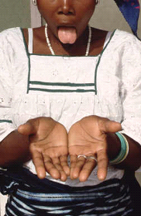
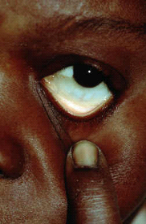
Pale mucous membranes in the eye and the tongue are signs of
anaemia. You may see these signs in males and females of all ages
.
Iron Deficiency Anaemia
Photo Card 2

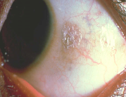
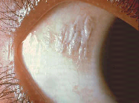
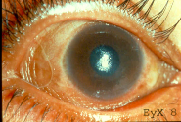
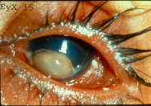
Vitamin A Deficiency
–
Xeropthalmia
Bitots spots (X1B) are foamy white areas on the white of the eye
. . Be careful
not to confuse them with other types of eye problems. These signs will
most often be seen in children.
Corneal Xerosis(X2)
Keratomalacia (X3)
Photo Card 3

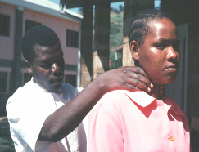
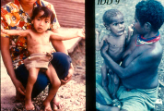
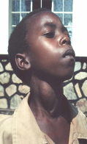
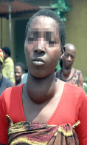
Goitre can be examined by looking or by feeling the neck (palpating)
The visible goitres seen in the 2 pictures on the top left are Grade 2
Iodine deficiency can also cause developmental problems in children such cretinism

Iodine Deficiency
–
Goitre examination
Photo Card 4

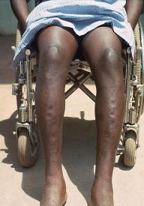
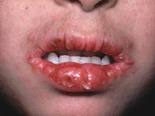
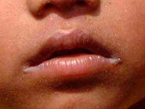
Thiamine Deficiency
-
Beriberi
Oedema is seen in the wet form of
beriberi. However, it is also caused
by general malnutrition and can be
seen in children and adults.
Lesions of the mouth are seen in
riboflavin deficiency. They are called
angular stomatitis
angular stomatitis
if the fissures are at
the corners of the mouth and
cheilosis
cheilosis
if
they are elsewhere on the lips.
Riboflavin Deficiency
-
Ariboflavinosis
Photo Card 5

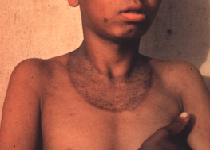
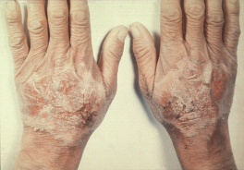
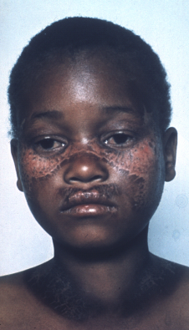
Niacin Deficiency
-
Pellagra
A symmetrical rash (dermatitis) which is on both sides of the body, and on skin normally exposed to sunlight is a sign of pellagra.
Check the face, neck, hands, arms and legs.
Butterfly sign
Casal
’
s
necklace
Photo Card 6

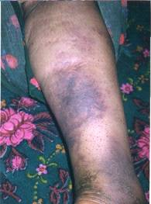
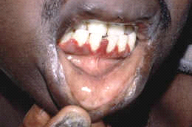
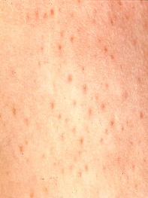
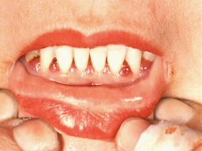
Vitamin C Deficiency
-
Scurvy
Bleeding around the bases of the hair on the legs
(
Perifollicular
hemorrhage) and the gums in
between the teeth are signs of scurvy. There
may be areas of bruising (ecchymoses) as seen in
the second photo. There may also be swelling of
the bone joints.

Photo Card 7

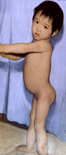
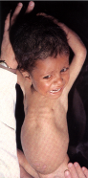
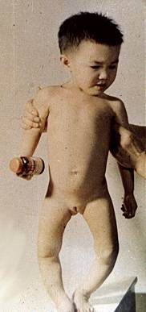

Harrison
’
s
Groove or
Pigeon Chest
Bow legs
Spinal
deformity
Vitamin D deficiency
-
Rickets
Beading of the rib cage
(rachitic rosary)
Beading of the rib cage
(rachitic rosary)
Handout 2b: Test cards for micronutrient deficiency diseases

Test Card 1

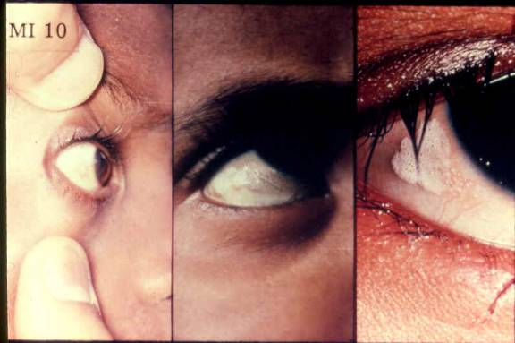
Test Card 2

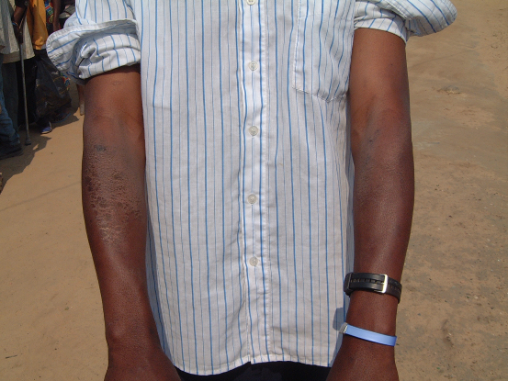
Test Card 3

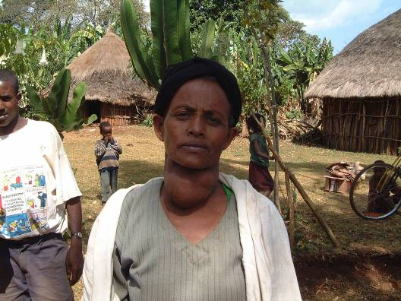

Test Card 4

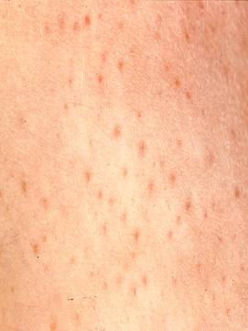
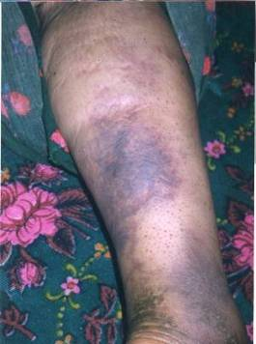
Test Card 5

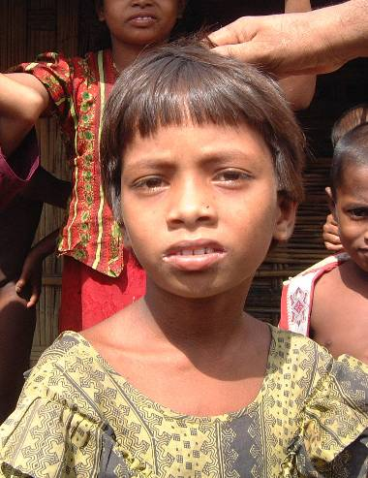
Test Card 6

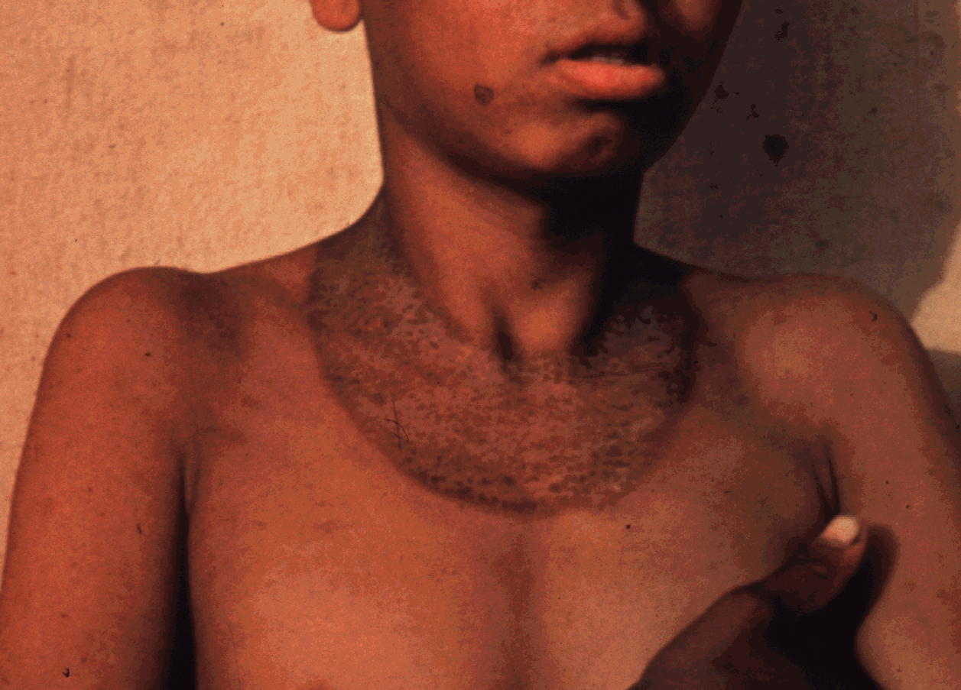
Handout 2c: Answers for test cards

For each photo Test Card the main clinical sign, micronutrient deficiency disease, and deficient nutrient is listed below:

Test Card 1 - Bitots Spots (X1B) - Xeropthalmia - Vitamin A Deficiency

Test Card 2 - Bilateral dermatitis on the arms - Pellagra - Vitamin B3 (niacin) Deficiency

Test Card 3 - Goitre - Iodine Deficiency Disorder - Iodine Deficiency

Test Card 4 - Perifollicular haemorrhage - Scurvy - Vitamin C Deficiency

Test Card 5 - Angular stomatitis - Ariboflavinosis - Vitamin B2 (riboflavin) Deficiency

Test Card 6 - Casal’s Necklace - Pellagra - Vitamin B3 (niacin) Deficiency

Exercise 3: Analysing the nutrient content of a planned food aid ration
What is the learning objective?
- Be able to calculate the micronutrient content of a food aid ration by hand

When should this exercise be done?
- After the main concepts about micronutrients have been introduced

How long should the exercise take?
- 45-60 minutes

What materials are needed
- Handout 3a: Analysing the nutrient content of a planned food aid ration. Questions
- Handout 3b: Food composition table
- Handout 3c: Analysing the nutrient content of a planned food aid ration. Answers
- Participants will need electronic pocket calculators

What does the trainer need to prepare?
- Familiarise yourself with the calculations and results before the session and ensure handouts are available and the participants will have calculators ready.

Instructions
Step 1: Give each participant a copy of handouts 3a and 3b, explain the exercise, and let them work through it. Provide individual support to participants as required.
Step 2: When participants have completed the calculation attempt provide a copy of handout 3c and hold a discussion to address any important questions and confirm that participants understood the exercise and results.

Handout 3a: Analysing the nutrient content of a planned food aid ration. Questions

Time for completion: 30-60 minutes

Read the following questions and attempt the calculations

      - Comment on the composition of ration 1 compared to ration 2. Which ration is most likely to be deficient in micronutrients?

Example: General rations distributed to refugee populations (grams/person/day)

Ration 1 – African refugee camp, 2002

Maize grain 328
Beans 96
Oil 16
CSB 32
Salt 8

Ration 2 - Kosovar refugees, Macedonia, 1999

Wheatflour  Rice/pasta  Beans  Meat/fish  Oil  Sugar  Salt  Fruit/veg.  Cheese  Milk | 350  100  30  30  35  10  5  300  33  300

      - Now calculate the energy, vitamin C and iodine content of Ration 1 by hand.

For each nutrient you should fill in a table like the one shown below. As an example, the table shows a calculation for the amount of iron in the ration. To do the calculation it is best to break down the process into a series of steps.

Step 1 – list the ration food commodities in Column A and enter the amount given per day in column B
Step 2 – look up the nutrient content per 100 g for each food in the attached food composition table, and enter it in column C
Step 3 – calculate the amount of nutrient coming from each food by dividing the value in column B by 100, and multiplying by the value in column C. Enter this result in column D.
Step 4 – add up the values in column D to give the total nutrient content in the daily ration.

In this case the answer for iron is 20.9 mg per/person/day

Calculation of the iron content of the ration
Commodity  (A) | Amount in daily ration (g/person/day)  (B) | Nutrient content  per 100 g  (C) | Nutrient content in daily ration  D = (B/100) x C
Maize grain | 328 | 2.7 | 8.9
Beans | 96 | 8.2 | 7.9
Oil | 16 | 0.0 | 0.0
CSB | 32 | 12.8 | 4.1
Salt | 8 | 0.0 | 0.0
Total |  |  | 20.9 mg

Now do the calculation for the energy, vitamin C and iodine content of Ration 1.

      - If NutVal software is available, use it to calculate the nutrient content of Ration 1 and Ration 2.
Handout 3b: Food composition table

(Nutrient content per 100 grams of raw uncooked food)*

Commodity | Energy | Protein | Fat | Calcium | Iron | Iodine | Vitamin A | Vitamin B1 (Thiamine) | Vitamin B2 (Riboflavin) | Vitamin B3  (Niacin) | Vitamin C
Commodity | Kcal | (g) | (g) | (mg) | (mg) | µg | µg RE | (mg) | (mg) | (mg) | (mg)
Maize | 350 | 10.0 | 4.0 | 7 | 2.7 | 0 | 0 | 0.39 | 0.20 | 2.2 | 0
Beans (dried) | 335 | 20.0 | 1.2 | 143 | 8.2 | 0 | 0 | 0.50 | 0.22 | 6.2 | 0
Oil^ | 885 | 0.0 | 100.0 | 0 | 0.0 | 0 | 900 | 0.00 | 0.00 | 0.0 | 0
CSB§ | 400 | 18.0 | 6.0 | 181 | 12.8 | 2 | 501 | 0.44 | 0.70 | 10.0 | 50
Salt~ | 0 | 0 | 0 | 0 | 0 | 6,000 | 0 | 0.00 | 0.00 | 00.0 | 0
*Nutritional values are taken from the spread sheet application NutVal 2006
^Vitamin A fortified according to WFP specifications
§ Formulated according to WFP specifications
~Iodised according to WFP specifications

Handout 3c: Analysing the nutrient content of a planned food aid ration. Answers

(1) Comparing Ration 1 and Ration 2 reveals the much more diverse contents of ration 2. Ration 1 contains only 5 items and includes no animal products, fruit or vegetables. In contrast, Ration 2 contains 10 different items that include meat/fish, milk and fruit/vegetables. Without doing any calculations it would be expected that Ration 1 is most likely to be deficient in micronutrients.

(2) The tables and calculation for the energy, iodine and vitamin C content of ration 1 should look like this:

Calculation of the energy content of the ration (kcal)
Commodity  (A) | Amount in daily ration (g/person/day)  (B) | Energy content  per 100 g  (C) | Energy content in daily ration  D = (A/100) x B
Maize grain | 328 | 350 | 1148
Beans | 96 | 335 | 322
Oil | 16 | 885 | 142
CSB | 32 | 400 | 128
Salt | 8 | 0 | 0
Total |  |  | 1740 Kcal

Calculation of the iodine content of the ration (µg)
Commodity  (A) | Amount in daily ration (g/person/day)  (B) | Nutrient content  per 100 g  (C) | Nutrient content in daily ration  D = (A/100) x B
Maize grain | 328 | 0 | 0
Beans | 96 | 0 | 0
Oil | 16 | 0 | 0
CSB | 32 | 2 | 0.64
Salt | 8 | 6,000 | 480
Total |  |  | 481 µg

Calculation of the vitamin C content of the ration (mg)
Commodity  (A) | Amount in daily ration (g/person/day)  (B) | Nutrient content  per 100 g  (C) | Nutrient content in daily ration  D = (A/100) x B
Maize grain | 328 | 0 | 0
Beans | 96 | 0 | 0
Oil | 16 | 0 | 0
CSB | 32 | 50 | 16
Salt | 8 | 0 | 0
Total |  |  | 16 mg

Exercise 4: Analysing on-site distribution monitoring (food basket monitoring) data
What is the learning objective?
- Know how to calculate results from on-site distribution monitoring data.

When should this exercise be done?
- When exercise 3 has been completed.

How long should the exercise take?
- 45-60 minutes

What materials are needed
- Handout 4a: Analysing on-site distribution monitoring (food basket monitoring) data. Questions
- Handout 4b: Onsite Distribution Monitoring data
- Handout 4c: Analysing on-site distribution monitoring (food basket monitoring) data. Answers
- Participants will need electronic pocket calculators.
If available, access to computer with NutVal software should be provided. The latest version of NutVal can be downloaded from http://www.nutval.net
User support will also be available from this site.

What does the trainer need to prepare?
- Familiarise yourself with the calculations and results before the session and ensure handouts are available and the participants will have calculators ready.

Instructions
Step 1 Give each participant a copy of handouts 4a and 4b, explain the exercise, and let them work through it. Provide individual support to participants as required.
Step 2 When participants have completed the calculation, attempt provide a copy of handout 4c and hold a discussion to address any important questions and confirm that participants understood the exercise and results.

Handout 4a: Analysing on-site distribution monitoring (food basket monitoring) data. Questions

- Using data collected during On-site Distribution Monitoring (OSDM), calculate the average amount of each of the commodities that were received by the beneficiaries during a food aid distribution in a refugee camp.

- Using the form provided (handout 4b), compare the energy content of the ration actually received by the 10 beneficiaries with the energy content of the planned ration.

- If available, use NutVal software to calculate the micronutrient content of the average ration that was received.

- Comment on the micronutrient content of the ration. Compare the content of the received ration with the nutrient content of the planned ration.

Handout 4b: Onsite Distribution Monitoring data

Here is some example data from an On-site Distribution Monitoring (Food Basket Monitoring) form, collected in a refugee camp in Southern Africa during 2004. The sample size in this monitoring programme was 60. For this exercise, only data on the first 10 samples are shown. Calculate the results and fill in the missing numbers in the empty cells below. (Maize has an energy content of 350 kcal/100 grams; Beans 335 kcal/100 grams; and Oil 885 kcal/100 grams. The energy content of salt is, of course, 0.)

Number of days covered by this distribution: 15
Ration planned for this distribution
Commodity | Maize | Beans | Vegetable oil | Salt | Total kcal/person/day
Grams/person/day | 400 | 120 | 20 | 10
kcal/person/day
90% of the targeted ration = |  |  | kcal/person/day
110% of the targeted ration = |  |  | kcal/person/day
Distribution Monitoring Data:
Family Number | Family Size | Maize (kg) | grams/  person/  day | kcal/  person/  day | Beans (kg) | grams/  person/  day | kcal/  person/  day | Vegetable oil (kg) | grams/  person/  day | kcal/  person/  day | Salt (kg) | grams/  person/  day | Total  kcal/  person/  day
1 | 1 | 9.7 |  |  | 2.5 |  |  | 0.25 |  |  | 0.15
2 | 6 | 36.0 |  |  | 10.5 |  |  | 1.45 |  |  | 1.05
3 | 4 | 24.0 |  |  | 10.0 |  |  | 1.00 |  |  | 0.50
4 | 5 | 30.9 |  |  | 7.2 |  |  | 1.37 |  |  | 0.75
5 | 7 | 40.0 |  |  | 10.3 |  |  | 1.70 |  |  | 0.95
6 | 5 | 27.6 |  |  | 7.2 |  |  | 1.30 |  |  | 0.75
7 | 6 | 32.0 |  |  | 8.7 |  |  | 1.60 |  |  | 0.90
8 | 2 | 11.0 |  |  | 5.8 |  |  | 1.80 |  |  | 0.90
9 | 7 | 37.5 |  |  | 18.5 |  |  | 1.83 |  |  | 0.93
10 | 7 | 47.5 |  |  | 10.5 |  |  | 1.70 |  |  | 0.95
Average

Handout 4c: Analysing on-site distribution monitoring (food basket monitoring) data.

Answers to Question 1 and 2

Shown below is the On-site Distribution Monitoring data form with the answers filled in. Compare it with yours to make sure you did the calculation correctly.

Number of days covered by this distribution: 15
Ration planned for this distribution
Commodity | Maize | Beans | Vegetable oil | Salt | Total kcal/person/day
Grams/person/day | 400 | 120 | 20 | 10
kcal/person/day | 1400 | 402 | 177 | 0 | 1979
90% of the targeted ration = |  | 1781 | kcal/person/day
110% of the targeted ration = |  | 2177 | kcal/person/day

Monitoring Data:
Family Number | Family Size | Maize (kg) | grams/  person/  day | kcal/  person/  day | Beans (kg) | grams/  person/  day | kcal/  person/  day | Vegetable oil (kg) | grams/  person/  day | kcal/  person/  day | Salt (kg) | grams/  person/  day | Total  kcal/  person/  day
1 | 1 | 9.7 | 647 | 2263 | 2.5 | 167 | 558 | 0.25 | 17 | 148 | 0.15 | 10 | 2969**
2 | 6 | 36.0 | 400 | 1400 | 10.5 | 117 | 391 | 1.45 | 16 | 143 | 1.05 | 12 | 1933
3 | 4 | 24.0 | 400 | 1400 | 10.0 | 167 | 558 | 1.00 | 17 | 148 | 0.50 | 8 | 2106
4 | 5 | 30.9 | 412 | 1442 | 7.2 | 96 | 322 | 1.37 | 18 | 162 | 0.75 | 10 | 1925
5 | 7 | 40.0 | 381 | 1333 | 10.3 | 98 | 329 | 1.70 | 16 | 143 | 0.95 | 9 | 1805
6 | 5 | 27.6 | 368 | 1288 | 7.2 | 96 | 322 | 1.30 | 17 | 153 | 0.75 | 10 | 1763*
7 | 6 | 32.0 | 356 | 1244 | 8.7 | 97 | 324 | 1.60 | 18 | 157 | 0.90 | 10 | 1726*
8 | 2 | 11.0 | 367 | 1283 | 5.8 | 193 | 648 | 1.80 | 60 | 531 | 0.90 | 30 | 2462**
9 | 7 | 37.5 | 357 | 1250 | 18.5 | 176 | 590 | 1.83 | 17 | 154 | 0.93 | 9 | 1994
10 | 7 | 47.5 | 452 | 1583 | 10.5 | 100 | 335 | 1.70 | 16 | 143 | 0.95 | 9 | 2062
Average | 5 |  | 414 | 1449 |  | 131 | 438 |  | 21 | 188 |  | 12 | 2075
* These families received less than 90% of the planned energy content of the ration
** These families received more than 110% of the planned energy content of the ration

Interpretation

From the results that you have calculated by hand we can look at the efficiency of the distribution system for delivering a ration with an adequate energy content. We can see that the average amount received (2075 kcal) was within the acceptable limits of 90 – 110% of the planned ration. However, 4/10 (40 %) of the beneficiaries received greater than or less than the planned amount so the equity of the system should be improved.

Please note we only included data on 10 beneficiaries in this exercise to save time. A normal on-site distribution monitoring programme should use a sample size of at least 30 beneficiaries at each distribution site. Beneficiaries should be randomly sampled using a systematic (interval) sample or a simple random sample.

This data does not tell you about the micronutrient content of the ration and how it compares with the planned ration. To work out the micronutrient content by hand would be time consuming and a software tool such as NutVal is recommended.

Handout 4c: Analysing on-site distribution monitoring (food basket monitoring) data.

Answers to Question 3 and 4 (NutVal analysis)

Analysis of the content of the planned ration and received ration, calculated from the on-site distribution results, is shown below. These results are what you should see if using NutVal 2006 software. Results calculated using other versions may differ.

Ration Name or Reference: Planned Ration
RATION CONTENTS | RATION | ENERGY | PROTEIN | FAT | CALCIUM | IRON | IODINE | VIT. A | THIAMINE | RIBOFLAVIN | NIACIN | VIT. C
 | g/person/day | kcal | g | g | mg | mg | µg | µg RE | mg | mg | mg NE | mg
MAIZE GRAIN, WHITE | 400 | 1400 | 40 | 16 | 28 | 10.8 | 0 | 0 | 1.54 | 0.80 | 8.8 | 0
BEANS, DRIED | 120 | 402 | 24 | 1 | 172 | 9.8 | 0 | 0 | 0.60 | 0.26 | 7.4 | 0
OIL, VEGETABLE (WFP SPECS.) | 20 | 177 | 0 | 20 | 0 | 0.0 | 0 | 180 | 0.00 | 0.00 | 0.0 | 0
SALT, IODISED (WFP SPECS.) | 10 | 0 | 0 | 0 | 0 | 0.0 | 600 | 0 | 0.00 | 0.00 | 0.0 | 0
Ration total | 550 | 1979 | 64 | 37 | 200 | 20.7 | 600 | 180 | 2.14 | 1.07 | 16.2 | 0
SAFE LEVEL OF INTAKE | 2100 | 2100 | 52.5 | 40 | 450 | 22 | 150 | 500 | 0.90 | 1.40 | 13.9 | 28
% of requirements supplied by ration |  | 94% | 122% | 94% | 44% | 94% | 400% | 36% | 238% | 76% | 117% | 0%
% of energy supplied by protein or fat |  |  | 13% | 17%

Ration Name or Reference: Average Results from On-Site Distribution Monitoring
RATION CONTENTS | RATION | ENERGY | PROTEIN | FAT | CALCIUM | IRON | IODINE | VIT. A | THIAMINE | RIBOFLAVIN | NIACIN | VIT. C
 | g/person/day | kcal | g | g | mg | mg | µg | µg RE | mg | mg | mg NE | mg
MAIZE GRAIN, WHITE | 414 | 1449 | 41.4 | 17 | 29 | 11.2 | 0 | 0 | 1.59 | 0.83 | 9.1 | 0
BEANS, DRIED | 131 | 439 | 26.2 | 2 | 187 | 10.7 | 0 | 0 | 0.66 | 0.29 | 8.1 | 0
OIL, VEGETABLE (WFP SPECS.) | 21 | 186 | 0 | 21 | 0 | 0.0 | 0 | 189 | 0.00 | 0.00 | 0.0 | 0
SALT, IODISED (WFP SPECS.) | 12 | 0 | 0 | 0 | 0 | 0.0 | 720 | 0 | 0.00 | 0.00 | 0.0 | 0
Ration total | 578 | 2074 | 67.6 | 39 | 216 | 22.0 | 720 | 189 | 2.25 | 1.12 | 17.2 | 0
SAFE LEVEL OF INTAKE | 2100 | 2100 | 52.5 | 40 | 450 | 22 | 150 | 500 | 0.90 | 1.40 | 13.9 | 28
% of requirements supplied by ration |  | 99% | 129% | 98% | 48% | 100% | 480% | 38% | 250% | 80% | 124% | 0%
% of energy supplied by protein or fat |  |  | 13% | 17%

Interpretation
It can be seen that with both the planned and received ration there are large deficits in micronutrient content. The ration contains no vitamin C at all, and is seriously deficient in riboflavin, calcium and vitamin A. There is also an excessive amount of iodine being provided via fortified salt. The energy content is also slightly lower than it should be and the fat content is inadequate.
Clearly, this ration plan needs revising
Case Studies

One case study is presented in this section. Case studies are useful for getting participants to think through real-life scenarios. They also provide an opportunity for participants to work in a group and develop their analytical and decision-making skills. Trainers should develop their own case studies which are contextually appropriate to the particular participant group. Preferably trainers should use scenarios with which they are familiar.

Exercise 5: Planning an outbreak investigation
What is the learning objective?
- To explore how to plan and carry out an investigation of a suspected outbreak of a micronutrient deficiency disease.

When should this exercise be done?
- After the main concepts have been introduced and the exercises 2 and 3 have been completed.

How long should the exercise take?
- 60 - 90 minutes

What materials are needed?
- Handout 5a: Planning an outbreak investigation
- Handout 5b: Planning an outbreak investigation (model answer)

What does the trainer need to prepare?
- Read and familiarise yourself with the scenario, questions, and answers.
- Photocopy handouts or prepare overheads.

Instructions
Step 1: Give each participant a copy of handout 4a
Step 2: Divide the participants into groups of 5 people (maximum)
Step 3: Give the groups 30 minutes to answer the questions and prepare a presentation of their answers
Step 4: Give each group 5 minutes for feedback in plenary
Step 5: Discuss the results

Discussion points for feedback in plenary
- What additional ideas did people come up with?
- How practical are the suggestions for collecting information?
- What resources would be needed to conduct the investigation?
- What are the possible and appropriate responses to an outbreak of a micronutrient deficiency disease?

Handout 5a: Planning an outbreak investigation

Time for completion: 30 minutes

Working in groups, read the following case example, address the questions and prepare a brief presentation of your discussion.

Scenario

You are asked to investigate a suspected outbreak of pellagra in a refugee camp in east Africa. At the start of your assessment you are given the following information:

An initial case of pellagra has been identified in a supplementary feeding programme (SFP) run by a nutrition NGO. UNHCR has requested a full assessment. A preliminary assessment has already been conducted by a national nutrition institute and has identified about 30 cases from a convenience sample of 200 school children. This has raised considerable concern.

The refugee population is largely food-aid dependent but some additional income generation and food production opportunities are known to exist. The food aid ration is comprised of maize, pulses, oil, corn soy blend (CSB) and salt.

Commodity | Grams per person per day
Maize grain | 328
Pulses (peas, lentils or beans) | 96
Oil | 16
CSB | 32
Salt (iodised) | 8

The health situation in the camp is generally good with no epidemics reported. The prevalence of global acute malnutrition is about 4%.

Questions

- What are your initial thoughts about the situation based on the preliminary data?

- What additional information do you need for your assessment and how will you collect it?

Handout 5b: Planning an outbreak investigation (model answer)

Question 1
From the available data, the general situation regarding health and nutrition appears quite good with a low prevalence of GAM and no epidemics reported. The general ration appears reasonable at first site with the inclusion of pulses and fortified blended food.

However, the prevalence of pellagra identified in the school children is alarmingly high at
15%. As a reference, the proposed WHO cut-off for a severe public health situation is 5%. A further investigation is urgently required.

Question 2
In any outbreak investigation it is important to organise and prioritise the information you need to collect. The table below summarises some of the key information that you would need to collect and possible sources for the information.

In addition to collecting this information it would be important to revisit the cases identified in the original assessment to confirm the diagnosis. Documenting cases with digital photography is very useful but remember to observe the need to obtain patients consent and preserve confidentiality.

To quantify the existence or extent of the problem it may be necessary to conduct a quantitative survey at the household level. Note that adults are more at risk of pellagra than children so a standard anthropometric nutrition survey is not an appropriate design for a survey of pellagra.

Collection of urine samples for laboratory analysis has proven useful in previous investigations of pellagra outbreaks. However, you will need to seek expert advice if you decide to collect biological samples for analysis.

Information required | Reason | Source
What was the Case Definition used in the original investigation? | It is critical to understand how cases were identified and, if doing a further investigation yourself, to come up with a practical case definition that can be used in the context in which you are working and is as sensitive and specific as possible. | The report describing the initial assessment or follow up communication with field staff and/or the national nutrition institute.
What is the CMR (crude mortality rate) and U5MR (under 5 mortality rate) in the camp? | You need to understand if there has been an increase in mortality in the camp as this might be associated with a severe outbreak of pellagra. | Health information system (HIS), survey reports.
What is the general health situation in the camp? | It is important to investigate if there has been an increase in admissions to health facilities or morbidity in the community. Pellagra causes diarrhoea, dementia, insomnia and symptoms of anxiety, as well as dermatitis. These signs and symptoms may have been observed without people knowing they were caused by pellagra. | Health facility records. Interviews with community health workers and other medical staff.
What is the niacin content of the food aid ration? | A general ration low in niacin is a major risk factor for pellagra. If more than 5% of the population has a dietary intake of niacin equivalents <5 mg/day the situation is classified by WHO as a public health problem. | Analysis of planned and received food rations using NutVal or other software.
What does the On-site Distribution Monitoring (OSDM) data and post-distribution monitoring data say about the reliability of the food aid ration? | While the planned ration may, or may not, contain adequate niacin and other nutrients you need to understand what ration the refugees have actually been receiving. OSDM data is useful for that purpose. As with all data sources you need to make a judgement as to the reliability of the data and its source. | OSDM records from the health and nutrition implementing NGO, or Government or UNHCR records. If OSDM data is not available then try to access food supply and distribution records from WFP or other partners.
Is the food aid ration sold or exchanged for other items? | People may sell food or exchange it to obtain other essential items. The amount received at a distribution may not be the amount used in the household kitchen. | Post-distribution monitoring records from WFP or other agencies.
How do people use the food aid ration in the kitchen and how do they distribute it within the household? | Understanding how people utilise food is just as important as understanding how much people have access to. Food preparation methods can have a major impact on the consumption of micronutrients. Intra-household distribution is a major determinant of which population groups may be at risk of nutritional deficiencies. | Reports from nutrition and health NGOs, direct observations, interviews and focus group discussions.
How widespread and important are income generation and food production activities in the camp? | An appreciation of people’s livelihoods is important to understand what other food sources people may have access to. | Reports from NGOs, direct observations, interviews and focus group discussions.

Field-based exercises

This section outlines ideas for exercises that can be carried out as part of a field visit. Field visits require a lot of preparation. An organisation that is actively involved in programming has to be identified to ‘host’ the visit. This could be a government agency, an international NGO or a UN agency. The agency needs to identify an area that can be easily and safely visited by participants. Permission has to be sought from all the relevant authorities and care taken not to disrupt or take time away from programme activities. Despite these caveats, field-based learning is probably the best way of getting over information that will be remembered by participants.

Exercise 6: Micronutrient malnutrition risk assessment
What is the learning objective?
- To allow participants to observe food aid monitoring and health information systems in an established refugee camp.

When should this exercise be done?
- After completion of the module material including the previous exercises.

How long should the exercise take?
- 1-2 days, or as dictated by local circumstances.

What materials are needed?
- Letters of agreement with the NGO or UN agency hosting the visit.
- Permission from the training institution for the visit to go ahead.
- Risk assessment forms prepared and completed by the trainer prior to the field trip.
- Handout 6a: Micronutrient malnutrition risk assessment (trainer’s guide)

What does the trainer need to prepare?
- A full itinerary for the field visit
- A plan for transportation, accommodation, meals and refreshments for participants.
- A briefing sheet for the participants on the local situation including safety and security procedures.
- Ensure that participants are suitably dressed and equipped for the field visit, and have note pads and pens.
- Prior to the visit work in a group with the participants to construct an observation checklist of things to look out for, e.g. method used to select beneficiaries for OSDM, number of refugee households with access to home gardens, provision of micronutrient supplements at health facilities.

Discussion points for feedback in plenary
- General impressions of the filed site visited.
- Detailed observations on the risk of micronutrient malnutrition in the site visited.
Ideas for improving the technical content and management of the programme.
Handout 6a: Evaluation of a general food distribution (trainer’s guide)

The following is a suggested activity that should be adapted to fit the local context.

Arrange a visit to a refugee camp to observe general ration distribution, on-site distribution monitoring, post distribution monitoring, and how data is collected for the health information system. If possible, data should be collected and analysed for micronutrient content and energy and macronutrient sufficiency.

- For all fieldwork and visits a risk assessment must be undertaken to look at the risks involved to the course participants, local staff and beneficiaries.

- Every effort must be taken to minimise disruption to the on-going work of the programme.

- Trainers and students must act with tact and discretion and avoid open criticism of any program activities they see. Observations should be discussed with trainers at the end of the field visit.

Key Observation Points for participants
(To be adapted according to the local situation)

- What is in the general food aid ration?
- Are any complementary food items distributed?
- Is there a supplementary feeding programme?
- Which agencies are involved in food aid delivery and distribution?
- What distribution and targeting mechanisms do they use?
- Are non-food items distributed?
- Is On-site Distribution Monitoring (food basket monitoring) done?
- Is Post-Distribution Monitoring done?
- Which agencies are involved?
- Who analyses the data?
- Who is responsible for assessing the data and taking programme decisions?
- What alternative food sources are available to the camp residents?
- What income generation activities, if any, are available?
- Which markets, if any, do the refugees have access to?
- What health facilities do refugees have access to?
- Which agencies run them?
- Do staff have knowledge of micronutrient deficiency diseases?
- Is there a Health Information System (HIS)?
- Who is responsible for the HIS?
- Are micronutrient deficiencies recorded in the HIS?

