MODULE 10
Nutrition information and surveillance systems

PART 2: TECHNICAL NOTES

The technical notes are the second of four parts contained in this module. They provide information on nutrition information and surveillance systems. These notes are intended for people involved in nutrition programme planning and implementation. They cover the major technical details, highlighting challenging areas and provide guidance on accepted current practices. Words in italics are defined in the glossary.

Summary
This module is about nutrition information and surveillance systems. It summarizes key elements of current guidelines and advises on best practice based on the diversity of approaches seen in the field. The module discusses what to consider when establishing a nutrition information or surveillance system. The role of different sources of data and the type of information collected are also discussed in conjunction with their analysis, interpretation and dissemination.

Key messages
- Before establishing a nutrition surveillance system, be clear on the objectives and what the information will be used for. Consider the availability of resources, staff capacity, sustainability, environmental factors and response capacity.
- Review and map existing nutrition information sources (indicators collected, frequency of collection, target population) to prevent duplication and, where possible, ensure linkage or integration with existing information systems.
- Define a minimum set of core indicators that refer both to nutritional status and provide an understanding of the underlying causes of malnutrition.
4. Design the system based on the most appropriate method. Several methods may be appropriate in some contexts.
5. Ensure adequate training and supervision of data collection.
6. Include simple quality checks to assure reliability of data.
7. Consider contextual issues when interpreting the data: seasonality, population movement, morbidity patterns, and historical trends in nutritional status.
8. Ensure triangulation of information with data from other sources.
9. Ensure information is presented in a timely and accessible manner to decision makers and to the community.
10. Establish triggers to determine when more detailed nutrition assessments are necessary.
11. Consider how the information from the surveillance system will link to action or response. Information is meaningless unless it is used appropriately.
12. For longer term systems in emergency prone areas, consider sustainability issues from the outset

These technical notes are based on the following references and Sphere standard in the box below:
- Ethiopian Early Warning System. (2002). Guidelines on Emergency Nutrition Assessment. Addis Abba, Ethiopia: Early Warning Department, Disaster Prevention and Preparedness Commission.
- Save the Children United Kingdom. (2004). Emergency Nutrition Assessment: Guidelines for Field Workers. Plymouth: Save the Children United Kingdom.
- SMART. (2006). Guidelines: SMART Methodology Version 1. (http://www.smartmethodology.org)
- CARE. (2006). South Sudan Anthropometric Surveys 1998 to 2006: Trends based on Conflict and Immediate Post Conflict Data.
- Young, H. & Jaspars, S. (1995). Nutrition matters: people, food and famine. London: Intermediate Technology Publications Ltd.
- Young, H. (1992). Food Scarcity and Famine, Assessment and Response. Oxfam Practical Health Guide, No 7. Oxford: Oxfam.
- Young, H. and Jaspars, S. (2006, November). The meaning and measurement of acute malnutrition in emergencies. A primer for decision makers. Humanitarian Practice Network Paper No. 56, London: HPN.
- Shoham, J., et al. (2003). The use of nutrition indicators in surveillance systems, Technical Paper 2. London: Overseas Development Institute.
- Tulane University School of Public Health and Tropical Medicine and the United Nations Children’s Fund. (2007). Nutrition Information Project for the Horn of Africa Working Session Report. New Orleans: Tulane University and UNICEF. Mortality notes and sampling issues available at www.tulane.edu .
- Food and Agriculture Organization/European Commission. (2007). Nutrition Status Assessments and Analysis. Rome: Information for Action Programme, FAO.
- Mitigating the Nutritional Impacts of the Global Food Price Crisis: Workshop Summary. Elizabeth Haytmanek and Katherine McClure, Rapporteurs; Institute of Medicine. ISBN: 0-309-14019-6, 200 pages, 6 x 9, (2010). This free PDF was downloaded from: http://www.nap.edu/catalog/12698.html

Sphere standard
Assessment and analysis standard 2: nutrition
Where people are at risk of malnutrition, programme decisions are based on a demonstrated understanding of the causes, type, degree and extent of malnutrition and the appropriate response.

Key indicators
- Before conducting an anthropometric survey, information on the underlying causes of malnutrition (food, health and care) is analysed and reported, highlighting the nature and severity of the problem(s) and those groups with the greatest nutritional and support needs.
- The opinions of the community and other stakeholders on the causes of malnutrition are considered.
- Anthropometric surveys are conducted only where information and analysis are needed to inform programme decision-making.
- International anthropometric survey guidelines, and national guidelines consistent with these, are adhered to for determining the type degree and extent of malnutrition.
- When anthropometric surveys are conducted among children of less than five years of age, international weight-for-height reference values are used for reporting malnutrition in Z scores and percentage of the median for planning purposes.
- Micronutrient deficiencies, to which the population is at risk, are determined.
- Responses recommended after the nutrition assessment build upon and complement local capacities in a coordinated manner.

Source: Sphere Project: Humanitarian Charter and Minimum Standards in Humanitarian Response, ‘Minimum Standards in Food Security, Nutrition’, The Sphere Project, Geneva, 2011.

Introduction

Nutrition surveillance or information systems (the terms are used interchangeably here) collect, analyse, interpret and report on information about the nutritional status of populations and most importantly are used to inform appropriate response strategies. Additionally, an information system also refers to one that provides data of many different types, which can be used in nutrition surveillance to provide a more complete picture. Furthermore nutrition surveillance can, and should, incorporate many sources of information (anthropometric, food security, nutritional, health) in order to maximize its usefulness and integration. Nutrition surveillance often happens at two different paces of data collection. In many development settings the need for information slows and data are often collected infrequently. However, in emergencies data are required immediately and with much greater frequency in order to inform rapid responses and adaptation to new and changing problems. This has led to quite different approaches in the provision of nutrition data, or at least in the manner in which the data are used.

Nutritional status is a well-recognized outcome indicator of human welfare. By closely monitoring the indicators that measure nutritional status, a better understanding of the evolving situation of a vulnerable population can be obtained. Over the past two decades, methods for collecting information on nutritional status have been standardized so that rates of acute malnutrition have become one of the most common and reliable indicators used in emergencies while measures of underweight are used in particular to determine attainment of development goals (e.g. the Millennium Development Goals). The role of nutrition surveillance in a nation’s arsenal of information is not only crucial in tracking progress against development goals but provides invaluable context information where if humanitarian emergencies arise.

At the World Food Conference in 1974, which marked the beginning of global interest in monitoring nutritional status, nutritional surveillance was defined as “an ongoing system for generating information on the current and future magnitude, distribution and causes of malnutrition in populations for policy formulations, programme planning management and evaluation”.

Nutrition surveillance systems vary significantly and will depend on context, type of emergency, type of information needed, frequency of reporting, capacity of staff and other resources available. In more stable contexts nutrition surveillance utilizes a more established set of data sources but with a generally lower frequency of reporting, i.e. globally practiced surveys such as the Demographic and Health Survey (DHS).

The biggest challenge of all for nutrition surveillance systems is to ensure the link with information and action. Collecting, analysing and reporting on nutrition information without the appropriate response is meaningless and wastes resources. Recent experience has demonstrated varying degrees of success for a variety of nutrition surveillance systems. However, issues such as reliability of data, timeliness of reporting, effective and efficient links to action and sustainability continue to be a challenge. A further challenge is to ensure how well nutrition information is interpreted. Similar levels of acute malnutrition can reflect different problems and unless the underlying causes are understood and reported, the appropriate response may not be provided. Contextual factors are essential for the interpretation of the situation.

Nutrition surveillance is a component of early warning systems (EWS). Since the severe famines of the 1970s and 1980s, many countries have developed systems to warn of impending famine and to invoke a response to prevent mass starvation and death. Most early warning systems are influenced by the administration through which they work. The international and national systems generally focus on estimating food deficits to predict acute food shortages at national levels and to warn of national shortfalls. In contrast, more localized systems often monitor increased vulnerabilities to livelihoods by examining the possible causes of food insecurity as well as trends in food security indicators. Systems such as the Food Security and Nutrition Analysis Unit (FSNAU) in Somalia use an Integrated Phase Classification system (IPC) to classify the severity of the crisis based on a range of indicators. The analysis of the severity of food insecurity is combined with an early-warning level to indicate threats to livelihoods. For details see Module 1.

Anthropometric (nutritional status) data are generally seen as a component of an EWS. The primary reason for this is that until recently there have been a set of thresholds for which there are a defined set of responses expected. This is unlike other indicators used for monitoring food security, for which not only the criteria/thresholds are difficult to define, but for which the various responses are still relatively subjective. However, with the recent release of the WHO 2006 growth standards and subsequent effect on prevalence of GAM and SAM, it is yet to be determined whether the thresholds based on the NCHS 1977 growth standards for response initiation are transferrable. This simple threshold/response use of data has generally served anthropometric data well.

This module introduces the objectives of nutrition surveillance systems, the different models in use, the various types of information collected, how this information is analysed and interpreted and how it can be linked to action, as well as the challenges. In addition, case studies of existing examples are provided for reference.

Objectives

The objectives of a nutrition surveillance system will depend on the context. In general there are four principle objectives. These are to: inform programme design, programme management and evaluation, policy-making and crisis management. These objectives are not mutually exclusive and may also be modified over time depending upon changes in the external environment.

Figure 1: The triple-A cycle model
Source: FAO/EC, Information for action, training materials nutrition indicators, Rome, FAO/EC, 2007.
ASSESSMENT
of the nutritional situation in target population

ACTION
based on the analysis and available resources

ANALYSIS
of the causes of the problem
The ASSESSMENT stage aims to define the nutritional problem in terms of magnitude and distribution.
The ANALYSIS stage aims to analyse the causes of malnutrition as represented in various conceptual frameworks such as UNICEF.

Nutrition surveillance refers to a continuous process and focuses on monitoring trends in the nutrition situation over time rather than providing one-time estimates of absolute levels of malnutrition. Figure 1 illustrates the triple-A cycle model, where an assessment of the situation defines the nutrition problem in terms of magnitude and distribution. In the analysis phase the causes of malnutrition are explored resulting with recommendations that trigger action, which is the stage of implementation. This is a continuous process as emergencies are dynamic and change continuously. Nutrition surveillance systems should be viewed in the same light: conducting an assessment of the nutrition situation; providing an analysis of the underlying causes; and, on the basis of this analysis, advocating for the appropriate action. This is done on a continuous basis.
In emergency settings, the objectives focus more specifically on:

- Advocacy: As a means to highlight an evolving crisis, nutrition information is a very powerful tool to highlight a deteriorating situation and to sensitize politicians and decision makers about needs.
- Identification of appropriate response strategies: The default response to large-scale emergencies, where high rates of acute malnutrition are reported, is generally in the form of a large relief distribution of free food. Nutrition surveillance systems have the ability to explore the underlying causes of the deterioration in the nutrition situation and therefore can inform a more appropriate and relevant response.
- Triggering a response: Although the World Health Organization (WHO) has set a range of thresholds for classifying the nutrition situation, these thresholds can have a different meaning depending on context. In many countries in Africa, high prevalence rates of acute malnutrition (above 15 per cent of children with weight-for-height less than -2 standard deviations of the mean) can reflect a chronic problem while in other countries such levels would be an indicator of a significant deterioration in the nutrition situation. Nutrition surveillance systems can help with an appropriate analysis of the nutrition situation by providing a trend analysis of the typical nutrition situation and by highlighting a situation where the magnitude of change, rather than the absolute prevalence, is significant (however, there is yet to be a clearly defined and standardized indicator of change to initiate a response). This can then be a signal to conduct more robust assessments, such as small-scale nutrition surveys that can establish the prevalence (rate) of acute malnutrition, which in turn can be used to trigger a specific response.
- Targeting: Anthropometric information can help to target areas or vulnerable populations that are at increased risk or in greater need of assistance.
- Identification of malnourished children: Depending on the method applied in the surveillance system, e.g., routine measurement of children through a clinic, or through a sentinel site, the children identified as acutely malnourished can be referred to the appropriate selective feeding programme (supplementary feeding or therapeutic care).

Methods

There are many approaches to establishing a nutrition surveillance system. Deciding which approach to adopt will depend on the objectives, resources, environment (humanitarian / development) and capacities available. The following are the main methods used for surveillance:

- Large-scale national surveys
- Repeated small-scale surveys
- Clinic-based monitoring
- Sentinel site surveillance
- School census data

In an emergency setting additional sources are also used:

- Rapid nutrition assessments
- Rapid screening based on mid-upper arm circumference (MUAC) measurement accomplished by either exhaustive community screening or screening groups of children to provide an indication of a problem
- Selective feeding programmes or services statistics monitoring (monitoring the use of services, such as health facilities)

There is no single prescribed method for nutrition surveillance systems in emergencies. What often occurs is that a variety of nutrition information sources are used depending on the context, what is appropriate, available and feasible. Representative data collected from the population provides information that can be directly translated into advocacy for specific responses based on certain criteria. However, some methodologies used in emergency settings provide surveillance data which can also simply be used for indicating detrimental change in the population (e.g. non-representative data such as admission rates).

Large scale national surveys

Representative, national level population based surveys, such as the demographic and health surveys (DHS) or the United Nations Children’s Fund (UNICEF) multiple-indicator cluster surveys (MICS) are generally conducted every three to five years. Nutrition information is collected with regional and national level prevalence estimates of wasting, underweight and stunting reported for children aged 6-59months. Anthropometric data on women may also be collected in some surveys and body mass index (BMI) is reported. The scale and the frequency of these surveys predicate that they are used primarily for long-term monitoring rather than a functional tool for emergency settings. However, they provide useful baseline data for comparison of estimates of acute malnutrition, stunting and underweight at regional levels as well as other health and nutrition indicators, such as immunization coverage, care practices and mortality (death) data. This information is generally available on the DHS or MICS websites and is usually stored with the National Bureau of Statistics for DHS or UNICEF for the MICS reports.

The cumbersome nature of large scale DHS or MICS type surveys makes them difficult to repeat frequently. However, it is possible to use small-scale, lighter, surveys over wider geographical areas, to provide data for nutrition surveillance on a more frequent basis. In Tajikistan, Action Against Hunger used a series of yearly surveys conducted at a provincial level to monitor acute malnutrition. These surveys were conducted using the same methodology each year and provided comparable data collected by conducting them at roughly the same time of year in the same geographical areas. This data was then consolidated to provide estimates of the prevalence of acute malnutrition at national level.

Case example 1: Nutrition surveillance system using repeated national level surveys in Tajikistan: 1999-2003

Tajikistan is the poorest republic of the former Soviet Union and has suffered even more after independence from the ravages of civil war in the early 1990s. In 1993 Tajikistan ranked 88th on the human development index and four years later in 1997 had dropped to 115th. Between 1999 and 2002 Tajikistan was severely hit by drought, which had a devastating effect on the nutritional status of the population. Due to the lack of reliable and up-to-date nutrition data a national interagency nutrition assessment was conducted in 1999, led by the international non-governmental organization (NGO), Action Against Hunger (AAH). The assessment involved conducting four 30 x 30 random cluster surveys simultaneously in four of Tajikistan’s five administrative divisions (excluding one due to insecurity). This was the first of five consecutive years of repeated inter-agency national level nutrition surveys. Throughout the five years of nutrition assessments, a key priority was capacity building of the Government of Tajikistan, National Republic Centre for Nutrition Issues. The assessments (expanded to all five administrative divisions) highlighted the significant deterioration of the nutrition situation in 2001 and the subsequent recovery in 2002 and 2003. The series of assessments also provided a major source of information for key nutrition, health, care practices and food security indicators that were used for advocacy purposes to address the underlying causes of malnutrition. Because the data was collected throughout Tajikistan it was possible to consolidate the surveys and present national level statistics.

Source: Action Against Hunger, Tajikistan national nutrition surveys, AAH, 1999-2003.

Despite the usefulness of this particular surveillance activity, the two main limitations of surveys conducted with frequencies of one year or more are 1) the chance that acute malnutrition increases rapidly and could be missed in the period between surveys and 2) there are still considerable costs involved in conducting these small-scale surveys. This type of surveillance therefore has a limited role in early warning. Thus, although small-scale surveys are cheaper to conduct than DHS or MICS this is out weighted by the need to repeat the small-scale surveys more frequently when using them to monitor acute malnutrition over multiple geographic areas. In parts of the world where multiple repeated surveys are still being used in surveillance (such as Sudan) they require considerable funding by donors.

Repeated small-scale surveys

Small-scale random sample nutrition surveys are the most common method used to assess the nutrition situation in emergencies. A single, ad-hoc small-scale survey has the ability to provide data to justify nutritional interventions by estimating the current anthropometric status of the population. When it comes to nutritional surveillance such surveys should be conducted in the same geographical area and at the same time of year/ same season. Thus the specific intention to repeat these surveys is what makes them most useful in surveillance. Nutrition surveys are designed to provide representative prevalence estimates of rates of acute malnutrition of children 6 to 59 months in a given population. Mortality rates can provide a clear idea of the severity of the situation. In addition, information to assess the underlying causes of acute malnutrition is collected, including public health status, immunization coverage, food security and care practices. Such surveys require a certain level of technical expertise and can be very costly, with average estimates of US$10,000 to 15,000 per survey based on experiences from East Africa, although these costs have been rising in recent years. International standards for conducting such surveys have been agreed upon. Consequently, the confidence in, and demand for, the data tends to be very high. Small-scale surveys are frequently used as a source of information in emergency nutrition surveillance systems. See Module 7 for details of how to conduct a nutrition survey.

Case example 2: The Food Security Analysis Unit in Somalia: 2000-2011

The Food Security Analysis Unit (FSAU) Somalia (now the Food Security and Nutrition Analysis Unit (FSNAU)) established a nutrition surveillance project in 2000. The FSNAU is the lead agency for the collection, analysis and reporting of nutrition information on Somalia. Given the protracted nature of the crisis in Somalia, rates of acute malnutrition exceeding the emergency threshold of 15 per cent weight-for-height are routinely reported. Due to this chronic nutrition crisis and the frequent shocks that affect the population, such as floods, displacement and drought, the availability of reliable estimates of acute malnutrition, including severe acute malnutrition, is essential to ensure deterioration in the situation is reported in a timely manner to facilitate resource allocation and to ensure the appropriate response is made. A significant component of the nutrition surveillance project involves conducting regular small-scale surveys in specific livelihood zones throughout the country. Nutrition surveys are repeated every six months with timing related to the onset of the hungry season, although not all areas in Somalia can be covered. The information is used to form the basis of an estimated nutrition situation map, which can guide donors and response agencies to priority areas for intervention as well as highlight areas of recovery. In addition, the nutrition information is produced to ensure timely integration into the integrated phase classification (IPC), a meta-analysis tool developed by the FSAU to classify the severity of a food security and humanitarian situation. See Annexes 1 and 2

The IPC is an innovative tool for improving food security analysis and decision-making. It is a standardized scale that integrates food security, nutrition and livelihood information into a clear statement about the nature and severity of a crisis and implications for response. The IPC describes the main phases of a crisis according to: (1) generally food insecure (2) chronically food insecure (3) acute food and livelihood crisis (4) humanitarian emergency and (5) famine /humanitarian catastrophe. The IPC was originally developed for use in Somalia but has received global attention in the last five years. Several national governments and international agencies are now working together to adapt it to the greater Horn of Africa region and beyond.

Source: FSNAU, Nutrition Surveillance Project, FSNAU, 2011.

Case example 3: Karamoja (Uganda) UNICEF/ACF Nutrition Surveillance System

Karamoja is a region in northern Uganda consisting of 5 districts and three main livelihood zones (Pastoral, Agro-Pastoral and Agricultural). Karamoja frequently experiences periods of acute food insecurity (because of recurring droughts) and civil insecurity. Nutrition information prior to the establishment of nutrition surveillance activity, in December 2009, came mainly from the DHS, MICS and UNWFP surveys. The most frequent of these surveys were bi-annual and were generally restricted to describing the nutrition situation at the regional level. It was felt, by UNICEF, the Ugandan MoH and other NGOs working in the nutrition sector that more information was required, in a timely manner and of a higher quality, to better respond to the endemic and recurrent high levels of acute malnutrition in this region.

The surveillance system established in 2009 is based on a repeated series of small-scale surveys that is designed to be representative of the population of districts and livelihood zones within the Karamoja region. Five surveys are carried out using SMART guidelines. Each survey comprises samples of 20 children from 25 selected clusters. In addition to the basic anthropometric data collected, information relating to underlying causes of malnutrition is also collected. The sample size has been determined using the CDC “two survey” calculator for ensuring that variations of acute malnutrition prevalence of a minimum of 4% GAM would be detected between two rounds of data collection with a probability of at least85% certainty (information on the CDC calculator are available in Module 7 and also the CDC website (http://www.cdc.gov/globalhealth/ierh/ResearchandSurvey/calculators.htm)).

What makes this system slightly more unusual compared to many small-scale survey nutrition surveillance systems is that it uses a series of surveys that is designed to represent both livelihoods and districts without carrying out specific surveys for each of these stratifications. That is, for each round there are 125 clusters sampled across the Karamoja region and these can be split between five districts or 3 livelihood zones to provide statistically representative prevalence data for each. Although this is unusual for nutrition assessments it is a sampling strategy much more employed in food security and economic assessments used by organisations such as WFP or the World Bank. The ability of this surveillance activity to report statistically representative data for multiple stratifications makes cost effective use of the available data.
Source:

Other systems that also use small-scale surveys for nutritional surveillance include the Action Against Hunger lead nutrition sentinel site surveillance in South Sudan. This uses a series of surveys based on the Lot Quality Assurance Survey (LQAS) methodology. LQAS allows for small sample sizes and provides a method to classify whether a binary yes/no outcome is at or above a critical threshold level. While this approach cannot detect significant differences in prevalence of acute malnutrition it does have some merit in that it can give warning when the prevalence of acute malnutrition exceeds a certain threshold in the observed population. For further information on the LQAS methodology, see the Food and Nutrition Technical Assistance (FANTA-II) guide on “Alternative sampling designs for emergency settings” (2009).

Clinic-based monitoring

Clinic-based monitoring of the nutritional status of children is one method that can be applied both in emergency and non-emergency situations. During the 1970s and 1980s, health-centre-based growth monitoring was established in many developing countries as a component of health information systems (HIS). However, over time the efficiency and effectiveness of growth monitoring has been questioned in the absence of parallel development programmes, as a method to reduce high rates of malnutrition in young children.

In an emergency, information from established HIS can be very useful and often may be the only available information about nutrition in the early days of an emergency. In most cases growth monitoring refers to measuring underweight or weight-for-age. For details see Module 7. Children who attend maternal and child health clinics (MCH) are measured on each visit and their weight-for-age is plotted on a chart, while health staff document the results in a register. Ideally the data from these registers is collected at a more centralized level where it is compiled into a larger register, analysed and the results and recommendations reported back to the district and health centre level. One of the main challenges of such systems are the lack of timely centralization, analytical capacity and reporting of the data in a manner that can be used for both the HIS and for identifying potential humanitarian crisis.

While the information can provide a snapshot of the level of underweight children in a given community, there tends to be a bias towards younger children (below one year of age) who visit the MCH clinic for immunization purposes. When older children visit, they are generally sick, which can also compromise the data. A further potential bias is toward populations who can actually access the health centre. Those communities who live far from the clinic will not be represented in the sample, although this is true of any centre-based data collection approaches. In addition the measurement and recording of anthropometric data is one of many tasks for which clinic staff are responsible so that there are frequently reports of poor quality data.

In many emergency settings, NGOs establish links with a local MCH clinic to provide training, equipment and incentives to MCH staff to routinely assess the nutritional status of all children who visit. This can be a useful way of monitoring the nutrition situation as well as identifying acutely malnourished cases who can be referred to the nearest appropriate selective feeding programme.

Case example 4: Integrated nutrition and food security surveillance system in Malawi: 2003-2008

Following the regional drought of 2001 and 2002, which resulted in increased levels of malnutrition in Malawi, the need for a nutrition surveillance system was identified, particularly given that the peak of the crisis appeared to have passed by the time a large-scale relief intervention had begun. The system was established in 2003 and is implemented by the Ministry of Health and Ministry of Agriculture and Food Security, with technical support from AAH and funding from the European Commission. Nutrition indicators were collected from five growth-monitoring clinics in 26 of the 28 districts in Malawi. Seventy children between the ages of 0 and 59 months attending growth monitoring clinics were randomly selected and had their weight, height and MUAC measured at monthly intervals. The surveillance system monitored the nutrition situation of approximately 9,100 children nationally. These children were randomly selected from a population of children attending the clinic. Food security data were recorded from 10 households with children in the sample. The same children were followed over time. Data was analysed at district levels and included at the national level, where a quarterly report was published on national and district trends. This surveillance system helped to identify specific areas of vulnerability and need. However, the INFSSS suffered from frequent gaps in data collection due to poor data submission rates of the clinics. In many cases whole districts were not reported on at any one point in time. Thus the actual sample reported and analysed was significantly smaller than required. Interestingly there have been fresh steps forward in implementing a new system to help improve reporting from the clinics by using Rapid SMS technology. This system aims to provide instant classification of the anthropometric status of the child and it is hoped that this will improve utilization of the data in the clinics for referral to feeding programmes as well as increasing the reported number of children. This increase in data should permit a more consistent analysis and reporting of all of the districts involved in the surveillance system, at least from the nutrition aspect. However, the most recent reports indicate that the system has generally stalled and requires considerable inputs from government and continued technical support from UN agencies and NGOs.

Source: Malawi Integration Nutrition and Food Security Surveillance System, Ministry of Health and Ministry of Agriculture and Food Security, 2003.
Source: RapidSMS System: http://www.unicef.org/infobycountry/malawi_52308.html

Sentinel site surveillance (see Annex 3)

Sentinel site surveillance refers to the monitoring of purposively selected communities or service-delivery sites, such as a health centre, in order to detect changes in context, programme or outcome variable. Communities are purposively selected for a number of reasons, such as vulnerability to food insecurity in times of stress. Sentinel sites can range from health centres to villages to districts. Sentinel site surveillance can involve technically sophisticated large-scale assessments with collection of multiple indicators at the site level or simple community-based monitoring of several key indicators. The objectives are to monitor trends in the nutrition situation in identified vulnerable areas in order to provide an early warning of deterioration. Community-based surveillance also has the potential advantage of empowering the community, being relatively inexpensive and particularly useful in emergencies where insecurity prevents representative sampling. There are both representative and non-representative forms of sentinel site surveillance?

Case example 5: Arid Lands Resource Management Programme (ALRMP) Kenya

This multimillion-dollar early warning system (EWS) in northern Kenya originated in Turkana in 1988 when it was funded by the Embassy of the Netherlands. In 1992, the system expanded into Samburu, Marsabit and Isiolo Districts. Between 1995 and 1999, the system spread to Wajir, Mandera, Garissa, Tana River and Baringo districts. In 2004/5 there was a further expansion and so that the project now includes 28 districts. The early warning system has been run under five different projects/phases, with the most recent project cycles named the Arid Lands Resource Management Programme with joint funding by the World Bank and the Government of Kenya. It is one of the longest running surveillance systems that include an anthropometric component in developing nations and its success is likely to be attributed to government ownership and how information is used to assist in identifying districts where the food security situation is deteriorating.

The ALRMP EWS surveillance system uses data from households that were repeatedly visited during the course of a year. For each district between 20 and 30 sentinel sites are selected and 30 households are visited each month at each of the sentinel sites. The data are collected by specially trained community members and include a comprehensive food security component with MUAC measurements for the anthropometric component. These data are collected by the district teams and analysed using specifically designed software. Trends in the prevalence of children with MUAC measurements under a fixed threshold (135mm) are presented and compared to reference years (mainly 5year means). Unusual variations are noted and interpreted along with the other food security and market data in order to identify deteriorating circumstances. To supplement these data two major assessments are conducted each year, at the end of the harvest season, to corroborate the data and include data from small-scale surveys.

Despite the usefulness of this system and the value of having a data-set going back over many years (baseline), the main difficulty with the nutrition data is that there is still a lack of good reference data for interpreting trends in MUAC data over time. However, this system is fully integrated into the national government decision-making process and continues to supply data that has been used to identify predictor indicators for deteriorating nutritional status,.

Source: USAID, Understanding nutrition data and the causes of malnutrition in Kenya; A special report by the Famine Early Warning Systems Network (FEWS NET), 2006.

Case example 6: Village based sentinel surveillance system in Sudan: 2005-present

Since April 2003, the Darfur crisis has resulted in massive population displacement, a complete collapse of livelihoods for millions and widespread insecurity culminating in a very severe humanitarian crisis. At the early stages of the crisis, emergency levels of acute malnutrition and mortality rates were regularly reported through the World Food Programme (WFP)/UNICEF Darfur-wide nutrition surveys that reported a global acute malnutrition rate of 21.8 per cent in September 2004. The following year a repeat study indicated significant improvement to 11.9 per cent following sustained and high-level humanitarian interventions. Due to the prevailing insecurity, restricted access and the precarious nutrition situation, UNICEF, in collaboration with the Sudan Ministry of Health (MOH), established a nutrition surveillance system in late 2005. The system incorporated repeated small-scale surveys, monitoring of selective feeding centre data and sentinel site surveillance to closely monitor the nutrition situation of children 6 to 59 months across Darfur’s three states. The sentinel site system defined sites as villages or camps for internally displaced persons (IDPs). In each of the three states up to 20 sites were identified in vulnerable areas and included places both directly and indirectly affected by the conflict. Monthly nutrition, health, food security, displacement and public health information are collected by MoH staff where access is possible and by UNICEF and NGO staff in areas inaccessible to the MOH staff. The information is centralized at the state level where is it entered and analysed at the Nutrition Directorate Department of the MOH. The information is then sent to Khartoum where bi-monthly Darfur nutrition updates report on the mean weight-for-height reported per site and state. The information provided from the sentinel sites has identified areas of concern in locations indirectly affected by the conflict and has led to responses. For details see Annex 3.

Source: UNICEF, Darfur, Sudan, 2006.

An additional approach to sentinel site surveillance was recently developed by Save the Children Fund (2009) and is given as an example here to show how sophisticated approaches to nutrition surveillance have become. This system is based around the concept of the “Cost of the Diet” (CoD) that calculates the lowest cost of an adequate diet, a relatively sophisticated and proprietary piece of software. The data from the surveillance system is then fed into the analysis software that calculates the percentage of households that are unable to meet these needs, based on estimated income. This surveillance system also proposes to collect dietary diversity, market price data and anthropometric data (that will provide information on mean weight gain, MUAC and oedema of children aged 6-24months) amongst other indicators every 3months. This tool could prove to be an interesting new approach to nutrition surveillance because of the strongly integrated nature of the data collection and analysis with its relatively novel approach to surveillance that is based around a food security indicator. The use of repeat measures of observations on the same households and children increase its ability to prove a powerful tool when identifying changes in nutritional status, flagging the number of children that fail to gain weight or even lose weight between observations. However, it has been shown that following the same households, and children, over time can have certain difficulties (such as the experiences of ALRMP EWS and the INFSSS in Malawi). Furthermore, there are currently no available operational examples of this system or reviews of its success.

School census data
Nutritional indicator monitoring is occasionally conducted in schools. The usual form of measurement is height-for-age (a measure of stunting). Children in the first grade at school are often measured through census data collection that is carried out every two to three years. The method has been used to identify high-risk populations with poor health, malnutrition and low socio-economic status. The main strengths of this method are that it is inexpensive and provides very good population coverage. It can however, be easily confounded by external factors, such as a reduction of attendance rates so that the data cannot be extrapolated (generalized) to the general population. Although this type of information is not useful in detecting nutritional changes during an emergency, it may serve as a useful baseline indicator for assessing attendance rates. Attendance rates can be seriously affected by a shock and can be an indicator of food insecurity whereby children, particularly girls, are taken out of school to support the households’ efforts to access food.

Rapid nutrition assessments
Rapid nutrition assessments are conducted to get a quick snapshot of the nutrition situation. Depending on the context, different indicators can be used, such as weight-for-height or MUAC. Agencies have developed a variety of tools that can be modified according to the context and the type of information considered to be appropriate. Although the information may not always be representative and thus not statistically valid, the results from a rapid assessment, even of a small sample of children, can provide a basis for determining whether a more detailed assessment is required to establish the actual prevalence of acute malnutrition or whether an emergency response is required. For this reason rapid assessments are an important source of information especially at the onset of an emergency to determine the magnitude and severity of a crisis. See Module 7 for more information about rapid nutrition assessments.

Selective feeding centre statistics (see Annexes 4 and 5)
In nutrition emergencies a component of the response will be selective feeding for acutely malnourished children. These usually include therapeutic care for the severely malnourished and supplementary feeding for moderately malnourished cases. For details see Modules 12 and 13. In selective feeding programmes, statistics are collected on admissions, cure rates, defaulter rates and case fatality rates. These indicators provide a measure of programme quality as well as act as a source of information on the trends in acute malnutrition. By including these indicators in a nutrition surveillance system they can provide useful information on the most vulnerable groups (by profiling the type of individual admitted, e.g., children under two years of age, adolescents, their location, etc.). They can also help to identify the underlying causes of malnutrition, such as morbidity (illness) patterns. Monitoring the trends in admissions (assuming reasonable coverage and access) can provide additional information on seasonal trends in the nutrition situation (e.g., during the pre-harvest rains the numbers of cases admitted to the feeding programmes may increase). One challenge is that NGOs have established different admission criteria for selective feeding programmes, which makes it difficult to compare data between centres. However, monitoring rates of cure, case fatality and defaulting can still contribute to an understanding of the nutrition situation. Additional care should also be taken when the number of centres reporting from month to month varies. In this case useful trends can be acquired by using a mean (average) admission rate per month. For details see Annexes 4 and 5.

Deciding which method is appropriate in different contexts

There is no single standard approach in nutrition surveillance. Different United Nations (UN) agencies and NGOs have developed their own guidelines based on their experiences for a variety of contexts. The table in Annex 6 outlines advantages and disadvantages of different approaches.

Which population groups should be monitored?

In emergencies, acute malnutrition, especially wasting, among children 6 to 59 months of age is usually taken as a proxy indicator for the general health and well-being of the entire community. This is based on the assumption that young children are more vulnerable than other age groups to external shocks (such as lack of food or disease) and therefore their nutritional status is more sensitive to change. In addition, this age group tends to be easier to assess in surveys as they have not started school and are generally still at home. There are internationally agreed upon standards and references for assessing nutritional status in children 6 to 59 months of age, which do not exist for adults and older people.

It should be noted however that in some situations, the nutritional status of the 6- to 59-month-old age group may not be a good proxy for the entire population and there may be other groups that are more nutritionally vulnerable.

Case example 7: The nutritionally vulnerable elderly in Bosnia: 1993–94

Bosnia entered the third year of war in April 1995. Populations in besieged areas continued to be subjected to constant bombardment, uncertain food supply, disruption of power and water supplies, a depressed economy and shrinking financial and physical reserves. In response to a need for objective information, the WHO implemented a nutrition and food security monitoring system in three besieged cities between December 1993 and May 1994. The aims were to detect early signs of decline in nutritional status and access to food and to identify those who were most severely affected. Five distinct household groups were identified that potentially differed in terms of vulnerability to food insecurity. These were: urban residents, rural residents, displaced persons living in private accommodations, displaced persons living in collective centres and elderly people living alone. The results indicated that little undernutrition was found in children but undernutrition (BMI < 18.5) was three times more prevalent in elderly people than in adults (15.5 per cent versus 5.1 per cent). The percentage of adults and the elderly with low nutritional status (BMI < 20) was higher than in the reference British population and was particularly high (27 per cent) among elderly people. These results were consistent with previous nutrition surveys where undernutrition was not detected among children. This suggested that children had been protected against food shortages and adverse environmental conditions and adults also seemed to have weathered the hardships better than elderly people. An increased vulnerability among elderly people to political, social and economic upheavals has been identified in Russia and Armenia. Up to half of a representative sample of elderly people surveyed had experienced a weight loss of 5 kg during the previous 6 months, and most had dental problems and illnesses that affected their ability to eat. Despite the apparent physiological and social risk factors, the nutritional vulnerability of elderly people generally receives little recognition during an emergency. Young children and pregnant and lactating women tend to be targeted with limited resources and children’s nutritional status is frequently used as an early indicator of distress in a population. However, as this study illustrates, this narrow focus may not be appropriate in a developed country where the population was previously comparatively healthy and well fed.

Source: Vespa, Josephine and Fiona Watson, ‘Who is nutritionally vulnerable in Bosnia-Hercegovina?’, British Medical Journal, 311, 9 September 1995.

What indicators should be monitored? (See Annex 4 ,5 and 6)

Indicators can be broadly classified into three categories: outcome, process and context. Outcome indicators refer to change in the prevalence of, for example, child wasting, stunting or low birthweight, and therefore reflect the immediate causes of malnutrition as represented in the conceptual framework of malnutrition (see Figure 2). Process indicators refer to factors such as coverage and quality (per cent defaulters or deaths in a selective feeding centre).

Nutritional indicators are measures of outcomes. The appropriate indicator depends upon the context. For example, in South East Asia, low birthweight is a key outcome indicator as it reflects poor maternal nutrition and can measure the impact of programmes designed to address intrauterine development. In Europe, the elderly may be included in the data collection as they may be a particularly vulnerable group. In some protracted emergencies, micronutrient deficiencies diseases (MDD) may be a concern.

As Figure 2 indicates, the health environment, social care environment and food security of a household are closely linked to nutritional outcomes and are underlying causes of malnutrition.
Figure 2: The conceptual framework for analysing the causes of malnutrition
Child malnutrition,
death and disability
Outcomes
Inadequate
dietary
intake
Disease
Immediate
causes
Inadequate
maternal & child
caring practices
Poor water/
sanitation &
inadequate
health services
Underlying
causes at
household/
family level
Quantity and quality
of actual resources -
human, economic
and organizational -
and the way they are controlled
Basic
causes in
society
Potential resources
environment,
technology, people
Political, cultural, religious, economic and
social systems, including status of women,
limit the utilization of potential resources
Inadequate and/or inappropriate knowledge and
discriminatory attitudes limit household access to
actual resources
Insufficient
access to
Food
Source: United Nations Children’s Fund, Conceptual framework for analysing the causes of malnutrition, UNICEF, New York, 2007.

In nutrition surveillance systems, information should be collected both on the nutritional status of the population and on the underlying causes of malnutrition. Examples of forms with different indicators are included in Annex 7.
Food security, health and care practice indicators are used to analyze the causes of the nutritional problem
Why are people malnourished or at risk of malnutrition?
Anthropometric and biochemical indicators are used to assess the nutritional status of the population
These indicators aim to answer the following questions?
Who suffers from malnutrition? (Children, elderly, mothers etc…)
What is the type of malnutrition? (Wasting, stunting, Iodine deficiency etc…)
When? (recent or chronic problem)
Where? Which areas are most affected?

Anthropometric indicators

Anthropometry refers to measurements taken on the body to assess nutritional status. There are three primary anthropometric indices for children under five years of age, the most commonly assessed group. These are wasting (using weight-for-height and MUAC), underweight (using weight-for-age) and stunting (using height-for-age). There are three additional anthropometric indicators, body mass index (BMI), which is used to assess nutritional status of adolescents and adults, low birth-weight, to assess nutritional status of newborns and MUAC used both for children aged 6 to 59 months and pregnant and breastfeeding women.

Table 1 outlines the main anthropometric indicators plus oedema (fluid retention), which is a clinical sign of severe acute malnutrition.

Table 1: Anthropometric and clinical indicators of malnutrition
Indicator | What it measures | Appropriate context to monitor
Bipedal pitting oedema | Kwashiorkor, a form of severe acute malnutrition | Emergency situations
Low weight-for-height | Wasting (acute malnutrition) | Emergencies
Low height-for-age | Stunting (chronic malnutrition) | Emergencies and stable situations
Low weight-for-age | Underweight (acute or chronic malnutrition or both) | Stable situations
Low BMI (weight/height²) | Wasting in adolescent, adults and elderly | Emergencies and stable situations
Low birthweight | Measures newborn weight and associated with poor nutrition in mothers | Stable situations
MUAC | Wasting (acute malnutrition) | Emergencies
Source: Adapted from Food and Agriculture Organization, Nutrition Assessment, European Commission/FAO Information for Action Project, 2005.

Clinical and biochemical indicators of micronutrient deficiencies

In some emergencies, particularly in protracted emergencies where populations are dependent on a limited source of food such as refugees or IDPs in camps, the population may be at risk of certain micronutrient deficiencies. In such populations, clinical symptoms of vitamin A, B or C deficiencies can be reported. Unfortunately, by the time clinical symptoms are apparent, the sub-clinical deficiency level may be high. Where populations are reliant on a limited variety of foods or are dependent on external support over a long period of time, MDD monitoring is advised and to ensure the target groups are protected from deficiencies, as well excessive consumption (WHO/WFP/UNICEF, 2007).

Case example 8: Bhutanese refugees in Nepal: 1994
The figure shows data from a surveillance system established for Bhutanese refugees in Nepal. These refugees had been living in camps in Nepal for many years with food aid as their predominant source of nutrition. The diet was lacking in fresh food and vegetables. Following the identification of a large number of cases of pellagra (niacin deficiency), scurvy (vitamin C deficiency) and beriberi, (thiamine deficiency) in early 1994, a surveillance system was established. The surveillance system identified confirmed cases and employed an outreach system to refer suspected cases and increase coverage.
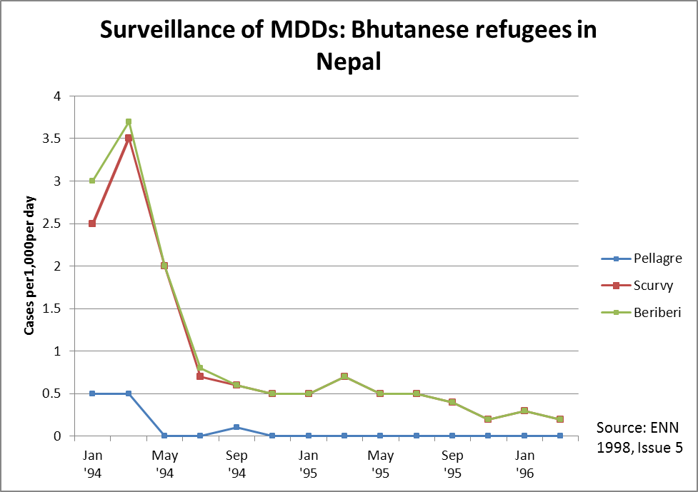
Source: Sphere Nutrition Training Modules, Save the Children United Kingdom, December 2004.

The Bhutanese example above shows a clear time series of cases recorded. There are other examples of micronutrient surveillance in protracted emergencies that have longer intervals. The Thailand Burma Border Consortium (TBBC) provides data on micronutrient availability in the rations and monitors the situation based on a series of yearly studies. This provides feed back for action such as food ration adjustments and other public health interventions. Full reports can be found at www.tbbc.org including a review of how this surveillance system has proven effective and lead to action and cost benefits.

Table 2 outlines the key indicators of micronutrient deficiencies. For details see Module 4.

Table 2: Biochemical and clinical indicators of micronutrient deficiencies
Biochemical/ clinical indicator | What it measures | Appropriate context to monitor
- Low haemoglobin  - Pallor, tiredness, breathlessness | Iron deficiency anaemia | Emergency and stable situations
- Low serum retinol  - Night blindness. Bitot’s spots | Vitamin A deficiency (zeropthalmia) | Emergency and stable situations
- Low urinary iodine  - Goitre, cretinism | Iodine deficiency | Emergency and stable situations
- Painful joints, minute haemorrhages around hair follicles, swollen and bleeding gums, delayed healing | Vitamin C deficiency  (scurvy) | Protracted emergency setting where cases have been reported
- Eight clinically recognizable signs of wet or dry beriberi, five in adults , three in children | Thiamin deficiency  (vitamin B)  Beriberi | Protracted emergency setting where cases have been reported  Symptoms are likely to occur in rice eating populations.
- Dermatitis, dementia, diarrhoea and death in extreme cases  - Cassal’s necklace | Niacin deficiency  (vitamin B)  Pellagra | Niacin deficiency occurs mainly amongst maize eating populations.  Mostly affects females >15yrs
Source: Adapted from Food and Agriculture Organization, Nutrition Status Assessment and Analysis course, European Commission/FAO Information for Action Project, Learning Centre at www.foodsec.org (2011).

Indicators to assess the underlying causes of malnutrition
One of the key principles within this area is that many of the indicators relating to the underlying causes of malnutrition do not change rapidly and may only change after a number of years. However there are some underlying causes that do fluctuate seasonally and can be measured in an ongoing manner to help focus intervention efforts more effectively. For example, food access varies seasonally and can be measured using tools such as dietary diversity, coping strategy index, Household Food Insecurity Access Scale (HFIAS; although this scale has not yet been fully accepted as a useful tool in measuring food insecurity in the humanitarian sector) and Food Consumption Score. Additionally illness is also a highly seasonal underlying cause of malnutrition that can be, and is, monitored throughout the year. Health clinics regularly collect morbidity data for systems such as the Health Management Information System (HMIS), as well as data on specific diseases such as measles, diarrhoea, malaria (or fever) and other communicable diseases as part of systems designed to warn of disease outbreaks (either run by the host government or with support of WHO). Health data are most often available from secondary sources whereas data on food access are likely to require specific data collection.

In order to determine the underlying causes of malnutrition, it is essential for a nutrition surveillance system to include indicators that measure food security, the health environment and the care environment. . In many countries data on underlying causes is already being collected as part of ongoing data collection systems and a nutrition surveillance system can benefit from these data outputs This can save one programme being overburdened with data collection and also utilizes a wider, often more established, set of data collection systems. Furthermore, data collected on underlying causes should, at least in theory, be the starting points for interventions to prevent increases in acute malnutrition. Therefore, data collected on underlying causes should also have a series of responses attached to analysis of causal factors. For example, as cases of diarrhoea increase response should entail the increasing the provision of clean water and rehydration treatment. Responses should not wait until the rate of acute malnutrition increases.

The indicators will depend on the context but there are several key indicators that should always be included in order to understand causes of malnutrition.

Care practices
In an emergency setting, disruption to care practices relating to feeding, health and hygiene can occur. These can all have an impact on nutritional status and should be included in nutrition surveillance systems. The following is a list of some of the indicators to consider. Some of these may only need to be collected at the initial assessment as they change little over time. This is true for both emergency and development settings.

- Infant feeding practices – breastfeeding practices, initiation, exclusive duration, introduction of other liquids and solids, use of bottles, reason for stopping breastfeeding
- Complementary feeding – age-complementary foods introduced, types and preparation methods
- Young child feeding – foods fed to young children, number of meals per day, snacks, feeding methods, e.g., sharing plates
- Home health practices – treatment of simple childhood illness, traditional treatments
- Hygiene practices – hand washing practices, disposal of child feces, availability of soap etc.
- Food preparation and storage – food preparation, storage, cooking

Health status
The link between disease and acute malnutrition is well documented and in many emergencies disease outbreaks can be a major factor leading to nutritional deterioration. Assessing the prevalence of the main childhood illnesses (malaria, diarrhea, acute respiratory infection, measles and malnutrition) as well as the immunization status is important to determine vulnerability and the potential contribution of health factors to the nutrition situation. The following list contains some of the key indicators to include in nutrition surveillance:

- Morbidity – from anthropometric surveys (sickness of child in last two weeks) and from health workers (major diseases in the under-five and general population, main causes of death, endemic diseases, seasonal outbreaks, epidemic history)
- Vaccination status and supplementation coverage – coverage of main vaccines and supplementation of vitamin A, which serves as a useful proxy indicator for access to health services and highlights vulnerabilities as well as providing information on the vaccination status of the child

Water and sanitation
Access to protected water sources and appropriate sanitation facilities is often reduced at the onset of large-scale emergencies and can be one of the main causes of diarrhoea and subsequent high rates of malnutrition. Key indicators for inclusion in nutrition surveillance are:

- Water – source, protected or not, containers used to carry and store water, treatment such as boiling or chlorination, amount consumed per day, distance to source
- Sanitation – facilities available, condition, number people using latrine, distance to latrines, male and female facilities

See Module 8 for more details on health assessments.

Food security
An understanding of food access, availability and utilization at the household level is essential to understand the potential contribution of food insecurity to the nutrition situation. Key indicators for inclusion in nutrition surveillance are:

- Access to food - market prices, terms of trade, household income, perception of food insecurity, dietary diversity
- Availability of food – production (agricultural and livestock), availability of local markets, rainfall patterns
- Utilization of food – intra-household distribution, meal frequency, food preference, gender issues
- Coping strategies – strategies households undertake to meet their food needs – whether these strategies are normal (seasonal sale of assets, livestock cereal), reversible (switching to less preferred foods), destructive (selling off productive assets) or crisis strategies (moving to search for food). The Coping Strategy Index (CSI) is one of the most common tools that capture these strategies and is a very useful indicator when collected over time.

It should be noted that attempts have been made to link anthropometric measurements directly to dietary diversity for nutrition surveillance. There has been evidence for using dietary diversity as a useful proxy for food security from large-scale surveys and small-scale surveys,. However there are few good examples of this within nutrition surveillance systems or activities. In terms of ease of use, dietary diversity tools provide a simple indicator that could prove to be very useful when developing nutrition surveillance systems and/or activities. Currently the FSNAU uses dietary diversity as part of the IPC framework, although there is ongoing work to better integrate this into the decision making process.

See Module 9 for more details on food security assessments.

Other indicators

In certain contexts, other indicators may be valuable for nutritional surveillance. These include:

- In insecure areas with large scale population movement, include population displacement numbers and shelter conditions.
- Mortality is a very sensitive indicator of the severity of a crisis. It can be difficult to get accurate mortality data. For details see Modules 7 and 8.
- In areas affected by HIV and AIDS it may be appropriate to include additional indicators such as numbers of orphan-headed households. Furthermore, care should be taken with nutritional indicators. For example, in Kenya, large areas of north-eastern region have regularly reported levels of wasting in excess of the emergency threshold. This has in turn triggered large-scale relief interventions. In contrast, areas of western Kenya have reported low levels of wasting. However, the rate of chronic malnutrition is significantly higher in western Kenya than the north-east. This is believed to be due to the high rate of HIV and AIDS. Monitoring both wasting and stunting is therefore important in this context. For details see Module 18.

The key points to consider when selecting indicators are:
Validity: the indicator that offers a true and as direct as possible measurement of the phenomenon considered
Ease and rapidity of measurement: the qualities that are relevant to both the measurers and the individuals being measured
Reproducibility: the degree to which the measurement is likely to be influenced by the person or instrument measuring the data, so that the value obtained will be the same, irrespective of the measurer, the place or the measurement instrument
Strength of association: the indicator should be as closely related to changes in nutritional status, from documented evidence if possible, if not it must be at least part of the causal framework used.
Will initiate a response in their own right: data collection is expensive and therefore data collected must be useable and should be part of defining a response.

What sampling methods should be used?

Sampling is critically important. There are several ways of selecting a sample. The main sampling methods are simple random sampling, systematic sampling and cluster sampling.

Small-scale surveys

In nutrition surveys the standard sampling approach used is the two-stage cluster sampling. This is described in detail in Module 7. Wherever this is applied, the results are comparable between populations and over a period of time. It may be difficult to apply cluster sampling to some populations such as pastoralist or mobile populations. Current research is attempting to identify more efficient ways of sampling in these populations.

Sentinel site surveillance (see Annex 7a and 7b)

Purposive sampling is generally used in sentinel site surveillance, where specific sites are selected on the basis of particular vulnerabilities. The results are not therefore representative of the larger population but trends over time can be detected. Although there are no agreed guidelines, current practice suggests that 50 to 120 children per site are enough to monitor nutritional changes in a population.

Rapid nutrition assessments

There are two main types of rapid assessments; rapid assessment where qualitative data is collected and rapid screening assessments based on MUAC. For both types of rapid assessment the sampling approach is not designed to ensure a representative sample of the community and can be referred to as convenience sampling. Results should therefore always be interpreted with caution.

Data collection (see Annexes 7a and 7b)

Frequency

Once the decision has been made about which indicators to collect on which population, the task of defining the frequency of data collection needs to be considered. The frequency will depend on the indicators for which the surveillance activity is designed to monitor. Some indicators, such as wasting, can change quickly over time in an emergency while others, such as stunting, may take many months to change significantly. Other indicators are likely to remain static unless interventions are made, for example, access to water, sanitation facilities or vaccination coverage. However, these indicators may also be affected by a further shock, such as a new wave of displacement, so updated information may be necessary to fully understand the altered context and the risk factors. Certain food security indicators, such as production, are seasonally influenced, so that it may only be necessary to collect production information every three or six months depending on the seasonal calendar. All these factors need to be considered when determining the frequency of data collection and the complexity of the questionnaires.

Identification of enumerators

It is essential to identify reliable staff to collect data. Ideally, experienced staff should be used although if sufficient training and ongoing supervision is provided, even the most innumerate and illiterate staff can maintain a nutrition surveillance system.

Case example 9: Community-based nutrition surveillance in South Sudan: 2007

Experience from South Sudan has illustrated that very simple tools can be used by children to monitor the nutritional status of other children in a community. This highlights that literacy or numeracy is not always necessary. This system is based on a child-to-child approach using a MUAC of < 13.5cm as an indicator of malnutrition. Rather than use a MUAC tape, a small cylindrical tool with a diameter of a well-nourished child at > 13.5 cm is employed. Older children using their thumb and fore finger can estimate what > 13.5cm feels like using the cylindrical tool. Then once a month all children are measured by an older child using the thumb and forefinger around the middle of the upper arm. A bag of pebbles is used to assign the children whose arms are broader than the diameter of the finger to thumb and those whose arms are thinner. With this simple early warning system the community is able to identify when there is need for a community-based intervention or advocacy for additional assistance.

Source: Save the Children United Kingdom, personal communication, 2007.

Analysis of data

There are a variety of tools that can support the analysis of nutrition data. Nutrisurvey software supports the analysis of the basic indicators used in nutrition surveys and can be used by those inexperienced with analysing nutrition survey data. Apart from Nutrisurvey, the most common software specifically designed for analysis of nutrition and public health indicators, is EpiInfo. For details see www.smartindicators.org, www.nutrisurvey.de, www.cdc.org, www.nutrisurvey.net/ena-epiinfo

Quality control of data (see Annex 8)

There are a number of problems with quality control of data. These were highlighted in a study by Tulane University in collaboration with UNICEF of over 500 nutrition surveys conducted in East Africa and Horn of Africa regions from 2000. The study indicated that up to one third of the assessments had problems of data quality, quality control and timing. The major challenges are:

Accurate estimation of age
In the absence of health records or birth certificates the estimation of age can be significantly flawed. In most situations enumerators round up to the nearest 12 months (e.g., a mother says her child is 3 years old and the enumerator documents 36 months, even though the child’s true age may be anywhere between 30 and 40 months). An inaccurate estimation of age by three months can provide an incorrect estimation of the child’s nutrition situation.

Height/length measurement
In spite of intensive training, the digit preference for 0 or 0.5 remains a significant problem in measurement of length or height. It has been suggested that this is largely due to enumerator fatigue, with more errors being reported in the second half of the day. The impact of this bias on data quality cannot be underestimated. In addition, measurement errors, such as failure to remove shoes, children not standing appropriately, and forgetting to remove head covers, also affect the quality of the data.

Weight measurement
Accurate measurement taking is often problematic while digit preference is also a significant challenge, particularly when hanging scales are used. The advent of reliable electronic scales has addressed this to some extent. However, other quality control issues, such as failure to remove clothes and incorrect placing of the scale on the ground (e.g., on slopes or uneven surfaces) can also interfere with the quality of the data.

How to address these concerns
The most important way of addressing these issues is through training and ongoing supervision.
As part of the SMART initiative to improve nutrition survey quality, a software package called Emergency Nutrition Assessment from Nutrisurvey has been developed to run quality checks on nutrition data and to provide acceptable ranges for certain variables such as age distribution, skewness of the population curve and reports of age heaping and digit preference in weight and height. This software was initially adapted in the Ethiopia Nutrition Coordination Unit (ENCU), where all raw survey data is run through a series of checks before being published. Surveys that do not meet the required standard are not published. The ENCU Quarterly Bulletin provides a summary of the quality checks of all surveys in that time frame. The Somalia FSAU Nutrition Update has also recently included these checks in all bulletins and there are similar plans for other bulletins currently under development in Africa. These checks, as well as highlighting the quality of the data, also improve the transparency and accountability to the community and donors. They have also lead to considerable improvements in the quality of the surveys conducted. For details see Annex 8.

Case example 10: Quality control Ethiopia: 2002–present

Since 2002 the Ethiopia Nutrition Coordination Unit (ENCU) in the Ministry of Health, with support from UNICEF and NGOs, have maintained a nutrition surveillance system using information collected through selective feeding centre statistics, monitoring, rapid nutrition assessments and small-scale localized nutrition surveys. The method applied for the small-scale surveys from 2002 to 2006 was the standard 30 x 30 cluster approach, with the SMART approach adapted in 2007. The introduction of the SMART approach has placed a strong emphasis on data quality. The recommended series of quality checks included in the Nutrisurvey package was adapted by the ENCU in 2006. These quality checks have resulted in a significant improvement in the quality of the data. Key areas identified as requiring further support have been sent to the implementing agency and more effort has been placed on training or supervision (e.g., digit preference, rounding up of age at whole year, etc.).

Source: ENCU, Quarterly Bulletin, 2010.

Presentation of data
Depending on the method used in the nutrition surveillance system, there are a variety of ways to present nutrition information. It is critical to always compare current data with past data, e.g., the nutritional trend. Numbers in isolation mean very little. In some cases the magnitude of change of the rate of acute malnutrition is more relevant than the actual prevalence. Seasonal interpretation is also critical. Many studies have shown up to 5 per cent change in wasting at different times of year due to seasonal variations. In addition to looking at trends, also consider the underlying causes to help describe the situation and from this recommend appropriate responses. Also, where possible, attempt to predict change, e.g., consider the risk factors and whether these are likely to result in further deterioration of the nutrition situation (epidemic, continuing displacement, food insecurity, etc.) or mitigating factors for improvement (predicted good harvest, increasing interventions, etc.). In many surveillance systems predictions on the evolution of the nutritional situation is not based on statistical calculations but lies with the experience of those interpreting the trends produced by the data collection system. Although this is not inappropriate the strength of the analysis will lie with the experience of the analyst but will be greatly assisted if there are good historical records on the trends of the nutritional situation. This greatly helps when making predictions and on the types of responses required to mitigate or stabilize increases in acute malnutrition. The following is a sample of the different ways in which nutrition data from surveillance systems can be presented.
In terms of the aesthetics of data presentation in national systems, or consolidated reporting of small-scale surveys, mapping provides a very powerful advocacy tool as well as assisting in the analysis of data. There are a number of examples of this but the most widely known is that of the FSNAU for Somalia. The approach is also successfully being used in the ENCU. The application of geographical information systems (GIS), quickly provides clear indication as to where the greatest needs lie. There are limitations with the use of GIS, i.e. for single, ad hoc, small-scale surveys. However, where there are multiple surveys or data collection systems that cover several geographical units then the GIS tool becomes much more powerful. If GIS expertise is available the use of mapping should be encouraged for the presentation of results where appropriate data are available. GIS application may not even require advanced software and the use of Google Earth and Google Maps is becoming more commonplace in humanitarian settings. MapAction provides a series of resources and technical briefings that encourage the use of this free and easy to use means of presentation. Furthermore, GIS can be used as a powerful advocacy tool. Other online resources, such as StatMapper can provide mapped information on a variety of nutrition indicators from large-scale surveys (such as the DHS).

Nutrition surveys
Results should be presented on global acute malnutrition (GAM; Z scores less than -2 standard deviations of the mean+ oedema cases) and severe acute malnutrition (SAM; Z scores less than -3 standard deviations of the mean + oedema cases). Recently, the growth reference values have changed from the NCHS 1977 references to the WHO 2006 references. There has been a period where nutrition surveys have been reporting prevalence values based on both references. However, now the transition to the new reference values is more established reporting the WHO 2006 data only has become more common. In surveillance systems that have spanned this transitional period it may be necessary to use NCHS 1977 values for the recent survey results as well, at least until the surveys analysed using the NCHS 1977 data are less relevant to current trends. Confidence intervals should always be reported so that it is clear if there has been a significant change from observation to observation (where repeat surveys have been made). Cases of oedema should be reported separately. For details see Module 7.

Sentinel site surveillance
As the sample population in sentinel site surveillance is not representative, nutrition information should be reported in terms of trends, taking into account expected seasonal variations. Monthly changes in mean weight-for-height are sometimes reported (for example, in the SCUK nutrition surveillance system in Ethiopia and currently in Darfur). A disadvantage of this approach is that because the information is not representative of the population, it may lack credibility and requires local experience to be interpreted. It is important to always report the sample size.

Rapid nutrition assessments
Agencies vary in how findings are reported. When purposive sampling is applied, the data should be presented as absolute numbers and not as percentages. When exhaustive screening is conducted, percentages can be reported. However, care should be taken to extrapolate this information to similar populations. Ranges of estimated levels of malnutrition are also sometimes used. As with sentinel site surveillance it is critically important to report the sample size.
Interpretation of data

To properly understand and interpret nutritional data the following interrelated perspective should be considered:

- Actual prevalence rates of acute malnutrition in relation to thresholds and decision making frameworks
- Trends over time and seasonality (inter and intra annual variation), reviewing expected seasonal changes in nutritional status (and associated changes in food security, morbidity and caring practices), for example, is it normal for the time of year, for the population of concern?
- Underlying causes, reviewing the underlying causes of malnutrition, by considering patterns of nutritional status in relation to likely causes, including food security, caring practices and public health
- The relationship between malnutrition and mortality

Use of thresholds

Various attempts have been made to classify the severity of an emergency using acute malnutrition in the population as one indicator of distress. These classifications suggest that emergencies can be divided into stages. In the most extreme stages, food insecurity, malnutrition and mortality are so severe as to be labelled ‘famine’. A number of systems have attempted to set thresholds above which particular emergency interventions should be initiated. In addition, more specific nutrition ‘decision-trees’ have been developed to indicate when selective feeding programmes should be started (for example, see the WHO decision-tree in Table 3). These classification systems are described in detail in Module 1.

Table 3: WHO classification by nutritional status
Severity of malnutrition | Prevalence of wasting  (% below median -2SD) | Mean weight-for-height  (Z score)
Acceptable  Poor  Serious  Critical | < 5%  5–9%  10–14%  > 15% | > -0.4  -0.4 to - 0.69  -0.7 to -0.99  < 1.00
Source: World Health Organization Rapid Nutritional Assessment in Emergencies, 1995.

Different classification systems apply different thresholds and therefore thresholds should be viewed as a starting point for interpretation, rather than the sole basis for interpreting nutritional survey findings. The use of absolute thresholds to judge the severity of a situation was rejected by the Sphere Project, which instead recommends examining trends by estimating whether the prevalence of acute malnutrition is unusual for the time of year and on the basis of a review of nutritional risks related to food, health and care.

In addition, work recently published on the relationship between mortality and malnutrition has suggested that different populations and livelihoods could have different thresholds for prevalence of acute malnutrition. Although this work has not been integrated into recommended emergency thresholds by the SCN, it shows that there may be a need to apply contextual interpretation if thresholds are to be used. Difficulties remain in the interpretation of mortality and malnutrition and it is clear that the relationship is not straightforward.

Trends over time and seasonality

The prevalence of malnutrition determined through a nutrition survey needs to be interpreted in relation to pre-emergency levels of malnutrition and normal seasonal changes in nutritional status. To interpret whether a prevalence of malnutrition is unusual, it needs to be compared with the prevalence of malnutrition that is normal for the time of year for the assessed population. A sudden increase in malnutrition can reveal more about the impact of a crisis than prevalence at a single point in time. This means that sometimes an emergency response can be justified even if the prevalence of malnutrition has not reached the emergency threshold. For example, in 2002 an increase in the prevalence of malnutrition in one area in southern Africa from 2.5 to 5 per cent led to large-scale humanitarian responses as humanitarian agencies feared malnutrition would increase to 10 per cent.

One danger of basing decisions on comparisons with pre-emergency levels is that unacceptable pre-emergency levels of malnutrition may be perceived as normal. Many parts of the world are now suffering from protracted crises and associated high levels of acute malnutrition. Furthermore, many populations experience seasonal changes in nutritional status, specifically rural communities that depend on a single harvest or pastoral populations and the associated milk production. For these populations the lowest prevalence of malnutrition may be found just after the harvest or when the grain prices are at the lowest, and the highest prevalence found during the hungry season prior to the harvest, when food is scarce. The hungry season usually coincides with the rainy season, which is also associated with a higher prevalence of disease and higher workload because it is the planting time in agricultural societies. The prevalence of malnutrition can vary by as much as 20 per cent within the space of three months in extreme cases.

For analysis of trend data from sentinel sites or admission data (or other non-representative data), it is also important to have some form of reference trend so that the observer, as well as the analyst, can better contextualize the observations made. Some important observations of trend data are the slope of the curve (i.e. the speed at which the situation is changing) and the magnitude of difference between the current observations compared to the reference (i.e. is the situation better or worse than the previous or average situation). This is an area where many surveillance systems fall short. Trend data requires context where possible. However, even when there are good reference data available there are still no strong, globally referenced, sources to assist in their interpretation. See Case example 11 for an example of how a change in data presentation greatly assisted analysis of trends in Ken ya.

Case example 11: Trend Analysis of MUAC data in ALRMP Kenya
Example of original presentation of MUAC data | Example of revised presentation of MUAC data with contextual reference.
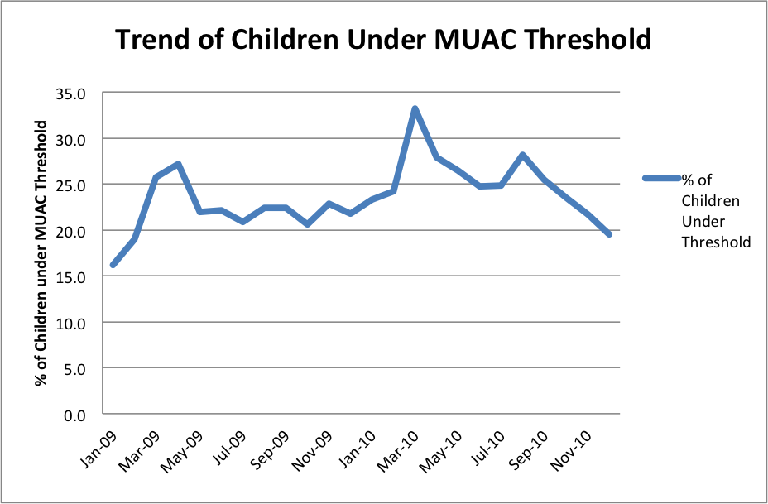 | 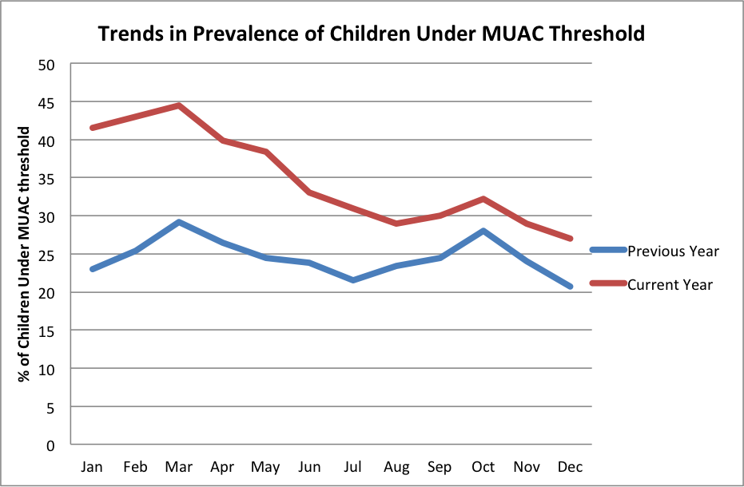
In Kenya the Arid Lands Resource Management Project has been collecting nutrition data based on MUAC each month in some districts for well over 15years. Although the system of nutrition data collection has faced a series of challenges in the past particularly with respect to the way in which the MUAC data have been collected and the quality of these data, there has been a great deal of assistance provided to improve the surveillance system. One of most significant improvements was a simple change to the way in which the data were presented.

Note that in the ‘original presentation’ example the single trend on the left makes it very difficult to spot seasonal trends and variations in those trends, both in magnitude and in terms of speed of onset. However, when a simple revision was made to include a reference year (in this case the previous year) a quick and relatively simple analysis could be made. This was very useful in this case as there are no commonly employed intervention trigger rates for MUAC data. This type of visual comparison would be equally useful for admission data to a selective feeding programme or WHZ data that are not statistically representative of the population.

Adapted from: McKinney, P. Nutrition, Malnutrition & Nutritional Status in Early Warning Systems, Oxfam 2005.

One of the latest developments in trend analysis of small-scale surveys is the development of CDC calculator. This tool helps the analyst to plan surveys that can show, with statistical confidence, relatively small increases in prevalence of acute malnutrition. The principle is that the calculator provides the sample size for both surveys for a given change in the estimated prevalence. Therefore the analyst can plan surveys to include the correct number of children to be statistically confident that the prevalence of acute malnutrition has changed. For a full explanation see the CDC website.

Underlying causes of malnutrition

An important component of nutrition surveillance is the analysis of underlying causes of malnutrition in order to better understand the relative importance of food, health and care as nutritional risk factors, and thereby determine the priority response. There is no clear formula for determining underlying causes, or indeed for proving causality: each cluster of causes needs to be reviewed in turn, with the aim of identifying potential nutritional risk factors that could be contributing to an increase in malnutrition. The existence of a known nutritional risk factor should be sufficient to justify action, for example, where people have become suddenly displaced and no longer have access to food. The highest prevalence of malnutrition usually occurs in situations where there has been severely restricted access to food or a combination of two or more underlying causes. There are few examples where increased disease prevalence or inadequate caring practices in isolation have contributed to malnutrition exceeding emergency thresholds. There is a long-standing debate over whether malnutrition is an early or late indicator of food insecurity. This is a complex issue with no simple answer. One recent study in Ethiopia on the relationship between malnutrition and food security indicators (rainfall, market prices and relief receipt) showed a clear link between trends in nutrition and food security indicators in three areas, but no such association in three other locations. Furthermore, even where nutritional status is affected by declining food security, the nutrition surveillance system may not be sensitive enough to pick up early signs. A simple rule for determining whether food insecurity is the main underlying cause of malnutrition is by considering the prevalence of malnutrition in different age groups. In situations of severe food insecurity, children older than two years may have elevated prevalence rates compared to younger children. This is not the normal pattern seen in nutrition surveys, where younger children generally have higher prevalence due to their increased susceptibility to disease.

The use of mortality data in surveillance

While most guidelines recommend the collection of mortality data as part of nutrition surveys, it is not clear how mortality data can be used in nutrition surveillance. Note that there is a large difference between mortality data collected by surveys such as the DHS and the MICS compared to that of small-scale nutrition assessments. The former examples provide under-five mortality rates (U5MR) or crude mortality rates (CMR) and the latter, zero to five death rates (0-5DR) and crude death rates (CDR). These are not comparable and refer to different epidemiological indicators. Therefore when integrating mortality into a nutrition surveillance system using multiple sources of data (large scale surveys and small-scale surveys) it is important to understand that there may be different indicators which cannot be used interchangeably.

Also, and highlighted in Modules 7 & 8, there are a number of limitations in mortality estimates when conducted as part of a small-scale nutrition survey. The principle limitation is the confidence interval in the estimate of 0-5DR and CDR can be so large that indicating significant difference between surveys will be very difficult.

Although there is no formal guidance it is certainly pertinent to monitor mortality to provide context of the underlying issues relating to changes in rates of acute malnutrition and also alert the humanitarian community if these death rates climb higher than emergency levels.

Dissemination of data

Given the importance placed on nutrition indicators in highlighting the severity of a crisis, the timely dissemination of information is essential to provoke an appropriate response. In some situations political pressure and bureaucratic processes may delay the release of up to date data. Furthermore, in emergencies the nutrition situation can change quite quickly. While reporting nutrition information that is older than the current season is very useful for trend analysis, the window of opportunity to address needs effectively can be missed.

There are several means of disseminating information. The most common way is through national nutrition coordination units or clusters, where key stakeholders in the nutrition sector are present. In the early stages of an emergency, weekly or bi-weekly coordination or cluster meetings may be held to provide a forum for sharing new information on the emergency from the nutrition surveillance system.

Regular bulletins are often produced. See Box 1.

Box 1: Examples of national, regional and global bulletins
National bulletins
Currently monthly nutrition bulletins are produced by FSNAU Somalia, bi-monthly bulletins are produced from Darfur and Malawi and quarterly bulletins by the Ethiopia Nutrition Coordination Unit and in Zimbabwe. There are also plans to produce a quarterly East and Horn of Africa Region Nutrition Update by UNICEF, and quarterly Ugandan, Eritrean and Namibian Nutrition Updates. For examples of bulletins, see Annex 9.

Regional bulletins
UNICEF regional office based in Nairobi has produced regional nutrition bulletins since early 2008. The first edition of this regional bulletin reported on the nutrition situation in the Horn and East Africa Region including Eritrea, Ethiopia, Somalia, and Uganda. Future editions will include information from other counties in the region. This publication aims to highlight regional concerns affecting nutrition as well as trends across countries with similar populations.

Global bulletins
The nutrition information in crisis situations (NICS) established in 1993 is an international system that monitors the nutritional conditions of populations in crisis worldwide. The main objectives of the NICS are:
- To provide a channel and means of disseminating information on nutritional problems among emergency-affected populations (Past experiences have indicated that such data were sometimes sensitive and therefore not widely circulated.)
- To build up a historical database on the nutrition of a population in crisis and to help identify recurrent issues and problems or improvement in humanitarian response
- To fulfil an advocacy role where problems are highlighted in order to mobilize resources or response measures
- To inform agencies about nutrition crises so that they can make an informed decision about whether to become involved in a response

The NICS produces a quarterly bulletin and is based on the data from a wide range of agencies, both NGOs and the United Nations, who provide survey results and reports. The information provided is focused mainly on nutrition and health; however, results from food security assessments are often quoted. Using the data provided, NICS classifies the situation of the population into four main categories relating to risk and or prevalence of acute malnutrition. The prevalence and risks are indirectly affected by both the underlying causes of acute malnutrition relating to food health and care and the constraints limiting humanitarian response. The categorization is based upon summation of the causes of malnutrition and the humanitarian response, but according to NICS, should not be used in isolation to prescribe the necessary response.

CE-DAT (www.cedat.be) is also a very useful resource that permits surveys to be uploaded into a global database. Its usefulness in surveillance is limited in that there is a need for a time series of data to be available. These need to be surveys carried out on the same population at a similar time of year and using the same methodology. However, as more surveys are uploaded (you are encouraged to do so) the more useful this resource will become in global nutrition surveillance, particularly in emergency contexts.

Challenges of nutrition surveillance systems

Sustainability

One of the biggest challenges facing nutrition surveillance systems is the issue of sustainability and the continued effectiveness of the system. There are many examples of information systems that have ‘withered’ away as donor interest has waned (either because the area served by the information system has not experienced a crisis for a number of years or because internal donor funding priorities have changed). Continuation of adequate financial resourcing is therefore crucial.

The continued availability of adequately trained and committed staff is also essential. Too often staff are expected to take on other roles and do not have sufficient time to adequately support the system. Competing activities, such as immunization campaigns, child health days and capacity building workshops, often prevent surveillance activities from being conducted. In addition to competing activities and overambitious workloads, turnover of ministry staff can also exacerbate this problem. For example, by the time the staff have been trained and become familiar and competent in their activities, they are moved to a different area or division.

Ideally if a system proves to be effective and sensitive to monitoring change over time, this should justify the additional resources. With the current renewed interest in nutrition surveillance systems, and improved quality of data collection tools and analysis, the availability of resources to establish sustainable surveillance systems is increasing. Case example 12 outlines some of the issues of sustainability faced by the Save the Children United Kingdom nutrition surveillance project in Ethiopia.

Case example 12: Sustaining nutrition surveillance in Ethiopia: 1980s–2002

Save the Children United Kingdom (SCUK) operated a longitudinal nutrition surveillance programme (NSP) for early warning in Ethiopia from the early 1980s until 2002. This long term investment in nutritional surveillance is noteworthy and unusual in Africa. However, SCUK was unable to build institutional sustainability for the NSP and the government had no capacity to sustain the NSP once SCUK’s decision to “phase out” was taken in 1998. The view that the NSP was extremely expensive is a myth. At its height in 1995, the annual cost of the NSP was £278,000. Though this may have been a lot for a poor government to maintain, it represented an insignificant expenditure (< 1 per cent) in comparison with the annual cost of American food aid. There are very few EWS being supported purely by governments in poor African countries today. Systems that have relied substantially on their governments for funding have been vulnerable and often unable to achieve stated aims. Rather donors have invested large amounts of money into sustaining systems. Sustainability of a system depends as much on outside donors as on the governments.
Lessons learned:
1) Investment in capacity building in its widest sense is essential to sustain a nutrition information system.
2) Nutrition surveillance is not necessarily very expensive but any information system in poor countries is likely to require external agency funding.
3) Agencies that establish and fund information systems (including nutrition information systems) have a responsibility to plan for medium and longer terms financial sustainability of these systems.
Source: Review of Save the Children United Kingdom Nutrition Surveillance Programme in Ethiopia, NutritionWorks, London, 2006.

Although the NSP in Ethiopia ceased operations in 2002 and later a new surveillance system was established within the Disaster Prevention and Preparedness Agency (DPPC). This “Emergency Nutrition Coordination Unit” (ENCU) provides multiple layers of nutrition data relating to acute malnutrition in the Ethiopia and receives technical assistance of UNICEF. This system remains in effect and has made some significant progress in defining useful models for other surveillance systems. This was only possible because of the political desire, long-term investment and will of the Ethiopian Government and NGO/UN community to have nutrition data available for decision-making.

There are other examples of nutrition surveillance systems falling by the way side. The INFSSS in Malawi all but halted when funding for Action Against Hunger (the main technical support for the system) concluded in 2008. Although the system was handed over to the Government of Malawi, the capacity that remained in government ministries as well as ability to continue to fund the system was limited. While the infrastructure of this system remains in place the system is not actively reporting data that continues to be collected by the clinic staff as part of the MCH programme.

The national nutrition surveys system of surveillance in Tajikistan faltered when Action Against Hunger ended nutrition operations in-country. The system was not seen as a priority by the Government of Tajikistan, and there was no strong political desire to continue the system. Furthermore, there was limited, capacity to implement the programme within the Ministry of Health nor was there funding to continue the activity.

In reviewing the observations/evaluation reports of many of the systems that have ceased to operate or reduced/stopped reporting compared to systems that remain functional, it is apparent that certain key factors predispose to longer-term success of nutrition surveillance systems.
- The engagement and commitment of national government is key to the success of any of the systems that are currently still active
- At inception, if the nutrition surveillance system is intended to be a long-term activity appropriate integration into government needs to be established and adequate funding acquired from the outset.
- Nutrition surveillance that relies on single activities for their data source tends to fail much more completely than those that use data from multiple sources. Support for the surveillance system comes from UN agencies, national government and NGOs
- Information provided by the surveillance system is easily be translated into action and reports provide clear indication of where the nutritional problems lie, the scale of the problem and focus the attention of implementing partners on where the greatest needs are.
- The users of the information believe in the data provided by the system and trust in its accuracy (system credibility).

Institutional issues

Issues, such as where the system should be located and how it links with existing early warning systems or health information systems, also need to be considered in terms of who ultimately makes the decisions about the analysis of the information and who determines the appropriate response. The challenge for many information systems is that they rely on a range of information sources that cut across several government ministries including health, agriculture and education while the Bureau of Statistics may have the mandate to deal with data collection in the country. This means that no one ministry takes responsibility for the management of the system. If strong ownership or a technical centre cannot be established, over time a system may well be abandoned.

In some countries (such as Ethiopia and Kenya) government structures have been put in place which specifically deal with acute and protracted crises. In this context nutrition surveillance systems are inform and are more accountable a clearer centre of responsibility making integration into government structures a more straightforward process.

Case example 13: Arid lands resource management project: Kenya (2011)

The Arid Lands Resource Management Project (ALRMP) is the early warning system of the Government of Kenya and is managed by the Office of the President. The project is funded jointly by the World Bank, and the Government of Kenya. Currently the ALRMP monitors the food security, nutrition and livelihood status of 28 arid and semiarid districts: The purpose of the ALRMP is to provide relevant and timely information on drought and other types of stress. It has two objectives:
- To act as an early warning system, alerting planners to the onset of a drought
- During the drought period, to consistently measure the levels of stress in the local population and integrate this information into relief planning

The information collected through the seasonal assessments and the monthly monitoring is used to directly inform response agencies including the Government, the UN and NGOs. The information is shared through the Kenya Food Security Steering Group which has representation from a range of government ministries, UN agencies and NGOs.

Source: USAID, Understanding nutrition data and the causes of malnutrition in Kenya; A special report by the Famine Early Warning Systems Network (FEWS NET), 2006.

Linking information to action

Data collection which is not linked to action is pointless and unethical. Nutrition surveillance systems should be designed in such a way as to maximize the likelihood that information will elicit an appropriate response if one is needed. There are two main reasons many surveillance systems fail to produce the desired response:

First, there can be a lack of confidence in the data. This is very common when data are based on trends and not on prevalence data. Sometimes, data indicating a deteriorating nutritional trend is only accepted if it is confirmed by prevalence estimates from representative surveys. The lack of international agreement on standards and indicators for sentinel site surveillance or rapid assessments and their interpretation is problematic.

Second, there are political reasons for failing to react to surveillance information. Issues of credibility and political inertia can both, to some degree, be addressed by involving decision makers (at government or international levels) in the design of the system. Joint prior decisions about thresholds, institutional location of systems and the role of data and process of data use in decision-making can all help to address these potential impediments. Credibility of systems is also enhanced by transparency and honesty with regard to shortcomings and failures where these occur.

Case example 14 from Somalia outlines how an integrated analysis of nutrition, health and food security information highlighted a rapidly deteriorating humanitarian situation that triggered a large-scale humanitarian response.

Case example 14: Deterioration in the Shabelle region in Somalia: 2007

Following the collapse of the government in 1991, Somalia has been faced with widespread insecurity, lack of infrastructure, low levels of humanitarian access and frequent shocks; all of which have had a devastating impact on the human wellbeing of the population. Large parts of South and Central Somalia have been faced with a series of shocks over the years: floods, drought, civil insecurity and displacements, which have left the population facing a chronic nutrition crisis where rates of acute malnutrition are frequently being reported above the emergency thresholds of 15 per cent. However, rates of severe acute malnutrition and mortality rates tend to be at acceptable levels. In Gedo region, bordering Kenya, a total of 23 nutrition surveys have been conducted since the collapse of the government from 1991 to 2007 all of which have reported levels of acute malnutrition above this emergency threshold.
Two regions in Southern Somalia, Middle and Lower Shabelle, have proven to be more resilient to the shocks with rates of acute malnutrition remaining < 10 per cent. This is due to the large production in the region, in addition to the strong trade links with Mogadishu, the capital which is situated in Lower Shabelle and which also provides labour opportunities to many of the population. In early 2007 the situation changed significantly when new violence broke out in Mogadishu causing wave after wave of displacement resulting in over 100,000 people fleeing into the neighbouring Shabelle regions over a period of two months. The food security situation also indicated a deteriorating trend following three seasons of below normal cereal production, loss of stocks during unexpected floods in January 2007 and sharp cereal price increases due to the negative impact of conflict on trade in Mogadishu. Finally endemic cholera was exacerbated by the population movement and resulted in 6,211 cases in Lower Shabelle with a case fatality rate (CFR) of 4 per cent (indicating a situation out of control) and 1,697 cases in Middle Shabelle with a lower CFR of 1.77 per cent. Two nutrition surveys conducted in May indicated rates of GAM of 17 per cent and rates of SAM of 4.8 per cent in the riverine population in Middle and Lower Shabelle and 17.3 per cent GAM and 4.5 per cent SAM in the agro pastoral population in the two regions. Crude mortality rates in both surveys were at alert level.
As a result of the significant and rapid onset deterioration, FSAU issued a press release, ‘A Special Focus Nutrition Update and a Food Security and Nutrition Brief’, which highlighted the key factors driving the deterioration and the nutritional outcome. This information was disseminated to all major actors in Somalia and beyond through a series of radio and newspapers interviews. As a result of this information emergency cluster meetings for all sectors were held and interventions were established in the affected areas. The most alarming indicators were the rates of severe acute malnutrition (> 4 per cent). This statistic provided advocacy opportunities for the key nutrition agencies to lobby for additional resources.

Source: FSAU, Nutrition Update, 2007.

Can a Nutrition Surveillance System accurately warn of deteriorating nutrition situation?
Many nutritional surveillance systems try to provide predictive data. The INFSSS in Malawi has tried to do this with limited success. The constraints experienced in doing so were consistent reporting, being able to track the same children and changes in the mean age of the children sampled during the course of the year. The ALRMP EWS has also attempted to provide such data. However, the data collection systems and analytical tools for predictive analysis require significant investment and technical expertise. Once a viable system has been established it is important to maintain a process which verifies the validity of findings and the responses which they inform.

The main logic for attempting to have a predictive system is that by the time a surveillance system has reported on deterioration in nutritional status it is often too late by the time Government, NGOs and UN agencies have responded. This has led to emphasis being given to the collection of data that can predict whether and if there will be o changes in nutrition status (e.g. increases in acute malnutrition). This is no easy task and although some nutrition surveillance systems attempt to do this many do not. One example is outlined in Case example 15 that shows how data can be used to predict the nutritional outcome of slow onset disasters.

Case example 15: Use of MUAC for effective famine early warning in Kenya: 2007

Based on data collected from primarily pastoralist communities selected across four districts in Kenya’s arid north, an empirical forecasting model has been developed that can predict, with reasonable accuracy at least three months in advance, the expected human impact of slow onset shocks such as drought. Information on herd composition and herd management, climate and forage availability and food aid flows enable reasonably accurate three-month-ahead forecasting of child nutritional status, specifically severe wasting reflected in very low MUAC levels, with impressive precision. Longer lead forecasts may also be feasible and warrant investigation. These forecasts were generated from a relatively small subset of variables that ALRMP regularly collects, augmented by data collected routinely by LEWS/LINKS. These data are not overly restrictive or costly to collect. Limiting data collection to these set of variables collected consistently through time, might offer a cost-effective way to provide effective early warning to policymakers and emergency response professionals. The precision of these predictions appears sufficiently high that delays in acting on this information due to concerns over forecast accuracy should be limited. However, there remains work to be done to establish how best to communicate this information as clear and timely as possible to appropriate audiences. The authors recommend that the model be adapted as an effective famine early warning tool. As the model can be easily and regularly updated with new information that should continuously increase its forecasting performance, a premium should be placed on developing standardized collection procedures and fail-safe methods for entering, identifying and storing the necessary data. Such a forecasting model could prove an invaluable tool for early warning and emergency response to food crises.

Source: Mude, A.G., et al, ‘Empirical Forecasting of Slow-Onset Disasters for Improved Emergency Response: An Application to Kenya’s Arid Lands’, Pastoralism and Poverty Reduction in East Africa:
A Policy Research Conference, Nairobi, Kenya, 27–28 June 2006.

Also in 2006, de Matteis used ALRMP EWS data to show that a livestock price index and a cereal price index had predictive abilities for changes in nutritional status (based on MUAC) of 6 and 3 months respectively.

However, in both cases this information has had limited bearing on the manner in which the EWS data have been utilized by the ALRMP to predict slow onset disasters. They still rely heavily on bi-annual assessments integrated into the IPC framework to determine the current state of food insecurity in the country.

Annex 1a: Integrated phase classification tool reference table for December 2010 FSNAU
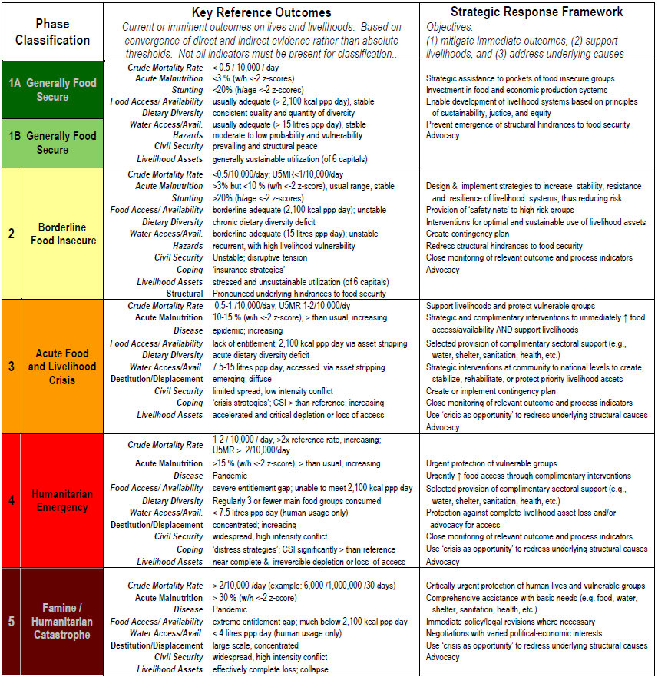
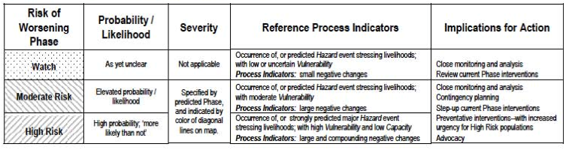
Annex 1b: Integrated phase classification tool map FSAU
POST Gu 2010, PROJECTION THROUGH December 2010
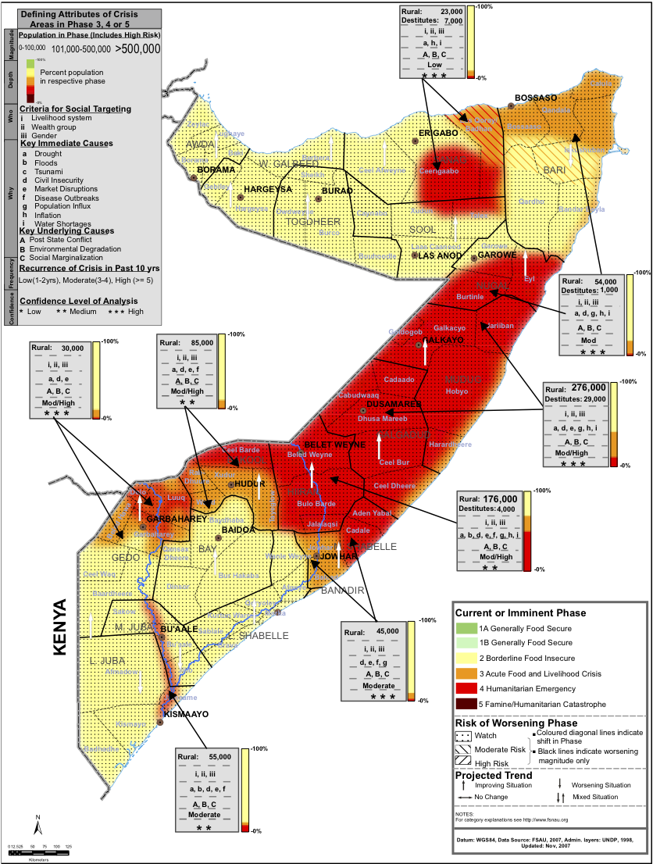

Annex 2: Estimated nutrition situation map FSAU

ESTIMATED NUTRITION SITUATION, SOMALIA, JULY 2010

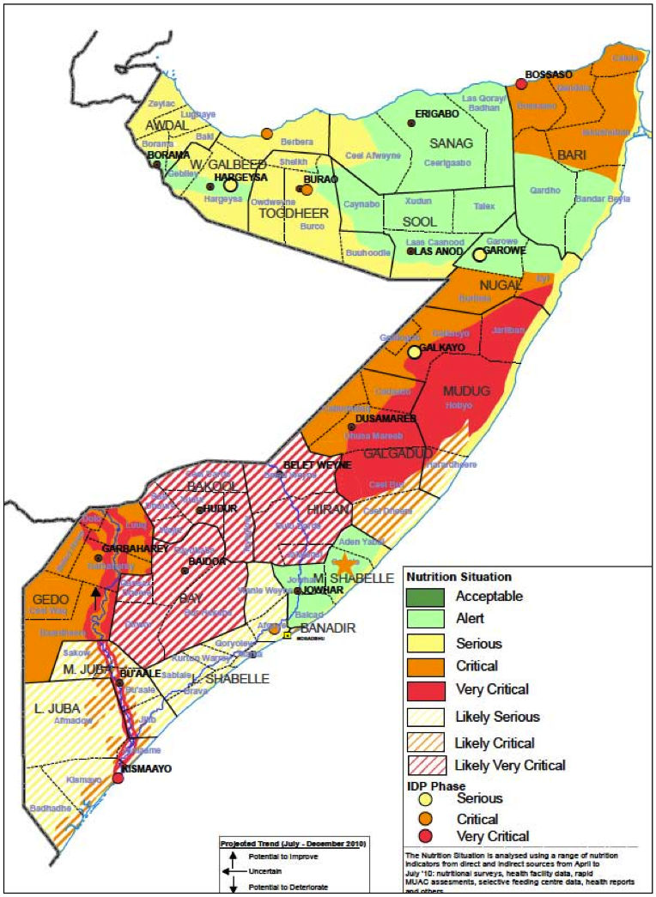
Annex 3: Location of nutrition sentinel site, Darfur, UNICEF

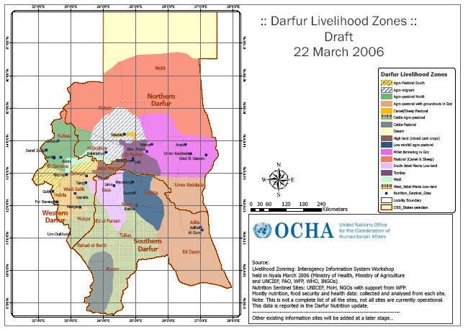

Annex 4: Indicators for Selective Feeding Centres

 | Indicators | Interpretation
Attendance | - Total number new admissions  - Total number of readmissions or relapse  - Total number discharged  - Total numbering the service or programme at the end of the month | Reflects size and expansion rate of the TFC/OTP/SFP.
Reasons for exit | - % Cured  - % Not responding  - % Died  - % Transferred  - % Defaulted | 1, 2, 3 and 4 reflect program quality.  5 reflect acceptability + accessibility.
Coverage | % children enrolled, out of the estimated number in the target group (e.g., moderately malnourished children under-five) | Reflects the acceptability + accessibility of the program.  (This information is generally collected during a nutrition survey, although this information is not sufficiently precise and the CI may include 0, thus estimated point prevalence is invalid), therefore not a good method. An improved method to estimate coverage of use of CTC is under development by Mark Myatt (see references in Part 4.
Mean weight gain | For recovered children | Reflects the quality of program
Mean length of stay | For recovered children | Reflects the quality of program

Reference values for Indicators (SPHERE 2004)
Indicators | TFC/OTP  Acceptable | SFP  Acceptable
Cured rate | > 75% | > 75%
Death rate | < 10% | < 3%
Defaulter rate | < 15% | < 15%
*Length of stay | < 4 weeks | < 8 weeks
*This has not yet been adapted for Community Management of Acute Malnutrition where the acceptable length of stay is recommended as < 2 months minimum.

Annex 5: Monitoring admissions in selective feeding centres, Darfur, UNICEF, 2005-2006

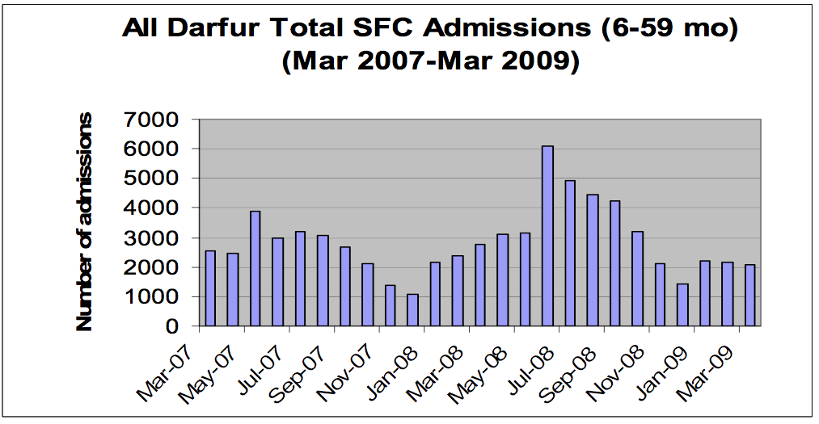

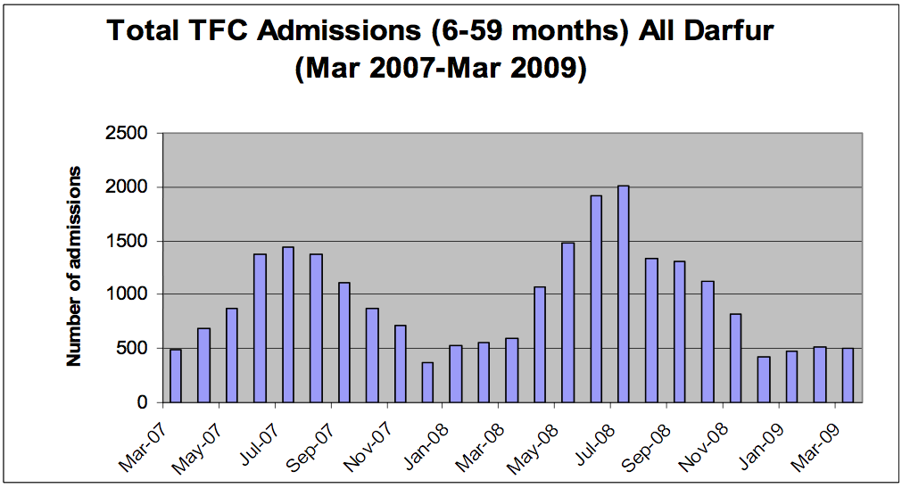

Annex 6: Nutrition data collection methods and role in emergencies
Method | Advantages | Disadvantages
Repeated small-scale surveys | - Provides representative point prevalence estimates of acute malnutrition  - If repeated, using the same method in the same population can provide accurate trends analysis of the evolution of the nutrition situation.  - Can provide understanding of the underlying causes of malnutrition when additional questions on public health care and food security are included  - Can provide information on immunization status, public health, social care environment  - Recognized as a reliable source of nutrition information  - Standard guidelines available  - Quality checks to monitor quality of data possible  - With the greater use of the ENA tool and SMART, more agencies are calculating the actual sample size required, which is often smaller than the traditional 900 children (based on the 30x30 surveys) and therefore save money and time. | - Costly  - Requires technical expertise  - Can take times to conduct in widely dispersed or insecure environments  - Requires access to population  - Data cannot be disaggregated further to identity at risk groups within the survey population.  - Community fatigue when repeated especially if no response is provided  - Requires a concerted funding commitment and skills base to maintain this approach
Repeated rapid assessments (qualitative and rapid exhaustive screening) | - Qualitative rapid assessments are quick, easy to get a snapshot picture of the nutrition situation.  - Can be conducted on a regular basis during an evolving situation  - Can be conducted in different livelihood groups to identify specific groups at risk  - Useful in insecure environments where access is limited  - Useful as a trigger to establish need for more detailed nutrition survey or response  - Can be linked with other activities such as vaccination campaigns, child health days, etc.  - Depending on selected indicators (WHZ < MUAC, oedema) can be used where there is limited capacity  - Initial rapid Assessment tool developed by nutrition cluster for qualitative assessment  - ACF have developed tools for exhaustive screening. | - Rarely representative with the exception of rapid exhaustive screening in vulnerable locations  - Often data not considered reliable and questioned  - No international guidelines available which agree on indicator, sample size, information to collect which can lead to data being questioned

Sentinel site surveillance (village/ community based) | - Useful for a chronically vulnerable population that requires close monitoring  - Sites can be selected to monitor specific livelihood groups.  - Useful for providing trend analysis over time  - Community can be involved in data collection.  - Useful in insecure environments where access is limited  - Useful as a trigger to establish need for more detailed nutrition survey or response  - Depending on selected indicators (WHZ/ MUAC) can be used where there is limited capacity  - Useful for monitoring other indicators such as disease outbreaks and market prices.  - Can be integrated into a longer term monitoring system | - Results do not provide reliable estimates of nutrition situation rather monitor trends.  - Often data not considered reliable and questioned  - Community fatigue especially if no response is forthcoming  - Quality of nutrition data can be a problem if supervision of data collection is not provided  - Although there are indicators available, the main problem arises when it comes to the analysis of trends. There are few reference criteria for the magnitude of deleterious trends in nutritional status and at what point a response should be initiated. Trend analysis also requires a certain degree of expertise and slightly more complicated sampling calculations than normal.  - Unless incentives provided for staff, community volunteer, etc., can be very difficult to sustain
Selective feeding programmes statistics monitoring | - Admission rates can provide useful information on the evolving nutrition situation as well as seasonal trends when admissions are highest.  - Provides useful information on most vulnerable groups (e.g. which age group are most affected and area of origin)  - Provides information of programme quality | - Rarely is representative of the area as highly dependent on access to beneficiaries  - Requires good quality programmes to provide reliable data which can be interpreted  - Requires a consistent reporting rate from programme centers otherwise trends can simply reflect changes in number of centres reporting data.  - Requires constant follow up and technical expertise to maintain data base and interpret figures
Health centre monitoring | - Useful for chronically vulnerable population who require close monitoring  - Sites can be selected to monitor specific livelihood groups.  - Useful for providing trends analysis over time  - Community can be involved in data collection.  - Useful in insecure environments where access is limited  - Useful source of information on health and vaccination data  - Can be integrated into a longer term monitoring system | - Rarely representatives of the area  - Incentives often required to motivate health centre staff  - Quality of data can be poor without supervision.  - Different indicators used by different agencies can cause confusion.  - Growth monitoring focused on weight-for-age indicator, which is harder to interpolate for use in emergencies  - Community and health centre staff can lose motivation if no appropriate referral centres are available for identified acutely malnourished cases.  - Delay in release of results due to logistical challenges of accessing health centre data  - Data collected often biased towards younger children 0-12 months of age who attend a clinic for vaccination  - Older children who attend are often sick therefore this can provide a biased picture of the nutritional status

Annex 7a. Sample of data collection tool for sentinel site surveillance – household questionnaire

Sentinel site surveillance
Household questionnaire - food, coping mechanisms, shelter, mortality
State: |  |  |  |  | Locality:
Date: |  |  |  |  | Team:
 |  |  |  |  | Camp/village:
Household No. |  |  | 1 | 2 | 3 | 4 | 5 |  |  |  | 6
Number of people in HH | Under 5
Number of people in HH | 5 and older
How many meals yesterday | For children (<5)
How many meals yesterday | For all others (>=5)
On how many days have your household members eaten these during the last 7 days? | Sorghum
 | Millet
 | Other cereals (wheat, maize, etc.)
 | Total cereals
 | Groundnuts, legumes
 | Meat, chicken, bush meat
 | Fish
 | Milk, yoghurt, cheese, etc.
 | Eggs
 | Total Proteins
 | Cooking Oil
 | Vegetables and fruits
 | Sugar
 | Wild foods (including leaves)
 | Others (specify)
Food Source | What were the main sources of food this month, in order of importance** Write the top 3
Coping Strategies | In the last 30 days, did you do any of the following?*** Include ALL that they did; if none, write -
Direct observation | Is the shelter suitable for the season? 1=good 2=medium 3=bad
Any deaths in the HH in last 30 days? | No
Any deaths in the HH in last 30 days? | Child under 5? (if more than 1, write number)
Any deaths in the HH in last 30 days? | Anyone 5 years or older? (if more than 1, write number)
Anything you would like to mention?

Annex 7b: Sample of data collection tool for sentinel site surveillance – child questionnaire

Sentinel site surveillance
Household questionnaire - child anthropometry & illness
State: |  |  |  |  | Locality: |  |  | Camp/village:
Date: |  |  |  |  | Team:
 | Household No | Child No | Children 6-59 months
 | Household No | Child No | Age  (months) Use local calendar | Sex (M/F) | Illness in last 2 weeks* | Oedema | MUAC (cm) i.e. 13.4 | Weight (kg) i.e. 11.3 | Height (cm) i.e. 103.7 | W/H% Use table
1
2
3
4
5
6
7
8
9
10
11
12
13
14

Annex 8: Ethiopian nutrition coordination unit, quality checks
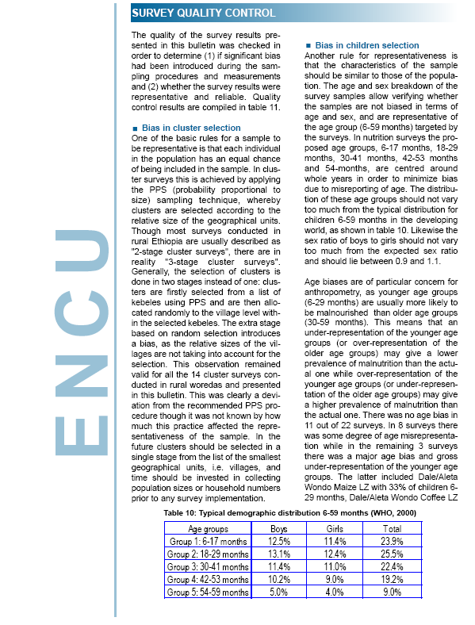

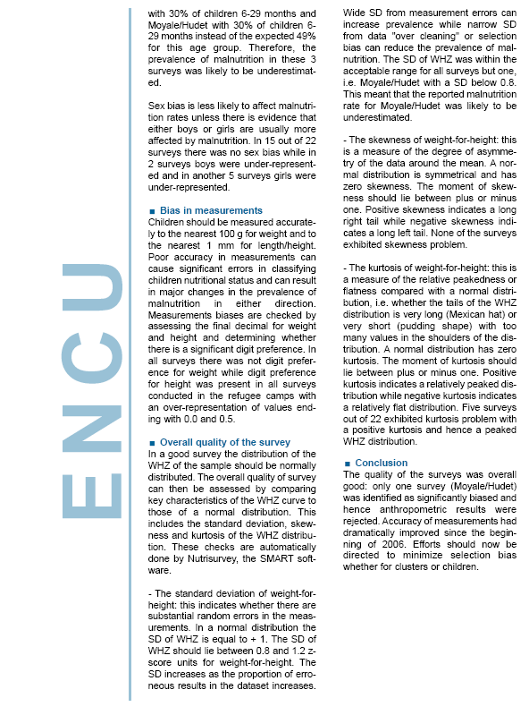
Annex 9: Examples of nutrition bulletins

Ethiopia, Quarterly Nutrition Bulletin,
ENCU/UNICEF

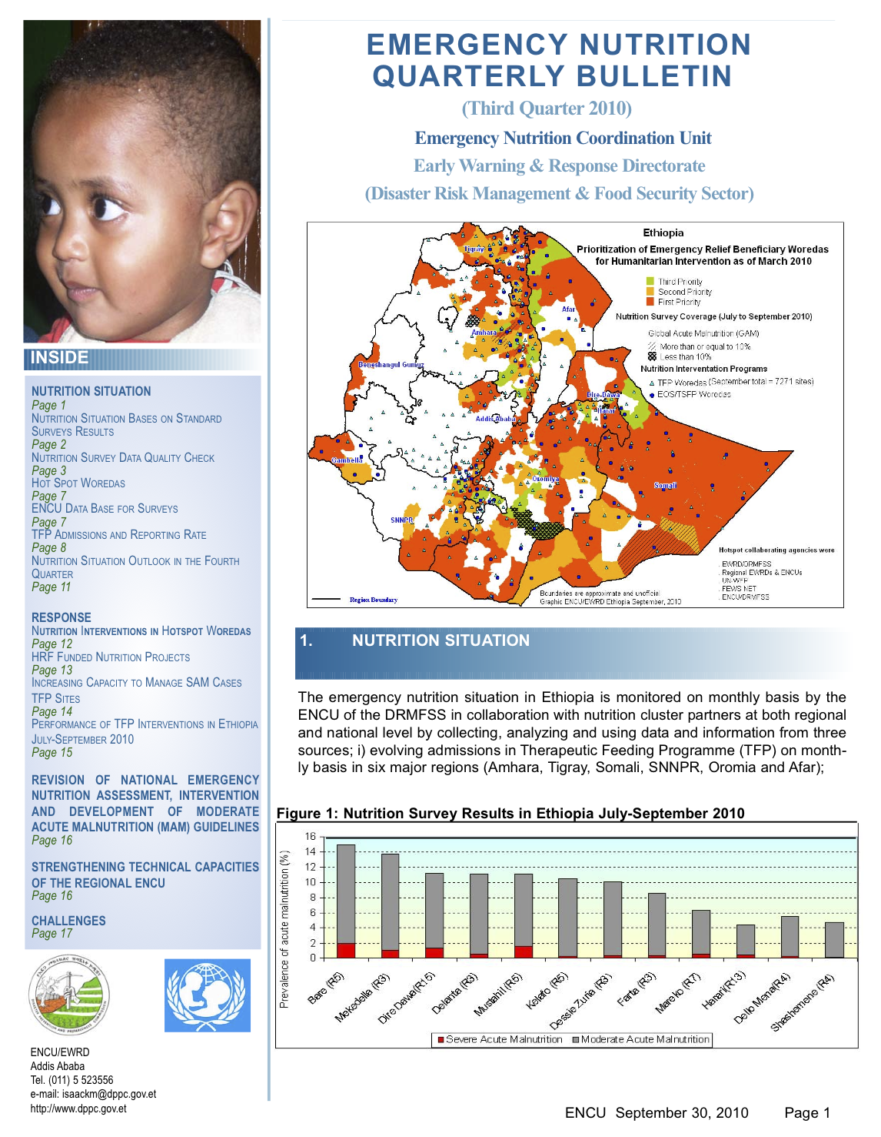
Malawi, Quarterly Nutrition Update, MoH/AAH
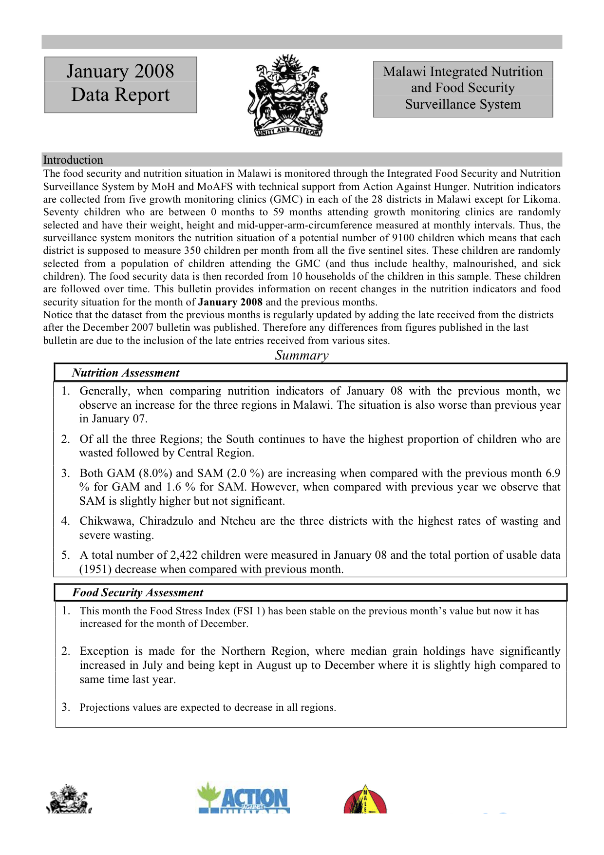

Darfur, Quarterly Nutrition Update, MoH/UNICEF
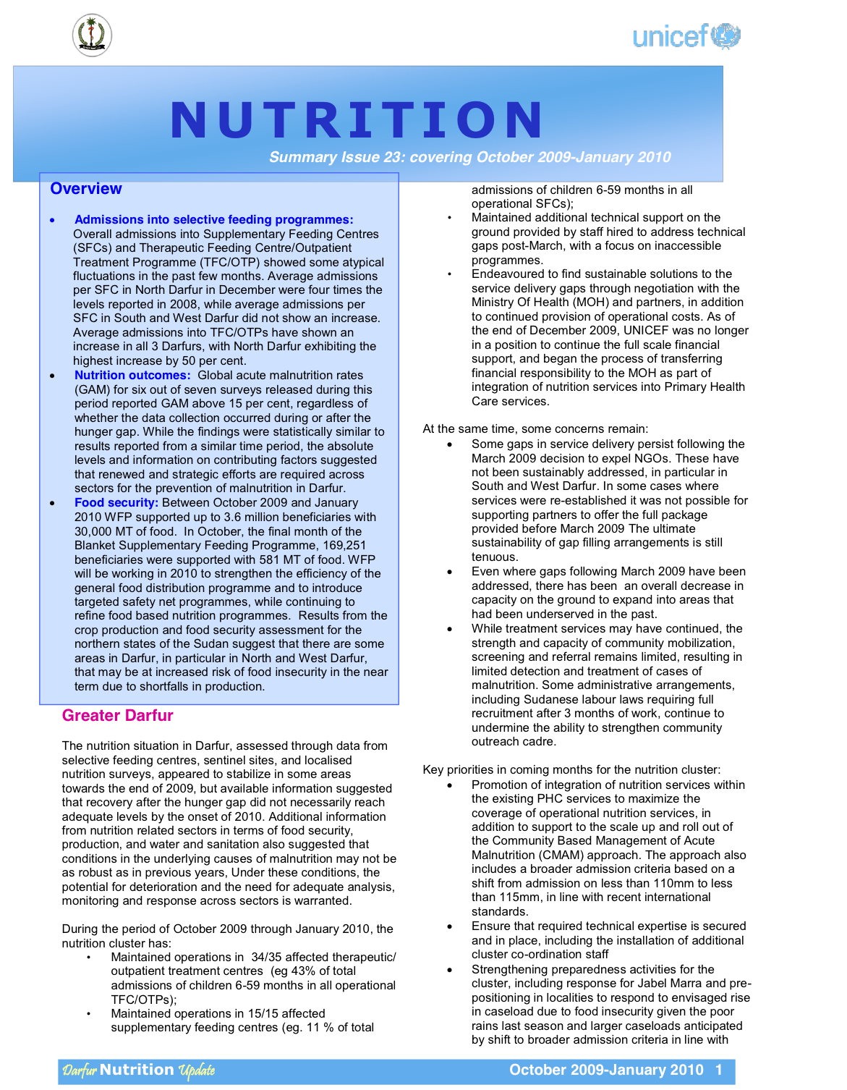

Somalia, Monthly Nutrition Update, FSAU

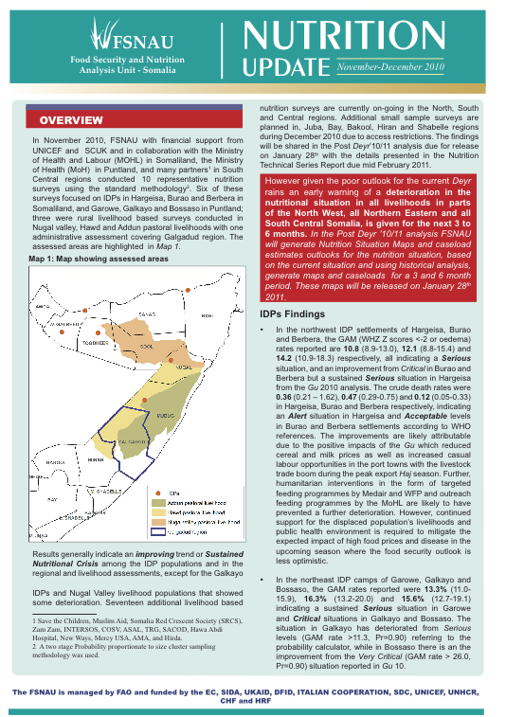

Tulane University School of Public Health and Tropical Medicine and the United Nations Children’s Fund, ‘Nutrition Information Project for the Horn of Africa Working Session Report’, Tulane University and UNICEF, New Orleans, 2007.
Mude A.G. et al. Empirical Forecasting of Slow-Onset Disasters for Improved Emergency Response: An Application to Kenya’s Arid Lands, ILRI, 2007.
De Matteis A. Market functioning in Turkana, Oxfam, 2006
Taylor A. Listening Posts project: a concept for a real-time surveillance system nested within a program. Mitigating the Nutritional Impacts of the Global Food Price Crisis: Workshop Summary, Institute of Medicine, 2009.
Joint statement by the World Health Organization, the World Food Programme and the United Nations Children’s Fund; Preventing and controlling micronutrient deficiencies in populations affected by an emergency, 2007
A Nutrition and Food Security Review: Protecting Nutritional Status And Saving Food Costs, TBBC, 2010
Arimond, M and Ruel, MT, Dietary Diversity Is Associated with Child Nutritional Status: Evidence from 11 Demographic and Health Surveys, Journal of Nutrition, 134, 2579–2585, 2004.
FAO Information for Action, “Report on the use of the Household Food Insecurity Access Scale and the Household Dietary Diversity Score in two survey rounds in Manica and Sofala Provinces, Mozambique, 2006-2007” www.foodsec.org, 2008.
Myatt, Mark, Preliminary description of a survey method to be developed by the Nutrition & Pastoralism Research Project, Nutrition Surveys in Pastoralist Populations, Draft, 2007.
A statistical term that refers to the symmetry of the population curve.
MapAction: Google Earth and its potential in the humanitarian sector: a briefing paper, April 2008.
Mason JB et al. Identifying priorities for emergency intervention from child wasting and mortality estimates in vulnerable areas of the Horn of Africa, Food and Nutrition Bulletin pp S234 – S246, 31, No.3, 2010.
http://www.cdc.gov/globalhealth/ierh/ResearchandSurvey/calculators.htm
SMART. Measuring mortality, nutritional status, and food security in crisis situations: SMART methodology. Version 1, April 2006, p 30. Available at: http://www.smartindicators.org/SMART_Methodol- ogy_08-07-2006.pdf.
http://www.dppc.gov.et/pages/ENCU.htm
De Matteis A. Market functioning in Turkana, Oxfam, 2006

