Section 1: Why IFE Matters

What is IFE?
What is an emergency?

- The vulnerability of infants and young children

2.0 Safe and appropriate infant and young child feeding in emergencies
2.1 Recommended infant and young child feeding practices
2.2 Supporting mothers to enable appropriate breastfeeding and complementary feeding practices: life saving interventions
2.3 The importance of breastfeeding (Why the fuss about breastfeeding?)
2.4 The importance of good complementary feeding

3.0 Summary points

Section 1 Why infant and young child feeding in emergencies (IFE) matters

What is IFE?

IFE concerns the protection and support of safe and appropriate feeding for infants and young children in all emergencies, wherever they happen in the world. The definition of safe and appropriate is based on international recommendations for infant and young child feeding.

IFE promotes emergency preparedness and a timely and appropriate humanitarian response in emergencies with the goal of safeguarding the survival, health and growth of infants and young children.

IFE is concerned with protecting and supporting breastfed and non-breastfed infants. In an emergency, breastfeeding is a lifeline – it is sterile, secure, instantly available, protects against illness and keeps an infant in the safest place: close to his/her mother. Breastfeeding is at the cornerstone of IFE due to the active protection it affords coupled with the nutrients and fluid it provides. But breastfeeding may not be available to all infants. IFE is also concerned with ensuring the resources needed by infants who cannot be breastfed are made available. This includes providing supplies, water, fuel, carer support and medical care, all of which are necessary to minimise the risks associated with artificial feeding in an emergency environment.

IFE is also concerned with the complementary feeding of infants over 6 months of age and also young children. Children over six months of age need safe, nutritious and acceptable foods in addition to sustained breastfeeding (or an acceptable breastmilk substitute) to meet their growing needs. See section 3.6.1)

Infants are children aged 0-<12 months of age. A young child is aged 1-2 years of age.

IFE as a focus for humanitarian concern is relatively new, having evolved over the past 10 years or so due to a growing recognition that the aid delivered to infants and young children was often not meeting their needs and might even be doing more harm than good [1, 2]. IFE encompasses a range of activities at different levels, from policy development to building capacity for one-to-one support of mothers. The acronym ‘IYCF’ is often used to describe ‘infant and young child feeding’ practices and is captured in ‘IFE’.

IFE is not just a nutritionist’s concern. IFE is about the feeding of infants and young children but it requires the participation of more than just nutritionists in the emergency effort. In fact, if only the nutrition sector is involved, implementation of the minimum-required IFE interventions is impossible. In an emergency, cross-sectoral responsibility and engagement – from water and sanitation, to camp management, to health, to food nutrition and livelihoods, to logistics, to child protection, to general coordination– is essential to meeting the broader nutritional needs of infants and young children. IFE should also be a concern to donors, the media, and the general public who through their actions, funding, donations, and press articles, can greatly impact the IFE response.

1.2 What is an emergency?
There are many different international definitions of an emergency. An emergency may be ‘acute,’ ‘chronic’ or ‘sudden’, and may have many causes and associated complexities. Simplistically, an emergency is an extraordinary/ urgent / sudden situation that puts the health and survival of a population at risk. The UNICEF/WHO Global Strategy on Infant and Young Child Feeding includes emergencies as one of the “exceptionally difficult circumstances” that puts an additional burden on the health of infants and young children.

The nature of an acute emergency
Emergencies often involve social disruption, population displacement, collapse of public health infrastructure, food and fuel shortages and lack of clean water and sanitation [3-5]. Completing basic survival activities can be difficult in emergencies and particularly so for mothers who are caring for children. Adding to this difficulty, mothers may have also lost family members who would normally assist them and may have an increased number of dependants [4]. Insecurity and lack of privacy may also compromise the capacity to care for children.

Emergencies can happen anywhere
Recent emergencies in China, Myanmar, Bangladesh, Mozambique, Haiti, Georgia, India, Peru and USA remind us that emergencies can affect any country, no matter its location or development status. Even in developed countries, artificially fed babies are at risk in an emergency. This was seen following Hurricane Katrina in the USA where many artificially fed babies lacked food and some died as a result [6, 7]. An emergency creates chaos and unpredictability in contexts that may previously have been well resourced and stable, or emergencies may hit high burden areas already chaotic and depleted in terms of capacity and resources. The severity of the consequences of an emergency to infants and young children will depend on a variety of factors, including the prevailing health and nutritional status, the resources available to the population, and the effectiveness of the humanitarian response. Each setting will have its own unique challenges but children under five years are always vulnerable.

Lessons: Opening scenarios
Case study from Cyclone Nargis, Myanmar: A mother suffering from trauma paralysis
Ma Gan is a new mother who survived cyclone Nargis. The storm tore the roof off the tiny brick house where the 22-year-old and her extended family live. Two days later, she gave birth. The baby is now two or three days old and Ma Gan, severely traumatised, has not touched the baby since her birth. Ma Gan's mother and the other women in the family who helped with the delivery are taking care of the infant. They are trying to keep her alive by giving her drops of water from a polluted canal. They believe that stress has prevented Ma Gan from making any breastmilk. The baby is growing weaker with time. (Photo to insert)

Reflect the following points in the Q&A of the Myanmar scenario;
High levels of stress are experienced by those affected by emergencies. This can make it difficult for mothers to care for their children. It is also commonly believed that stress can make milk dry up. This can result in babies being fed inappropriately and requests for breastmilk substitutes.

What could have helped Ma Gan and her infant?
Placing the infant on Ma Gan’s bare chest would have resulted in the release of hormones that reduce stress and promote mothering behaviours. This may have allowed Ma Gan to be pulled from her trauma sufficiently to be able to care for her infant. This would also allow the infant to breastfeed and since stress does not dry up milk the infant would have had food and water and every chance of survival. Even if Ma Gan could not care for the infant herself, her mother could have held the infant to her breast for her, allowing the infant to survive until they could get more help for Ma Gan. Note: that since the infant was only 2 or 3 days old it would not be expected that Ma Gan would have a lot of milk at this stage, the colostrum that she would have made though would have been more than sufficient for her infant.

1. The vulnerability of infants and young children

More than ten million children under the age of five years die each year, mostly from preventable causes and mostly in poor countries [8]. Generally the younger the children the more vulnerable they are. Nearly 70% of under five deaths occur in the first year of life and 38% of under one year deaths occur in the first month of life [9]. (Graph 1, Graph 2- Emergency examples, children under five years vulnerable and the younger the children the more vulnerable they are to death). Worldwide infections cause most under five mortality, and diarrhoea and pneumonia are the most significant infections causing death, accounting for about 20% each [8]. Malnutrition is an underlying cause to many of these deaths as shown in Graph 3.

Graph 1, Graph 2- Emergency examples, children under five years are vulnerable and the younger the children the more vulnerable they are to death

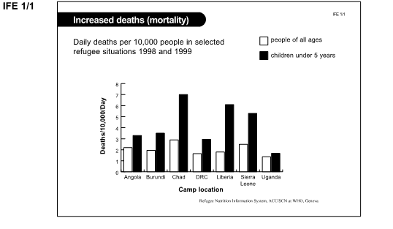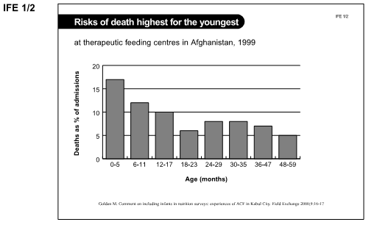

Graph 3. Causes of death in children under five years worldwide
SAM: Severe Acute Malnutrition

In emergencies the most common cause of death of infants and young children remains diarrhoeal disease and respiratory tract infections and again malnutrition is commonly associated with both illnesses [10-13]. However, although the causes of death remain the same as in non-emergency situations the mortality rates are often greatly elevated- up to 67 times higher than average [14]. A significant proportion of infants may be affected; published total mortality rates for children under a year of age in emergencies range from 12% to 53% [11-13].

Examples of vulnerability of young children in an emergency
In March 1991, 500 000 Kurds fled Iraq towards Turkey and were stranded in the mountains between the two countries. Despite a previously health population, prompt relief efforts and the fact that the acute phase of the emergency lasted only a few months there were high mortality rates. Two thirds of all deaths occurred in children under five years and half among children under a year. An estimated 12% of all infants died during the first two months of the crisis. Most deaths were due to diarrhoea, dehydration, and resulting malnutrition. [15]

Burmese refugees in Leda refugee camp, Bangladesh 1978-79- over a 10 month period it was estimated that 53% of children under one year and 30% of children between one and four years died. Primary cause of death, diarrhoea [12].

Conflict in the eastern Democratic Republic of Congo, 2001- under one year mortality an average of 26% over five regions. It was estimated that 75% of children in two of these regions had died before their second birthday. Deaths primarily due to malnutrition, febrile illness (thought to be malaria), respiratory disease and measles [11].

2. Safe and appropriate infant and young child feeding in emergencies
2.1 Recommended infant and young child feeding practices
The way an infant is fed has a large impact on their vulnerability to disease and death. Recommendations for infant and young child feeding practices that maximise health and minimise morbidity and mortality have been developed. They include:
Early initiation of breastfeeding: introducing breastfeeding within one hour of birth [16].
Exclusive breastfeeding: an infant receives only breastmilk for the first 6 months of life and no other liquids or solids, not even water, with the exception of necessary vitamins, mineral supplements or medicines [17].
Continued breastfeeding: sustaining breastfeeding to two years of age or beyond [18].
Complementary feeding: age-appropriate, adequate and safe solid or semi-solid food is provided in addition to breastmilk. The complementary feeding period is six months to two years[18]. Appropriate complementary foods are those that provide sufficient energy, protein and micronutrients to meet the child’s growing nutritional needs [18].

The recommended feeding practices are sometimes called ‘optimal infant and young child feeding’ however, use of the descriptor ‘optimal’ may suggest that these practices are an unattainable ideal. Increasingly research has identified that these practices, rather than being ideal, are central to the wellbeing of children. Thus, it is considered more useful to consider exclusive and continued breastfeeding and appropriate complementary feeding as the standard [19]. In an emergency context, these practices are referred to as ‘appropriate and safe’ rather than as ‘optimal.’

What about non-breastfed infants? Where breastfeeding is not possible, infants require a breastmilk substitute meeting Codex Alimentarius standards until breastfeeding is re-established or until at least six months of age. They also require some source of milk and/or animal source food during the complementary feeding period (6-24 months) [20]. The feeding of an appropriate breastmilk substitute, also called infant formula, is termed ‘artificial feeding.’

The recommended infant and young child feeding practices are accepted by health authorities worldwide but traditional cultural practices are often different from these recommendations. Feeding practices that diverge from recommendations are shown in Box 1.

Box 1: Feeding practices that diverge from recommendations
Delaying breastfeeding initiation for more than an hour after birth [21].
Feeding foods and liquids other than breastmilk to babies before they are six months of age [22-24]
Delaying the introduction of solid foods past six months of age [24]
Ceasing breastfeeding before about two years of age [25]

Where feeding recommendations are not followed there are negative repercussions for infant and young child health. For example, a study in Ghana found that infants for whom breastfeeding was delayed for more than 24 hours after birth were 2.4 times more likely to die during their first month of life. Delaying the initiation of breastfeeding accounted for 22% of deaths that occur in the first month of life [16]. Further, the risk of neonatal death was four times greater if milk-based fluids or solids were provided to breastfed infants less than four weeks of age [16].

Possible exercise
Considering recommended infant and young child feeding as the ‘safe and appropriate’ feeding practice, then what are the corresponding ‘risky practices’?

Box 2: Safe and risky infant feeding practices
Safe infant and young child feeding practices | Risky infant and young child feeding practices
Breastfeeding started within an hour of birth | Delaying breastfeeding after birth
Feeding infants under six months of age only breastmilk | Giving infants under six months of age any other food or liquid including water, infant formula or solid foods
Starting complementary feeding from six months of age | Starting complementary feeding before or after six months of age
Providing complementary food of sufficient quality and quantity to meet energy, protein and micronutrient needs | Providing complementary food of insufficient quality and/or quantity
Continuing breastfeeding up to two years or more | Stopping breastfeeding before about two years of age

2.2 Supporting mothers to enable appropriate breastfeeding and complementary feeding practices: life saving interventions
Infant and young child feeding interventions are life-savers for children under five years of age. Even in non-emergency situations, enabling the recommended infant feeding practices is by far the most effective intervention to prevent under five mortality (more effective than insecticide treated materials; water and sanitation programmes; measles, Hib or tetanus vaccination; zinc supplementation or clean delivery) [26]. It has been estimated that 13% deaths could be prevented in the under five age group through enabling exclusive and continued breastfeeding in the first year [26]. In addition, 6% of deaths could be prevented through improved complementary feeding [26]. Box 3 lists the top 10 interventions for preventing under 5 year deaths.

Box 3: Top 10 interventions for preventing under 5 year deaths
Preventative interventions | Proportion of under 5 deaths prevented
Breastfeeding | 13%
Insecticide treated materials | 7%
Complementary feeding | 6%
Zinc | 5%
Clean delivery | 4%
Hib vaccine | 4%
Water, sanitation, hygiene | 3%
Antenatal steroids | 3%
Newborn temperature management | 2%
Vitamin A | 2%
[26]

The younger the infant, the greater the risk of not following the recommended feeding practices
A pooled analysis of statistics from developing countries found that not being breastfed (artificial feeding) increases the risk of mortality by six times (a 500% increase) in infants less than two months old, and by 1.4 times (a 40% increase) in infants between nine and eleven months of age [27]. See Graph 4. In an emergency, the protection and risks associated with different feeding practices are magnified.

Addressing poor feeding practices in non-emergency times may be considered an emergency preparedness activity – the stronger the prevailing feeding practices and the more well nourished infants and young children are, the better their chances in an emergency. However, whether or not risky feeding practices existed before an emergency, or are a consequence of an emergency is irrelevant in determining action - emergency response needs to act to minimise the risks associated with prevailing practices. While poor pre-emergency infant and young child feeding practices add to the challenge of IFE, a strong intervention in an emergency can actually be a catalyst for improvement and change. For example, interventions around breastfeeding support in Indonesia post-earthquake have strengthened national programming on breastfeeding [28].

Graph 4 Risk of death in non-breastfed infants according to age

2.3 The importance of breastfeeding (Why the fuss about breastfeeding?)
The reason why protecting breastfeeding is so important to the health and wellbeing of infants lies in the nutritional and immune support it provides and in non-nutritional aspects of breastfeeding that assist mothers in caregiving. Breastfeeding is important to the child, mother, family and the community and there are costs and risks attached to artificial feeding as shown in Tables 1, 2, 3 and 4. The importance of breastfeeding and the costs of artificial feeding are magnified in emergencies.

Importance of Breastfeeding for the Infant/Young Child
- Breastfeeding is essential to the normal health, growth and development of infants
- Breastmilk contains antibodies and many other ingredients that actively and passively protect against diseases, especially against diarrhoea and respiratory infections.
- Breastmilk is a whole food for the infant, contains balanced proportions and sufficient quantity of all the needed nutrients for the first 6 months of life.
- Breastmilk is a safe source of water (the only safe source of water for infants under 6 months of age).
- Breastmilk helps the infant’s immune system to mature
- Breastfeeding helps jaw and teeth development; suckling develops facial muscles.
- The skin-to-skin contact associated with breastfeeding stabilises the newborn’s respiration rate, heart rate and temperature which is especially important in low birth weight or premature babies.
- Breastfeeding provides comfort and relief from stress and pain to the child.
Costs of Artificial Feeding for the Infant/Young Child
- Infant formula lacks the ingredients in breastmilk that protect infants from illness. This makes it easier for artificially fed infants to become seriously ill and makes it more difficult for them to recover from illness when they do become ill. Artificially fed infants are at a greater risk of death.
- Infant formula contains ingredients that damage the lining of the intestine and encourage the growth of pathogenic bacteria. This makes it easier for artificially fed infants to become infected with diarrhoea-causing pathogens. A single exposure to infant formula can increase susceptibility to illness for several weeks.
- Water used to make infant formula can be contaminated with disease causing organisms, exposing artificially fed infants to disease.
- Artificial feeding delays the maturation of the immune system and makes infants more vulnerable to illness for longer.
- An increased risk of diarrhoea increases the risk of malnutrition and stunting
- Artificially fed infants receive less touch and care from their mother
- It is the combination of deficiencies in the composition of infant formula and reduced maternal interaction that is thought to lead to the decreased IQ seen in artificially fed infants

Importance of Breastfeeding for the Mother
- Breastfeeding is more than 98% effective as a contraceptive method during the first 6 months after birth provided that breastfeeding is exclusive and amenorrhea persists.
- Putting the baby to the breast immediately after birth stimulates uterine contractions which facilitates the expulsion of placenta and helps to control bleeding.
- Breastfeeding provides mothers with all the food and water that their baby needs from immediately after birth to 6 months of age. After 6 months breastfeeding still provides a substantial proportion of food and drink for the child. This is food that mothers do not need to buy or prepare.
- Breast milk is available at anytime and anywhere, is always clean, nutritious and at the right temperature.
- Breastfeeding is reliable and even when circumstances suddenly change for the worse. For example if there is an emergency of some kind, a breastfeeding mother is still able to nourish her child.
- Hormones released during breastfeeding reduce mother’s stress levels and help her to care for her baby

Costs of Artificial Feeding for the Mother
- Women who do not breastfeed are at increased risk of excessive bleeding and death as a result of bleeding after birth. They also experience an early return to menstruation and fertility and are therefore at risk of anaemia and maternal depletion.
- Mothers who do not breastfeed have an increased risk of suffering from breast and ovarian cancers, type 2 diabetes, hip fracture and heart attack.
- Artificial feeding is time consuming and difficult to do. Substantial effort is required to boil water, gather fuel, prepare milk and clean feeding implements as well as to care for a sick baby. This takes time away from other activities that mothers need or want to do.
- The absence of breastfeeding hormones makes it more difficult for a mother to care for her baby and increases her stress levels.

Importance of Breastfeeding for the Family
- Breastfeeding means that a family’s economic circumstances need not impact the quality of food that their baby receives. There is no better food than breastmilk for a baby and it is available to even the poorest family.
- Breastfeeding is central to the health and wellbeing of both mothers and children and therefore is important to the family as a whole.

Costs of Artificial Feeding for the Family
- Infant formula and the other resources required to artificially feed are expensive and take resources away from the other needs and wants of the family.
- Medical costs associated with increased illness in artificially fed babies can be a significant financial burden on families.
- Closely spaced births occurring because of a premature return fertility reduce the ability of parents to care for all their children and even place children in the family at an increased risk of death.

Importance of Breastfeeding for the Community
- High rates of breastfeeding in a community underpin the health and wellbeing of mothers and children in the community. This supports the security, happiness and productivity of the community.
- High rates of breastfeeding mean that scarce health resources can be allocated to unavoidable illness rather than to the unnecessary illness which results from artificial feeding.
- Long term- healthy babies grow into healthy, smart children and adults who can benefit the community.

Costs of Artificial Feeding for the Community
- High rates of artificial feeding mean high rates of child morbidity and sometimes mortality. This places a burden on the health system. It is also of significant emotional cost to the community in the worry and grief experienced by community members when a woman or a child in the community is sick or dies.
- Since artificial feeding decreases IQ, a community loses some of its potential for achievement, creativity and productivity when there are high rates of artificial feeding.
- Artificial feeding can harm the environment. For example, firewood used to boil water to make up infant formula may be taken from trees in the community resulting in increased erosion.

Nutritional and immunological value of breastmilk
Breastmilk is an incredibly complex fluid that enables the normal health, growth and development of infants and young children [19]. Breastmilk contains all of the nutrients needed by infants in a highly bioavailable form, in balanced proportions and of sufficient quantity to enable healthy growth [29]. Factors in breastmilk aid the digestion and uptake of these nutrients [29]. Breastfeeding provides a safe source of water and for infants under six months it is the only safe source of water [22]. Breastfeeding provides food security to the infant as the milk is produced in proportion to the child’s need [30]. In an emergency situation, breastmilk is an aid worker’s dream ration because it is a complete food that meets all the nutritional needs of the recipient, is safe and reliable.

Infants are born with an immature immune system but breastmilk actively and passively protects them from infections [29, 31]. Ingredients in breastmilk bind to and neutralise pathogens [29, 32, 33], attack and kill pathogens [34], deprive pathogens of nutrients [35] and encourage the growth and maturation of the protective lining of the intestine [31]. The digestion of breast milk releases anti-bacterial, anti-viral, anti-protozoal and anti-parasitic factors [19, 36]. Breastmilk promotes the growth of beneficial bacteria in the intestine which out-compete pathogenic bacteria for infection sites and nutrients [37], inhibit the growth of pathogens [38, 39] and encourage the growth of the protective mucous layer in the intestine [40]. In emergency situations, where hygiene is usually poor and medical care often unavailable the protection that breastmilk provides to infants and young children is critically important.

Importance of breastfeeding for the health of mothers
Immediate, exclusive and continued breastfeeding helps to protect mothers from morbidity and mortality due to post-partum haemorrhage, anaemia and maternal depletion [41-43]. This protection is vital in emergency situations where medical care for post-partum haemorrhage may be difficult to obtain and where food insecurity heightens the risk of anaemia and maternal depletion. Breastfeeding aids child spacing and is more than 98% effective as a contraceptive method during the first six months after birth provided that breastfeeding is exclusive and amenorrhea persists [42]. Breastfeeding also reduces the risk of mothers developing breast and ovarian cancers, hip fracture, type 2 diabetes, rheumatoid arthritis, and heart attack [44-49] .

Trauma and breastfeeding
Breastfeeding has a role in assisting mothers and children to deal with the stressful circumstances associated with an emergency. Breastfeeding releases relaxant hormones which help to calm mothers and reduce their stress levels [50-52]. This helps them to be able to care for their infants [53-55]. Neither breastmilk production nor quality is adversely impacted by stress or moderate malnutrition [56, 57].

Breastfeeding can help children who may be injured, unwell or otherwise distressed to cope in an emergency. Breastfeeding releases hormones and other chemicals in the brain that block pain and reduce stress [52, 58-60]. Children who are stressed will often want to breastfeed more frequently than usual [60]. This is a good thing for mothers’ milk supply but it also underlines the importance of facilitating conditions that keep mothers and their infants and young children together.

Importance of skin-to-skin
Skin-to-skin contact is both a part of breastfeeding and facilitates breastfeeding. Skin-to-skin contact is the basis of an important intervention called Kangaroo care with newborns (especially premature infants) to both help them regulate their temperature, heart and respiration rates and to establish and maintain breastfeeding [61-63] [64]. Placing babies in maternal skin-to-skin contact is a low tech, simple way of stabilising fragile infants and increasing survival and is an easy way of enabling breastfeeding [65].

Role of breastfeeding in infant HIV-free survival
There is a risk that HIV can be transmitted via breastfeeding. However, artificial feeding (which is called replacement feeding where a mother is artificially feeding because she is HIV positive) also carries risks. The risk of transmission of HIV via breastfeeding, and the associated morbidity and mortality, needs to be weighed against the risks of not breastfeeding for an individual mother/infant pair. The key measure in assessing infant feeding options is the probability of HIV-free survival for the infant. In emergency contexts artificial feeding is unlikely to be an ‘acceptable, feasible, affordable, sustainable and safe (AFASS)’ option. Avoidance or early cessation of breastfeeding in children of HIV positive mothers in poor contexts has been associated with increased morbidity, especially from diarrhoea [66, 67]. In addition, the risk of HIV transmission through breastfeeding is as low as 4% in infants who are exclusive breastfed for 6 months. Giving other foods or liquids as well as breast milk (mixed feeding) carries a heightened risk of HIV transmission via breastmilk in young infants [66, 68].

If the HIV status of individual mother is unknown – where there is no voluntary and confidential counselling and testing (VCCT) available – or the mother is HIV positive and AFASS conditions are not in place for replacement feeding, then the safest and most appropriate feeding options for HIV-free survival are exclusive breastfeeding for six months followed by continued breastfeeding after the introduction of appropriate complementary foods, just as for the general population [69].

Case study: Role of breastfeeding in infant HIV-free survival [70]
This study reflects the risks of artificial feeding in the context of HIV, the need to weigh up risks, and the vulnerability of HIV infected infants. It shows the protection that breastfeeding affords to infants of HIV infected mothers, and especially to HIV infected infants.

A study of the survival of infants (n=182) born to HIV infected mothers according to feeding mode was carried out in rural Uganda in 2008.

Some of the key findings were:
- The cumulative 12 month probability of mortality was 18% in artificially fed infants compared to 3% in breastfed infants (adjusted for maternal age and use of antiretroviral therapy - ART).

-There was no statistically significant difference in HIV-free survival between breastfed and non-breastfed infants despite the fact that most infants were mixed fed. Only 25% of infants were exclusively breastfed at one month of age, and 18% at six months of age and had exclusive breastfeeding been achieved for more infants that HIV-free survival would have been higher in the breastfed group.

The survival of HIV–infected infants was severely compromised by artificial feeding. All 3/69 artificially fed infants who tested HIV positive at one month of age had died by 1 year of age but all 12/92 breastfed HIV infected infants were alive at 1 year.

For more detailed information on HIV transmission and infant feeding, see Section 3 (technical interventions).

2.3 The risks of artificial feeding
Graph 5. Dangers of artificial feeding

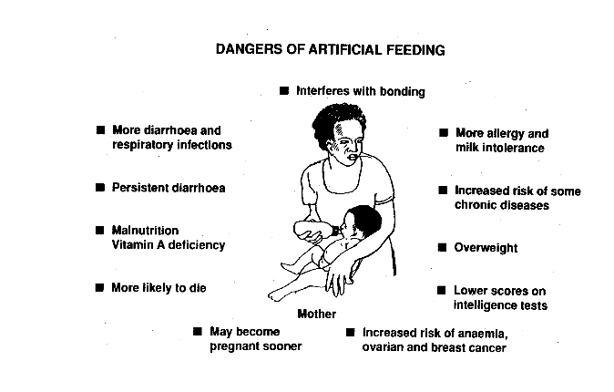

Source of graph: Breastfeeding counselling: a training course. WHO/CDR/93.5
UNICEF/NUT/93. Part 1.

In some populations, a large proportion of infants may be artificially fed. In other populations, poorly managed aid increases the rates of artificial feeding. Artificial feeding carries an increased risk of morbidity and mortality for infants.

Examples of risk: artificially fed infants are at heightened risk regardless of the context but the magnitude of the risk is greatest where living conditions are poor

In a middle class area of Spain, artificially fed infants were five times more likely to be hospitalised with infections in their first year of life as compared to infants that were fully breastfed for four months [71].

In the USA, children who were never breastfed were 61% more likely to die in infancy than children who were breastfed for three months [72].

In poor areas of Brazil, artificially fed infants under three months of age were 61 times more likely to require hospitalisation for pneumonia than infants that were not consuming any breastmilk substitute [73]

In Basrah city, Iraq, artificially fed infants under two months were 55 times more likely to be hospitalised with diarrhoea than exclusively breastfed infants [74].

In Lahore, Pakistan, artificially fed infants under one month were 21 times more likely to die than infants that were breastfeeding despite the fact that most infants were mixed fed [75, 76].

There are a number of reasons why artificial feeding increases infant vulnerability:
- Breastmilk substitutes do not have the protective properties of breastmilk
Artificial feeding deprives infants of the disease prevention and fighting action of breastmilk and retards the development of the immune system [31]. Without the external immune support provided by breastmilk, infants are effectively immuno-compromised [29].

- Artificial feeding actively makes babies more vulnerable to infection.
The use of breastmilk substitutes (and the early introduction of solid foods) damages the protective mucous barrier in the small intestine [77, 78] and delays the maturation of the intestine [79] making it easier for pathogens to colonise the infant [34, 80]. Consumption of breastmilk substitutes also creates an environment that retards the growth of beneficial bacteria that protect from infection while encouraging the growth of pathogenic bacteria [39, 81]

- Methods of providing artificial feeding have risks
Even where clean water and refrigeration are available, feeding bottles and teats harbour unacceptably high levels of bacterial contamination a [82-86] which thorough cleaning may not eliminate [85].

- Infant formula is not sterile
Powdered infant formula is not sterile. As well as the risk of external contamination of infant formula, there is also the risk of infection with micro-organisms that are commonly present in powdered infant formula. Infants that are newborns, malnourished infants or HIV positive are at greatest risk [87]. See section 3 and also Section 9.15 Module 2.

- Artificial feeding increases dependency on external support.
Artificial feeding relies on a safe, secure water source, on fuel for hygiene and to boil water for preparation of feeds, and on safe storage facilities. This increases the infants’ and mothers’ dependency on external conditions which are subject to change. See section 3 and Module 2

An emergency heightens the risks associated with artificial feeding. For example:
- Artificial feeding risks exposing infants to contaminated water, a particularly large risk in emergencies [88]. Earthquakes can rupture sewage pipes resulting in the flow of sewage into water supplies. Storms, tsunamis and flooding similarly can wash human and animal faecal material into water supplies [89]. In addition, when large numbers of people are homeless, sanitary services may be makeshift and inadequate which creates an environment where water supplies are easily contaminated. It’s important to note that while contaminated water increases the risk of artificial feeding, clean water is by no means a guarantee of safety because of the inherent risks associated with artificial feeding

- Lack of food security is a significant risk factor associated with the use of breastmilk substitutes in emergency situations. Continuity of supply of breastmilk substitutes cannot always be guaranteed, and the emergency itself may disrupt supply. If breastmilk substitutes are not available, then even poorer foods may be substituted leading to malnutrition [90]. Malnourished babies are vulnerable to infection and death [91].

- In an emergency environment where sanitation is often poor, the risk of bacterial contamination of feeding implements are increased.

- The availability of medical care can be compromised in an emergency. This means that obtaining treatment for sickness resulting from artificial feeding can be difficult and increase the probability of such illness being fatal.

All of these factors mean that artificial-fed infants are an especially vulnerable group in emergencies.
Artificially-fed infants are more likely to become infected with pathogens, more likely to be malnourished and thus more likely to suffer from multiple bouts of more serious illness and eventually die than breastfed babies.[90]

CASE STUDY reflecting the vulnerability of artificially fed infants in an emergency:
An example of the vulnerability of artificially fed infants comes from Botswana in 2006/07. This reflects a context where a large proportion of infants were artificially fed – in this instance, replacement fed in the context of prevention of mother to child transmission of HIV. The findings of this investigation also show how unsafe feeding practices contribute to severe acute malnutrition, morbidity and death.
Between November 2005 and February 2006, there were unusually heavy rains and flooding in Botswana. By February, a large number of cases of diarrhoea in infants and young children were overwhelming hospitals throughout the country. In the first quarter of 2006, in just 12 health districts, there were 22,500 cases of diarrhoea, with 470 deaths in children under five (compared to 9,166 cases and 21 deaths for the entire country in the first quarter of 2005).
The Ministry of Health (MOH) had difficulties identifying the reason for the outbreak. Assistance from the US Centres for Disease Control (CDC) was sought. The CDC found that the public water supply, which had long been considered safe, was in fact contaminated with diarrhoea causing organisms in 26 villages tested. A variety of pathogens were identified, including cryptosporidium, enteropathogenic e-coli (the classic 'bottle diarrhoea' pathogen) and salmonella.
The CDC conducted an evaluation of children visiting hospital emergency rooms for treatment for diarrhoea. They identified a variety of risk factors the most significant of which was how the infant was fed – an infant who was not breastfed was 50 times more likely to present for treatment for diarrhoea than an infant who was breastfeeding at all (ie including mixed fed infants), as shown in Table 5 [92].
Table 5 : Risk factors for diarrhoea in Botswana flood
Characteristic | Odds Ratio | 95% CI
Not breastfeeding | 50.0 | 4.5-100
Storing drinking water | 3.7 | 1.5-9.1
Caregivers not washing hands | 2.5 | 1.1-5.0
Overflowing latrines | 3.0 | 1.1- 8.6
Standing water near home | 2.6 | 1.1-6.3
[92]
An inpatient hospital cohort of 154 of the most seriously affected infants was also examined. It was found that most (96%) of the children admitted were under two years of age (median age 9 months) and the majority (90%) were not breastfeeding at all. The investigation also found that:
- Among the hospitalised children, 18% were HIV infected.
- Many developed severe acute malnutrition during or after diarrhoea - 42% developed marasmus and 20% developed kwashiorkor.
- Twenty-one per cent of the children admitted died (32/154). Of the children who died 32 were completely artificially fed, and one child was fed breastmilk, infant formula and cows milk [93]. No exclusively breastfed infants died in this hospital cohort [93]. HIV status (maternal or infant), socio-economic status, water source, urban versus rural residence and pathogen were not associated with the risk of death.
Feeding even a little breastmilk substitute carries risks
Even supplementation with a small amount of breastmilk substitute can be problematic and increase the risk of illness. Use of a small amount of breastmilk substitute can still introduce pathogens via contaminated water. It also alters the bacterial composition of the intestine so that it has few beneficial bacteria and a greater population of potentially pathogenic bacteria like fully artificially-fed infants. It may take several weeks of exclusive breastfeeding for the bacterial composition to revert back to the pre-supplementation state [94, 95]. A small amount of breastmilk substitute can also damage the protective mucous layer in the intestine making the infant more vulnerable to infection [78]. The reason why the infants of HIV positive mothers who are mixed fed are at a heightened risk of contracting HIV as compared to exclusively breastfed babies is thought to be due to the damage caused to the intestine by the introduction of non-human milk or solid food [78].

Harmful aid
Harmful aid in the form of the poorly targeted distribution of breastmilk substitutes is a common problem in emergencies [1, 96-99]. The poorly targeted distribution of breastmilk substitutes exposes both breastfed and non-breastfed infants to increased risks. Such distributions result in an increased likelihood of breastfed infants being unnecessarily exposed to the risks of artificial feeding [100, 101]. They are also not accompanied by support to reduce the risks of artificial feeding for non-breastfed infants such as fuel for boiling water, educational support for caregivers and medical care. Continuity of supply for non-breastfed infants is similarly often not considered in poorly targeted distributions. Supporting the well being of and avoiding harm to both breastfed and non-breastfed infants in emergencies requires a coordinated and evidence-based aid response.

See lesson on donations for detailed exploration into the problems of untargeted distributions, the evidence of harm and how donations in emergencies significantly contribute to this problem.

2.4 The importance of good complementary feeding
Inappropriate complementary feeding also contributes to poor health and increased risk of death in infants and young children [26] The timing of introduction and the type and amount of complementary foods are both important. Early introduction of complementary foods and liquids (before six months of age) increases the risk of illness in babies. This is because it replaces breastmilk, adversely alters the intestinal environment and introduces a possible source of infection [102-105]. Feeding babies foods or liquids other than breastmilk before six months of age can also result in a premature return to menstruation and fertility in mothers with the associated risks to her and her infant’s health [42]. Delayed introduction of complementary foods is also a problem. It can cause slowed growth, nutrient deficiencies (particularly iron) and a resultant increased vulnerability to infection [24]. An inadequate amount or low nutrient density of complementary foods can result in growth retardation and nutrient deficiencies that make a child vulnerable to infection [106, 107]. However, complementary foods should add to the breastfed infants diet and not replace breastmilk [108]; breastmilk should remain the main food for infants during most of the first year of life [108].

Breastmilk continues to supply about half of the energy needs of a child from 6 – 11 months

Breastmilk continues to supply 30-40% of the energy needs of a child from 12 – 23 months [93]

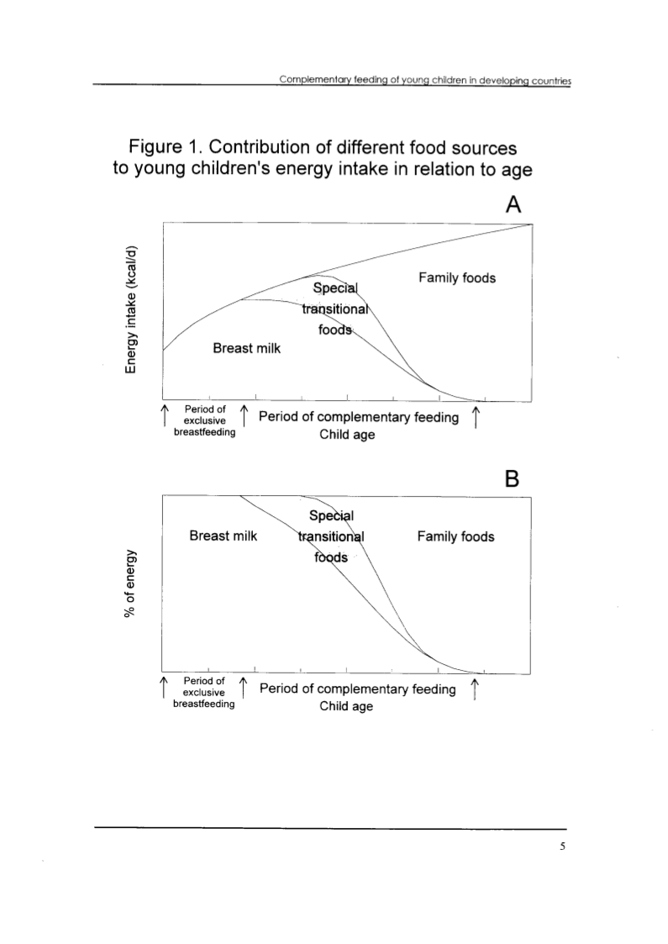
[109]

This is reflected in Graph 1, above, which shows how breastmilk significantly contributes to the energy intake of children during the entire complementary feeding period.

Where complementary foods displace breastmilk inappropriately, children are placed at risk of nutrient deficiencies and infections [110]. Children who stop breastfeeding earlier than two years have a higher morbidity and mortality than children who continue to be breastfed [111-113].

Complementary feeding is not just about the provision of nutritious food in order to meet nutrient requirements. Regarding the food, other considerations are the frequency, amount, texture (consistency), variety and hygiene [109]. As reflected above, breastmilk continues to be a key fluid and nutrient source during the complementary feeding period. So protecting and supporting sustained breastfeeding in children 6-24 months of age or beyond is an important aspect of complementary feeding that sometimes can get forgotten in the pursuit of food-based nutrition- sometimes it is forgotten that breastmilk is a food.

Table 6 The five requirements for good complementary feeding
Complementary Feeding Requirements
1. Right time | From six months
2. Right type | Energy dense, micronutrient rich
3. Right amount | Sufficient to meet growing needs of the child, increasing with age
4. Provided in the right way | Hygienically prepared, fed with clean feeding implements- not using a bottle
5. While breastfeeding continues | For up to two years or more

4 Summary points
There are global recommendations for safe and appropriate infant and young child feeding practices that apply in emergencies. They involve early initiation of breastfeeding, exclusive breastfeeding for six months followed by the introduction of complementary foods and continued breastfeeding. Supporting these practices in emergencies is essential to minimising child morbidity and mortality in emergencies and reducing the risk of malnutrition.

Artificial feeding carries risks that are heightened in emergency contexts. This means artificially fed infants are especially vulnerable in emergencies and require special support. Untargeted distribution of breastmilk substitutes exposes both breastfed and non-breastfed infants to increased risk of malnutrition, morbidity and mortality.

The decisions that mothers make about how to feed their infants are made against in the context of what is the usual practice in a particular location. In any emergency context these practices must be considered in how aid is provided. The consequences of inappropriate infant and young child practices are greatest in the most resource poor contexts. In an emergency, the protection and risks associated with different feeding practices are magnified. The need is to maximise protection and minimise risk in the context of prevailing practices.

Ensuring that aid does not undermine good infant and young child feeding practice but supports it requires multi-sectorial cooperation and is the role of everyone involved in emergency response:
Those “involved in response and recovery work, have an obligation to protect all people from the avoidable consequences of disasters and from further harm, discrimination, and rights violations [114].”
The aim of IFE is to implement this obligation to infants and young children and their families.

Mixed feeding was associated with >100% increased risk of transmission of HIV compared to exclusive breastfeeding for six months in three large cohort studies conducted in Côte d’Ivoire, South Africa and Zimbabwe. Evidence presented at WHO Technical Consultation. HIV and Infant Feeding New evidence and programmatic experience. Report of a Technical Consultation, Geneva, Switzerland, 25–27 October 2006. Held on behalf of the Inter-agency Task Team (IATT) on Prevention of HIV Infections in Pregnant Women, Mothers and their Infants. WHO, 2007.

