MODULE 5
Causes of Malnutrition

PART 1: FACT SHEET

This Fact Sheet is part one of four parts in this module. It provides a summary of key information relating to the causes of malnutrition for decision-makers, such as managers and policy-makers. It is not intended to give detailed technical information as this is provided in parts two and three. Words in italics can be found in the glossary.

Introduction
Figure 1 shows a conceptual model developed to help understand the causes of malnutrition. The model identifies three levels of causality:
- Immediate causes that act on the individual.
- Underlying causes that act at the household level.
- Basic causes that act on entire societies but have a greater or lesser impact on specific
groups within society.
The conceptual model captures some of the elements that influence nutritional status at different levels - immediate, underlying and basic - illustrating that it is not just an issue of food, health, or care. The model promotes a broader understanding of factors that affect nutritional status and encourages agencies to look beyond the food needs of people. Factors that affect nutrition at all levels need to be assessed during emergencies to identify and prioritise needs and gaps in services for vulnerable groups and for the general population.
Figure 1: A simplified conceptual model for understanding the causes of malnutrition.
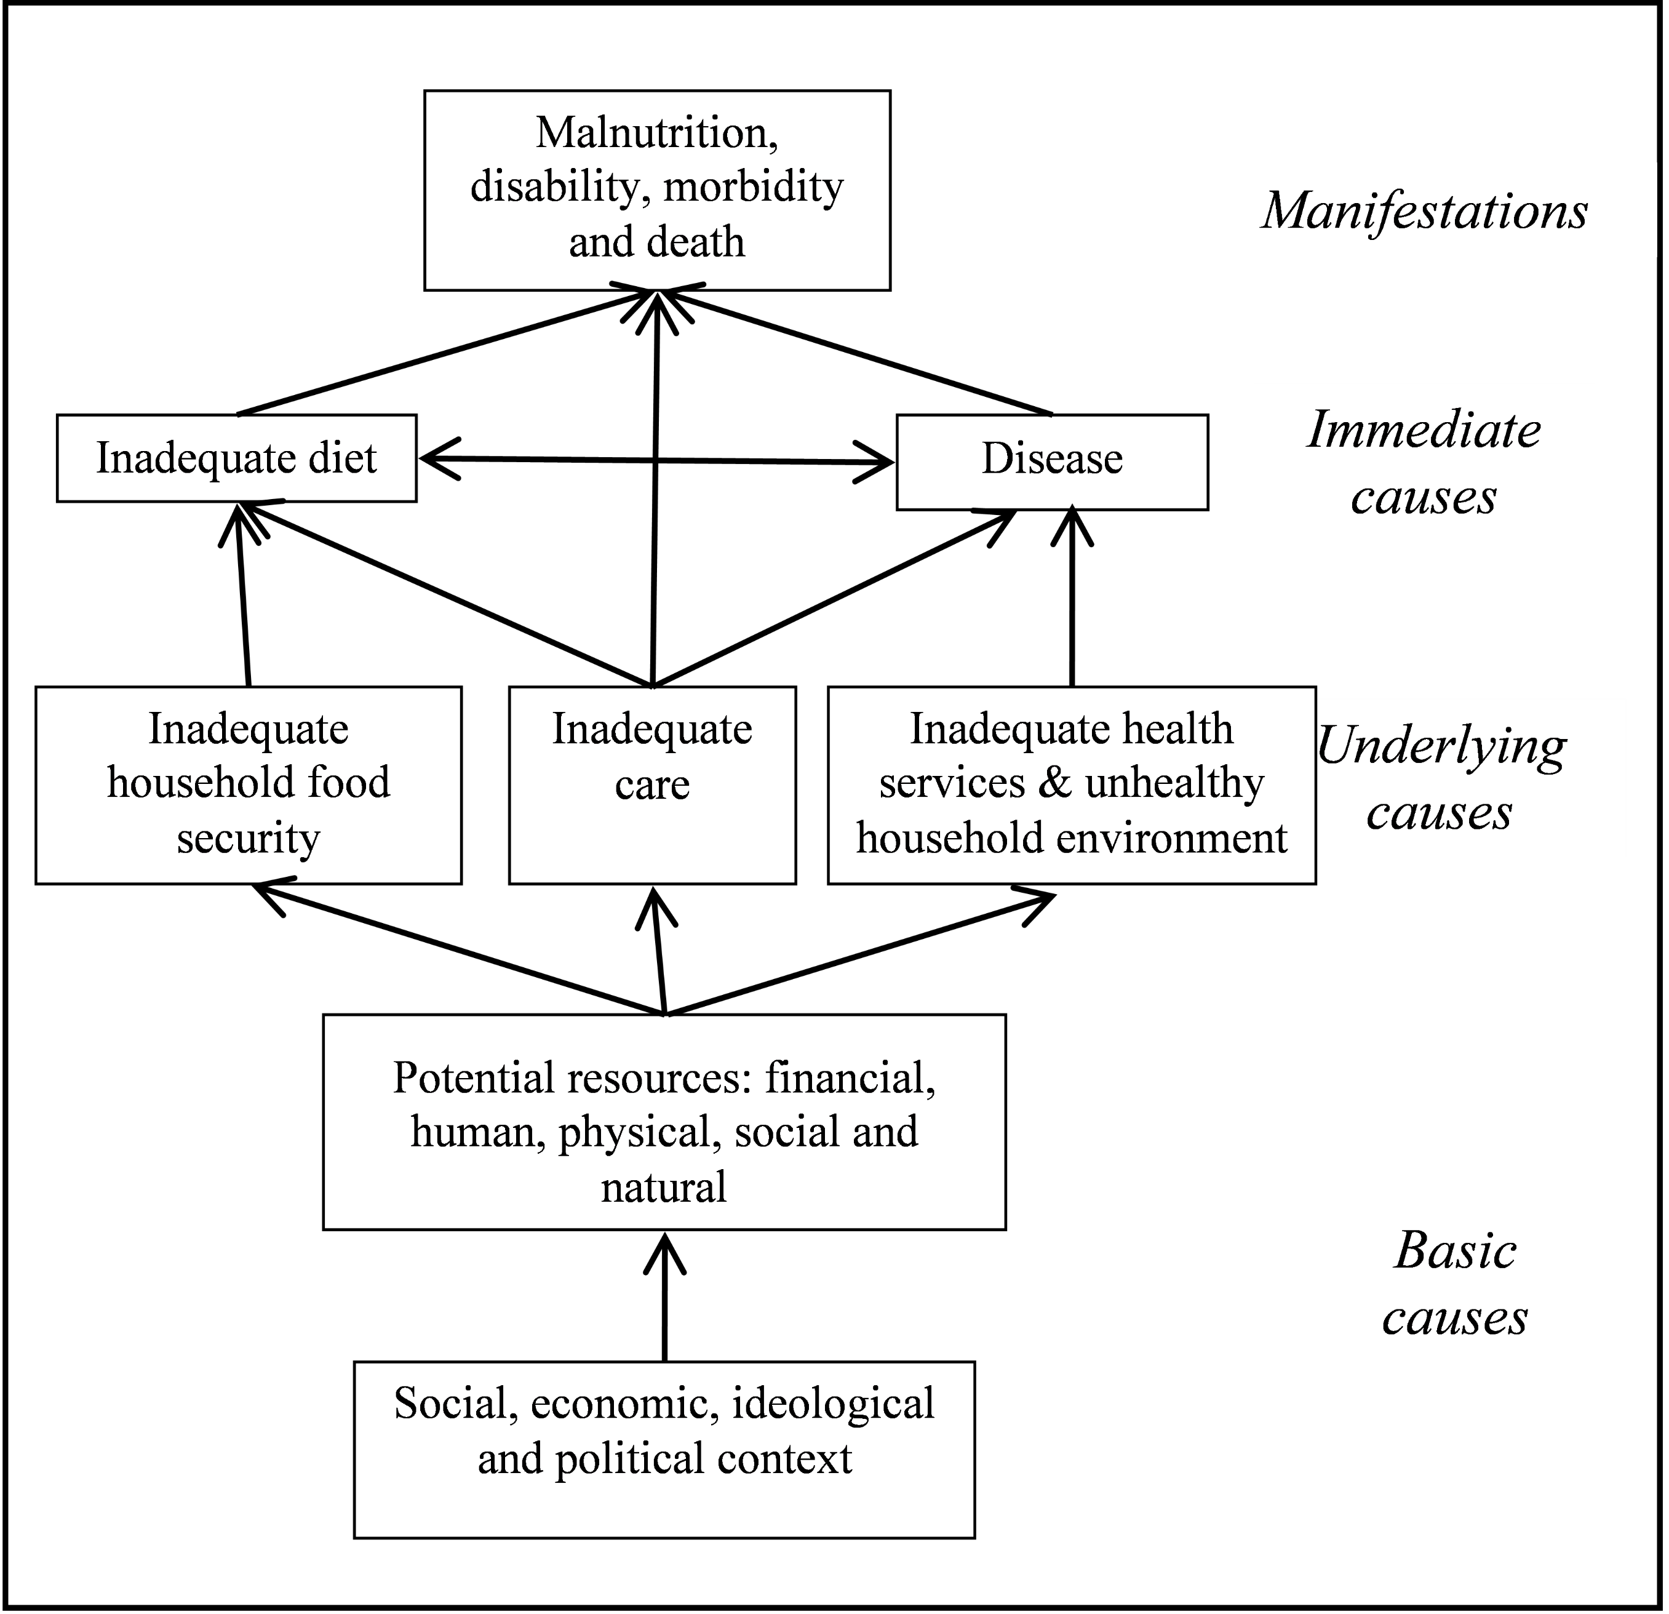
Adapted from: Lancet series on Maternal and Child Undernutrition 2008 and United Nations Children’s Fund (1997), Conceptual framework for analysing the causes of malnutrition, UNICEF, New York
Seasonality and its impact on nutrition

Causal pathways which act directly or indirectly on nutritional status may be affected by the seasons of the year. For example, there are seasonal cycles in food availability and access as a result of agricultural cycles and variations in household income and expenditure. This can have an impact on the quality and adequacy of the diet. When farmers are busy it can affect the degree of care they give to their children. During the rainy season drinking water may be collected from nearby contaminated water pools rather than walking further distances to safe water sources. Drinking unsafe water will increase the risk of having diarrhoea which is often more common during rainy seasons. In emergencies, the impact of these seasonal changes may become more pronounced and have a greater effect on the poorest people and the prevalence of malnutrition may increase.

Some basic causes such as flooding and conflict may increase during particular seasons.

Application of the Conceptual Model
- The conceptual model can be used as a check list to identify and prioritize the short and long term needs and gaps in services, both for vulnerable groups and for the general population during an emergency.
- It is a widely accepted model and, because of this, it can encourage organisations to collaborate and form a consensus on the priority of needs.
- The conceptual model provides a structure to organise the cross sectional data on factors impacting on the nutrition situation.

Limitations of the Conceptual Model
The main limitations of the conceptual model are;
- The conceptual model does not provide standard methods to assess factors that impact on nutrition.
- The conceptual model does not take into account individual factors that affect nutritional status.
- The conceptual model does not take into account how the different factors that impact on nutrition may be affected by seasonality.

Cross sectional data collected during food and nutrition surveys
Cross sectional data on factors that are expected to influence the nutritional status are frequently collected during food and nutrition surveys. This information can be used to identify needs and set priorities for programmes. However, cross-sectional data cannot be used to determine the causes of malnutrition; it can only indicate an association, which may not be causal.

Immediate causes of malnutrition
The immediate cause of malnutrition is due to an inadequate diet and disease. The manifestation of malnutrition is due to the difference between the amount of nutrients absorbed by the body and the amount of nutrients required by the body. This happens as a consequence of consuming too little food or having an infection, which increases the body’s requirements for nutrients, reduces appetite, or affects the absorption of nutrients from the gut.

Malnutrition and infection often occur at the same time. Malnutrition can increase the risk of infection while infection can cause malnutrition leading to a vicious cycle referred to as the infection-malnutrition cycle. The deaths of most children during an emergency are caused by diarrhoeal diseases, acute respiratory infections, measles and malaria. Malnutrition increases the risk that children will die of these diseases.

Underlying causes of malnutrition
The underlying causes of malnutrition can be grouped under the three broad categories: inadequate household food security, inadequate care and inadequate curative and preventative health care services and an unhealthy household environment, such as lack of access to safe water and effective sanitation. The three categories are interrelated, and actions affecting one area may have significant consequences on another. For an individual to be adequately nourished, all three need to be addressed.

Inadequate Household Food Insecurity
The World Food Summit in 1996 defined food security as, ‘Food Security exists when all people at all times, have physical and economic access to sufficient, safe and nutritious food to meet their dietary needs and food preferences for an active and healthy life’

The three main components of food security are access, availability and utilisation.
In emergencies, the way people obtain food is often disrupted. Emergencies can destroy food stocks in the home and warehouses, as well as affect land where crops are grown. Markets for food, livestock and labour can be disrupted, as can usual sources of household income. Some major famines have been caused by market shocks e.g. rapid prices increases which have resulted in an inability to buy food because of high inflation rates.
Inadequate Care
Caring practices captures the way that vulnerable people, particularly children and the elderly, are fed, nurtured, looked after, taught and guided. This is the responsibility of adults and of society in general. Caring practices are determined by cultural factors and by resources, such as income, time and knowledge. The values of society strongly influence the priority given to the care of vulnerable people. Attitudes to modern health services, water supplies and sanitation also affect caring practices. The care of vulnerable groups is particularly linked with the status, responsibilities, power and education of women, which may be culturally dependent. The unequal division of labour and resources in favour of men affects the well-being of both women and children.

Inadequate health services and unhealthy household environment

Health care services
This refers to access to health care to treat or prevent disease. Effective treatment can reduce the duration and the severity of infection and lower the risk of infecting other people. An essential element of good health is access to affordable, good quality health services and a healthy environment. Access to health services is determined by physical distance and the cost, which includes the cost of transport, consultation and treatment and the time it takes to attend the clinic. Poor quality health services may put people off, who then delay treatment until the disease is serious and the outcome of the treatment may be less successful. During an emergency, health services may be limited because there are no medical staff or medical supplies.

Unhealthy household environment
In emergencies access to adequate clean water and effective sanitation may be adversely affected. A lack of enough safe water, no proper sanitation systems, overcrowding and unhygienic conditions can lead to an increased incidence (new cases) of disease and a rise in the prevalence of malnutrition. Disease can reduce the capacity of adults to work and increases the amount of time they spend caring for sick members of the family.

The wellbeing of people is also affected by the quality of their shelter and by cold and stress.

Basic causes
Political, economic, ideological, legal and cultural factors may hinder or defeat the best efforts of people to attain good nutrition. For example, these include the degree to which the rights of women and girls are protected by law and custom; the control that women have over resources; the political and economic system that determines how income and assets are distributed; and the ideologies, policies and beliefs that govern social sectors.

Basic causes such as discrimination can lead to the marginalisation or exclusion of minority groups from food distribution systems and other relief services. Injustices are often exacerbated during emergencies and can lead to the nutritional status of minority groups deteriorating rapidly.
Economic marginalization and poverty is also one of the basic causes of malnutrition in many emergencies. In some countries prone to disasters, the poorest members of society are often the most badly affected. They may have few resources to protect them from the effects of an emergency.
Climate change directly affects the food and nutrition security of millions of people, and is affecting current efforts to address malnutrition. Comprehensive short and long term approaches are needed to preserve and improve nutrition security while addressing climate change.

Key messages

- Malnutrition has many interrelated immediate and underlying causes that need to be addressed effectively during an emergency.

- The conceptual model of malnutrition is a useful tool to help understand the many factors that impact on nutrition status. It identifies three levels of causality: immediate, underlying and basic which can all be exacerbated during emergencies.

- The conceptual model can be used for the following;
- To create a check list to identify and prioritize the short and long term needs of vulnerable groups and the general population during an emergency.
- It can encourage organisations to form consensus on the priority needs.
- It provides a structure to organise and analyse data collected during surveys.

- The limitations of the conceptual model are;
- The conceptual model is not an assessment tool.
- It does not take into account individual factors that affect nutritional status.
- It does not take into account how the different elements that impact on nutrition may be affected by seasonal factors.

- The use of cross sectional data concerning factors impacting on the nutrition situation may indicate an association but this does not necessarily mean causation.

- The immediate causes of malnutrition are inadequate diet and disease, both of which can make each other worse; this is referred to as the infection-malnutrition cycle.

- There are three main underlying causes: inadequate household food security, inadequate care and inadequate health services and an unhealthy household environment.

- The basic causes of malnutrition are related to potential resources and the social, political, ideological and economic context.

